**Digital Transformation: Enhancing IoT**

**-**

**driven Solutions for Smart Islands**

___________________________

Dr. Farzad Ebrahimi

Chairman of IoT Academy

ITU Expert

ebrahimi@iotaci.com



Smart Island and its capability for smart agriculture



Hamid Naghizadeh

Researcher in the field of smart

agriculture

h.naghizadeh@iotaci.com

# Farzad Ebrahimi

CEO of IoT Academy (ITU Academia Member & ITU IoT Center of Excellence in Asia-Pacific)

Faculty Member in ICT Research Institute

International Internet of Things (IoT) Speaker & Lecturer

International Telecommunication Union (ITU) Expert

Chairman of The corresponding ISO/IEC JTC1 SC41 (Internet of Things and related technologies Standards) in Iran

Chairman, Member of the founding board and the board of trustees of Non-Commercial Institute (as a NGO) of “Promoting the Internet of Things and data science” at national level.



Doctor of Business Administration from the University of Tehran, MBA, M.Sc in Electrical EngineeringTelecommunication systems, B.Sc in Electrical Engineering- Electronics.

**Other Records:**

Counselor of the Director of ICT Research Institute

Superintendent of IT Faculty in Iran Telecom Research Center

Deputy of IT Faculty in Iran Telecom Research Center

Head of Multimedia Systems Research Group in Iran Telecom Research Center

Project Manager, Consultant and Observer of more than 50 Regional and National ICT related Projects.

**Hamid Naghizadeh**

**Education:**

MSc. – Agricultural Engineering, Animal Physiology BSc. – Agricultural Engineering, Animal Sciences

**Professional Experience:**

Research activities at Iran's national animal breeding and promotion of animal products center



Research activities at Iran's ministry of agriculture

Work and research experiences in the livestock and poultry farms

Head of the Group “Students of Animal Sciences” (student society(

**Areas of Interests:**

Smart Agriculture

Precision Farming

Applications of IoT and AI in the developing farms

# Outline

**1**

**. Introduction to the**

**agriculture**

✓

Terminology

✓

Definitions

✓

Agriculture as art,

science and

business of crop

production

✓

Branches of

Agriculture

**2**

**. IoT**

**-**

**Enabled Smart**

**Agriculture**

✓

Introduction

✓

IoT Ecosystem

Architecture for

Smart Agriculture

✓

Typical

Applications of

IoT in Smart

Agriculture

**3**

**. Precision Farming**

✓

An Introduction to

Precision

Agriculture

✓

The need for

precision

agriculture

✓

Tools of precision

agriculture

**4**

**. Climate**

**-**

**Smart**

**Agriculture**

✓

Why climate

-

smart

agriculture,

forestry and

fisheries?

✓

Water

management

✓

Soils and their

management for

Climate

-

smart

agriculture

**5**

**. Smart agriculture in**

**the Islands**

✓

Smart Islands

✓

The capability of

smart Islands for

smart agriculture

✓

Climate Smart

Agriculture in

Small Island

Developing

States

**1**

**. Introduction to the Agriculture**

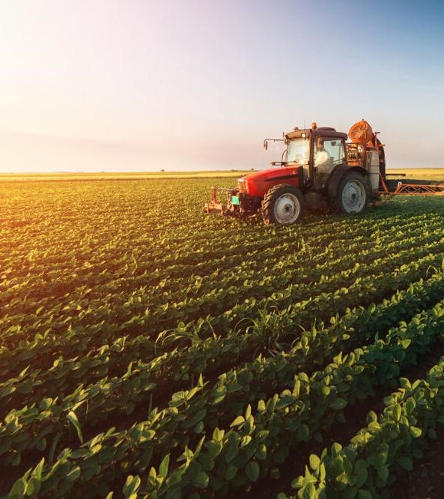

## 1. Introduction to the Agriculture

### 1.1 Terminology

Agriculture is derived from the Latin words Ager and Cultura. Ager means land or field, and Cultura means cultivation. Therefore the term agriculture means cultivation of land. i.e., the science and art of producing crops and livestock for economic purposes. It is also referred to as the science of producing crops and livestock from the earth's natural resources. The primary aim of agriculture is to cause the land to produce more abundantly and, at the same time, to protect it from deterioration and misuse. It is synonymous with farming–the production of food, fodder, and other industrial materials.

## 1. Introduction to the Agriculture



### 1.2 Definitions

Agriculture is defined in the Agriculture Act 1947 as including ‘horticulture, fruit growing, seed growing, dairy farming and livestock breeding and keeping, the use of land as grazing land, meadowland, osier land, market gardens, and nursery grounds, and the use of land for woodlands where that use ancillary to the farming of land for Agricultural purposes”. It is also defined as ‘purposeful work through which elements in nature are harnessed to produce plants and animals to meet human needs. It is a biological production process that depends on the growth and development of selected plants and animals within the local environment.

## 1. Introduction to the Agriculture

### 1.3 Agriculture as art, science and business of crop production

Agriculture is defined as the art, science, and the business of producing crops and livestock for economic purposes.

**As an art:** it embraces knowledge of how to perform the farm's operations skillfully. The skill is categorized as follows;

Physical skill: It involves the ability and capacity to carry out the operation in an efficient way, e.g., handling of farm implements, animals, etc., sowing of seeds, fertilizer and pesticide application, etc.

Mental skill: The farmer can make a decision based on experiences, such as (i) time and method of plowing, (ii) selection of crop and cropping system to suit soil and climate, and (iii) adopting improved farm practices, etc.

## 1. Introduction to the Agriculture

### 1.3 Agriculture as art, science and business of crop production

**As a science:** It utilizes all modern technologies developed on scientific principles such as crop improvement/breeding, crop production, crop protection, economics, etc., to maximize the yield and profit. For example, new crops and varieties developed by hybridization, transgenic crop varieties resistant to pests and diseases, hybrids in each crop, high fertilizer responsive varieties, water management, herbicides to control weeds, and bio-control agents to combat pests and diseases, etc.

**As the business:** As long as agriculture is the way of life of the rural population, production is ultimately bound to consumption. But agriculture as a business aims at maximum net return through the management of land, labor, water, and capital, employing the knowledge of various sciences for the production of food, feed, fiber, and fuel. In recent years, agriculture has been commercialized to run as a business through mechanization.

## 1. Introduction to the Agriculture

### 1.4 Branches of Agriculture

Agriculture has 3 main spheres viz., Geoponic (Cultivation in earth-soil), Aeroponic (cultivation in air) and Hydroponic (cultivation in water). Agriculture is the branch of science encompassing the applied aspects of basic sciences. The applied aspects of agricultural science consists of study of field crops and their management (Arviculture) including soil management.

**Crop production** - It deals with the production of various crops, which includes food crops, fodder crops, fibre crops, sugar, oil seeds, etc. It includes agronomy, soil science, entomology, pathology, microbiology, etc. The aim is to have better food production and how to control the diseases.

**Horticulture** - Branch of agriculture deals with the production of flowers, fruits, vegetables, ornamental plants, spices, condiments (includes narcotic crops-opium, etc., which has medicinal value) and beverages.

## 1. Introduction to the Agriculture

### 1.4 Branches of Agriculture

**Agricultural Engineering** - It is an important component for crop production and horticulture particularly to provide tools and implements. It is aiming to produce modified tools to facilitate proper animal husbandry and crop production tools, implements and machinery in animal production.

**Forestry** - It deals with production of large scale cultivation of perennial trees for supplying wood, timber, rubber, etc. and also raw materials for industries.

**Animal Husbandry** - The animals being produced, maintained, etc. Maintenance of various types of livestock for direct energy (work energy). Husbandry is common for both crop and animals. The objective is to get maximum output by feeding, rearing, etc. The arrangement of crops is done to get minimum requirement of light or air. This arrangement is called geometry. Husbandry is for direct and indirect energy.

## 1. Introduction to the Agriculture

### 1.4 Branches of Agriculture

**Fishery Science** - It is for marine fish and inland fishes including shrimps and prawns.

**Home Science** - Application and utilization of agricultural produces in a better manner. When utilization is enhanced production is also enhanced. e.g., a crop once in use in south was found that it had many uses now.

On integration, all the seven branches, first three is grouped as for crop production group and next two for animal management and last two as allied agriculture branches. Broadly in practice, agriculture is grouped in four major categories as,

|  |  |
| --- | --- |
| A. Crop Improvement | Plant breeding and genetics Bio-technology |
| B. Crop Management | Agronomy  Soil Science and Agricultural Chemistry  Seed technology  Agricultural Microbiology  Crop-Physiology  Agricultural Engineering  Environmental Sciences  Agricultural Meteorology |
| C. Crop Protection | Agricultural Entomology  Plant Pathology  Nematology |
| D. Social Sciences | Agricultural Extension Agricultural Economics |
| Allied disciplines | Agricultural Statistics  English and Tamil  Mathematics  Bio-Chemistry etc. |

**2**

**. IoT**

**-**

**Enabled Smart Agriculture**

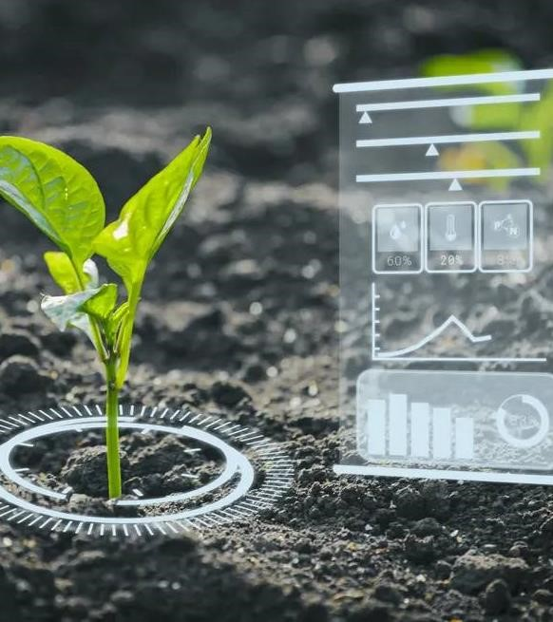

## 2. IoT-Enabled Smart Agriculture

### 2.1. Introduction

In order to meet the current global needs of humanity, new solutions and technologies are constantly being proposed and implemented. This has led to the advent of the Internet of Things (IoT). IoT is defined as the network of all objects that are embedded within devices, sensors, machines, software and people through the Internet environment to communicate, exchange information and interact in order to provide a comprehensive solution between the real world and the virtual world. In recent years, IoT has been applied in a series of domains, such as smart homes, smart cities, smart energy, autonomous vehicles, smart agriculture, campus management, healthcare, and logistics. Series of other IoT applications have been described by Shafique et al.

An illustration of rich and diverse IoT applications for smart agriculture is provided in Figure 1.

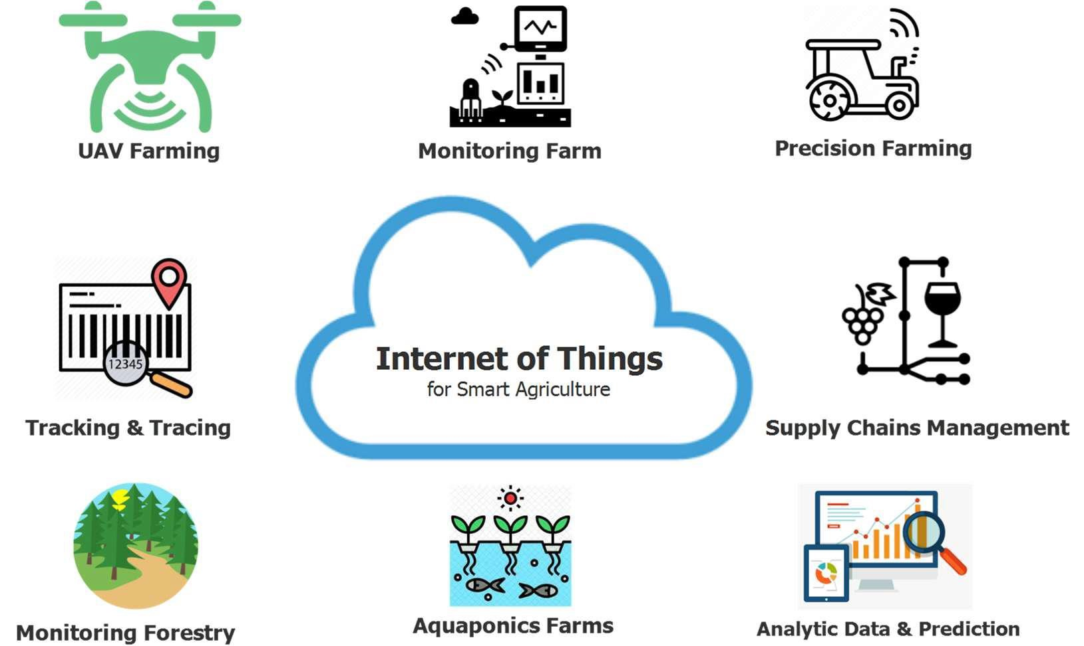

An illustration of IoT applications for smart agriculture.

## 2. IoT-Enabled Smart Agriculture

### 2.2. IoT Ecosystem Architecture for Smart Agriculture

In this section, we present a common framework of an IoT ecosystem for smart agriculture based on three main components, including (1) IoT devices, (2) communication technologies, and (3) data process and storage solutions. An illustration of the IoT ecosystem for smart agriculture is presented in Figure 2.

Figure 2. An illustration of IoT ecosystems’ architecture for smart agriculture.

## 2. IoT-Enabled Smart Agriculture

### 2.2. IoT Ecosystem Architecture for Smart Agriculture

#### 2.2.1 IoT Devices

The common architecture of an IoT device consists of sensors to collect information from the environment, actuators based on wired or wireless connections, and an embedded system that has a processor, memory, communication modules, input– output interfaces, and battery power. The common architecture of a typical IoT device for smart agriculture is shown in Figure 3.

An illustration of the common architecture of an IoT device.

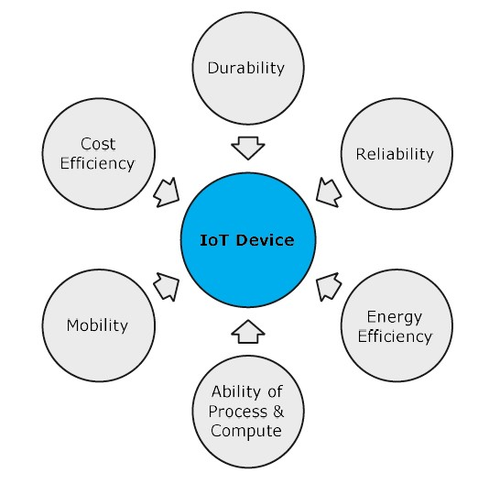

The main characteristics of IoT devices.

## 2. IoT-Enabled Smart Agriculture

### 2.2. IoT Ecosystem Architecture for Smart Agriculture

#### 2.2.2 Communication Technology

The survey of communication technologies for IoT indicated that to integrate IoT into the smart agriculture sector, communication technologies must progressively improve the evolution of IoT devices. They play an important role in the development of IoT systems. The existing communication solutions can be classified as: protocol, spectrum, and topology.

Protocols: many wireless communication protocols have been proposed for the smart agriculture sector. Based on these protocols, devices in a smart agricultural system can interact, exchange information, and make decisions to monitor and control farming conditions and improve yields and production efficiency. The typical, low-power communication protocol numbers commonly used in smart agriculture can be divided into short-range and long-range categories based on the communication range.

Some typical communication technologies for smart agriculture.

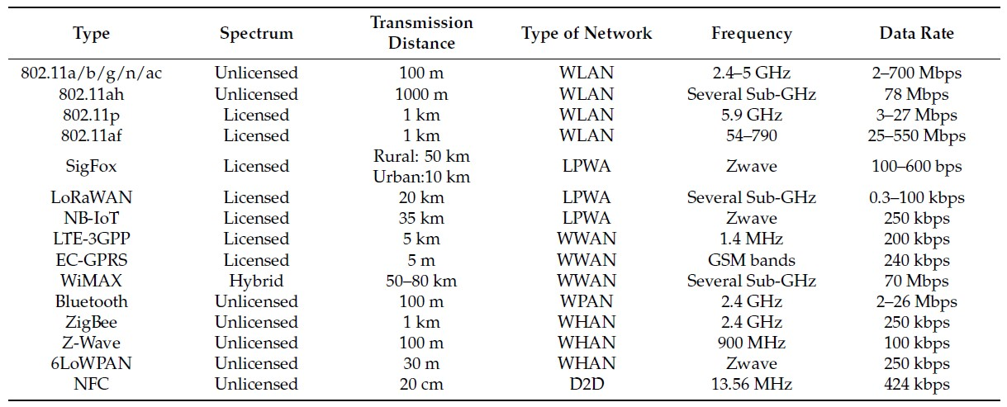

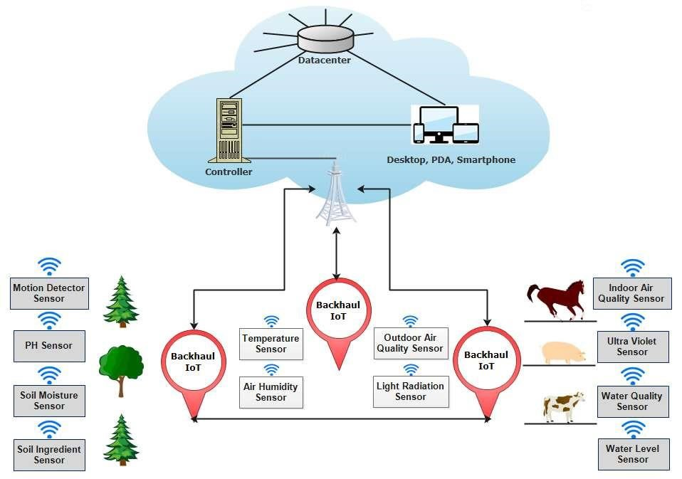

An illustration of the common IoT-based smart agriculture topology.

## 2. IoT-Enabled Smart Agriculture

### 2.3. Typical Applications of IoT in Smart Agriculture

#### 2.3.1 Monitoring

In the agriculture sector, factors affecting the farming and production process can be monitored and collected, such as soil moisture, air humidity, temperature, pH level, etc. These factors depend on the considered agricultural sector. Some smart agricultural sectors are applying the following monitoring solutions:

* Crop Farming
* Aquaponics
* Forestry
* Livestock Farming

## 2. IoT-Enabled Smart Agriculture

### 2.3. Typical Applications of IoT in Smart Agriculture

#### 2.3.2 Tracking and Tracing

In order to meet the needs of consumers and increase profit value, in the future, farms need to demonstrate that products offered to the market are clean products and can be tracked and traced conveniently, thereby enhancing the trust of consumers in product safety and health-related issues.

#### 2.3.3 Smart Precision Farming

The advent of the GPS (global positioning system) has created breakthrough advances in many fields of science and technology. The GPS provides the most important parameters for locating a device, such as location and time. GPS systems have been successfully deployed in many fields, such as smartphones, vehicles, and IoT ecosystems. However, GPS is only good support for outdoor systems and the sky. Meanwhile, the demand for the locating and navigating systems in the home and on the streets of smart cities is growing rapidly. Aiming to solve this problem, an advanced global navigation satellite system (GNSS) is being deployed. Based on GPS and GNSS systems, suitable farming maps have been established for fields and farms. As a result, agricultural machinery and equipment can be operated autonomously.

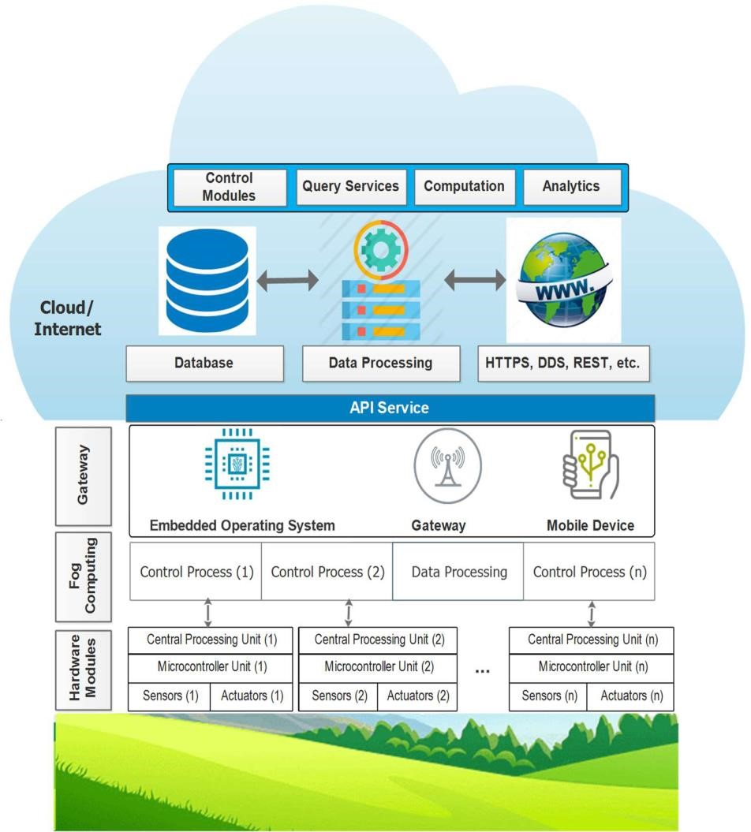

Cloud-assisted IoT-based precision agriculture platform.

## 2. IoT-Enabled Smart Agriculture

### 2.3. Typical Applications of IoT in Smart Agriculture

#### 2.3.4 Greenhouse Production

A greenhouse consists of walls and a roof, which are usually made from transparent materials, such as plastic or glass. In a greenhouse, plants are grown in a controlled environment, including controlling for moisture, nutrient ingredients of the soil, light, temperature, etc. Consequently, greenhouse technology makes it possible for humans to grow any plant, at any time, by providing suitable environmental conditions.

An illustration of IoT application for monitoring farming conditions in a greenhouse.

**3**

**. Precision Farming**

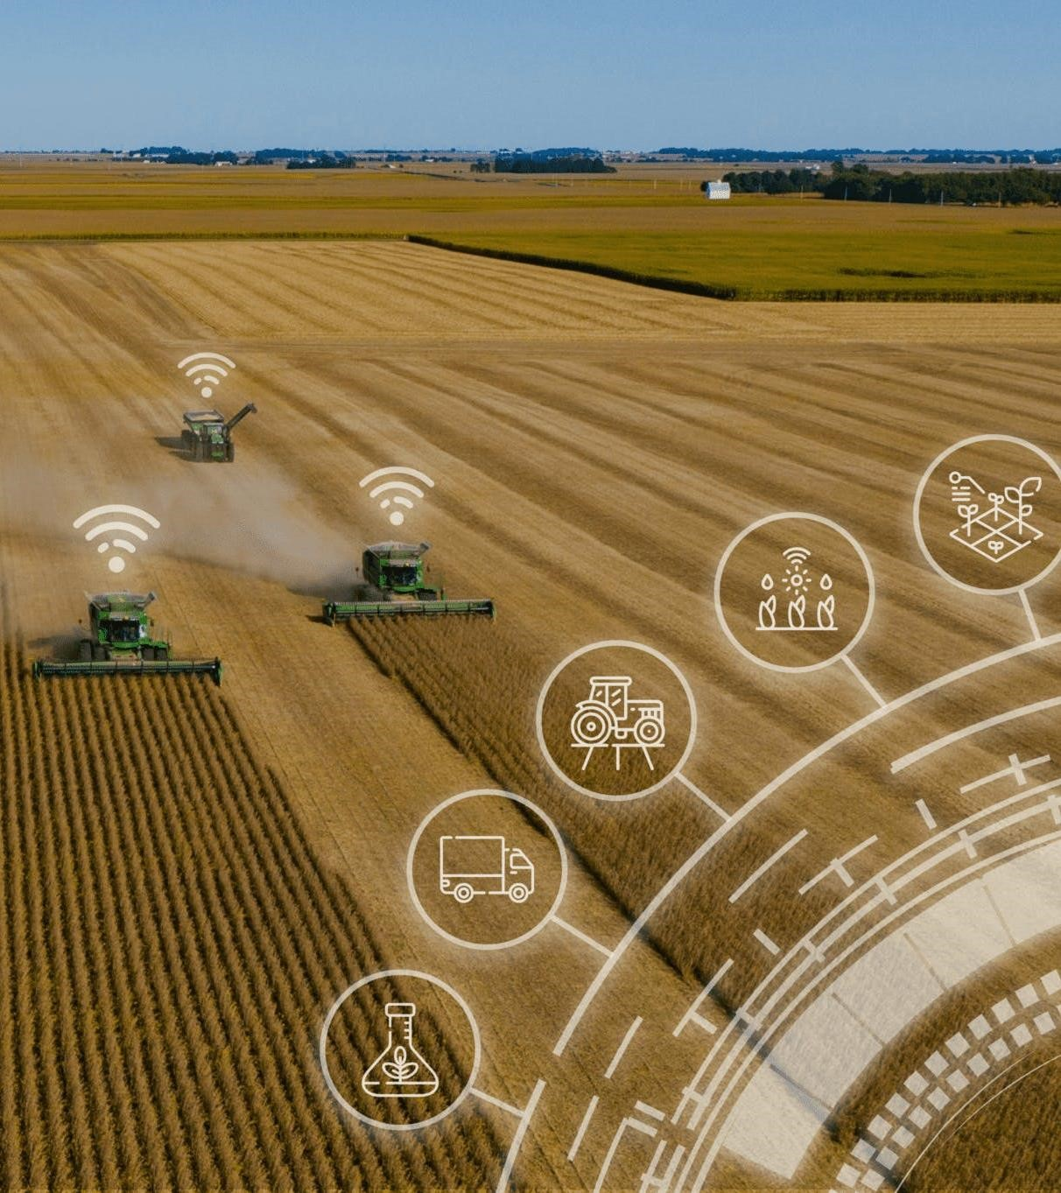

## 3. Precision Farming

### 3.1. An Introduction to Precision Agriculture

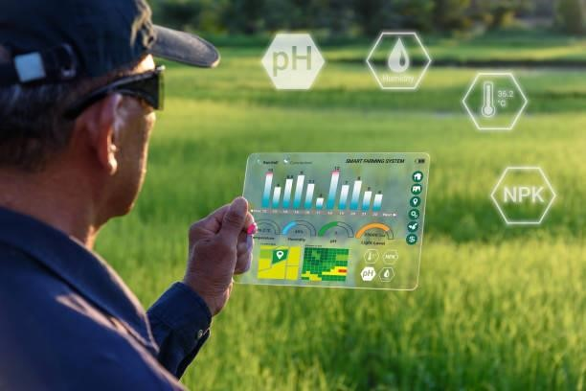Precision agriculture merges the new technologies borne of the information age with a mature agricultural industry. It is an integrated crop management system that attempts to match the kind and amount of inputs with the actual crop needs for small areas within a farm field. This goal is not new, but new technologies now available allow the concept of precision agriculture to be realized in a practical production setting.

Precision agriculture often has been defined by the technologies that enable it and is often referred to as GPS (Global Positioning System) agriculture or variable-rate farming. As important as the devices are, it only takes a little reflection to realize that information is the key ingredient for precise farming. Managers who effectively use information earn higher returns than those who don't.

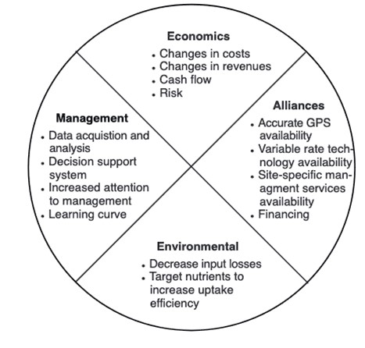

Issues affecting adoption of precision agriculture management.

## 3. Precision Farming

### 3.2. The need for precision agriculture

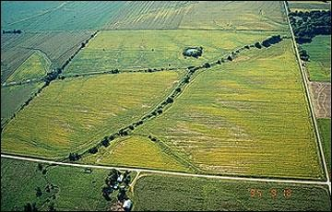Farmers usually are aware that their fields have variable yields across the landscape. These variations can be traced to management practices, soil properties and/or environmental characteristics. Soil characteristics that affect yields include texture, structure, moisture, organic matter, nutrient status and landscape position. Environmental characteristics include weather, weeds, insects and disease.

The aerial photo in front Figure illustrates that in some fields, within-field variability can be substantial. In this field, the best crop growth was near waterways and level areas of the field.

## 3. Precision Farming

### 3.3. Tools of precision agriculture

In order to gather and use information effectively, it is important for anyone considering precision farming to be familiar with the technological tools available. These tools include hardware, software and recommended practices.

#### 3.3.1 Global Positioning System (GPS) receivers

Global Positioning System satellites broadcast signals that allow GPS receivers to calculate their position. This information is provided in real time, meaning that continuous position information is provided while in motion. Having precise location information at any time allows soil and crop measurements to be mapped. GPS receivers, either carried to the field or mounted on implements allow users to return to specific locations to sample or treat those areas.

Uncorrected GPS signals have an accuracy of about 300 feet. To be useful in agriculture, the uncorrected GPS signals must be compared to a land-based or satellite-based signal that provides a position correction called a differential correction. The corrected position accuracy is typically 63-10 feet. In Missouri, the Coast Guard provides differential correction beacons that are available to most areas free of charge. When purchasing a GPS receiver, the type of differential correction and its coverage relative to use area should be considered.

## 3. Precision Farming

### 3.3. Tools of precision agriculture

#### 3.3.2 Yield monitoring and mapping

Grain yield monitors continuously measure and record the flow of grain in the clean-grain elevator of a combine. When linked with a GPS receiver, yield monitors can provide data necessary for yield maps. Yield measurements are essential for making sound management decisions. However, soil, landscape and other environmental factors should also be weighed when interpreting a yield map. Used properly, yield information provides important feedback in determining the effects of managed inputs such as fertilizer, lime, seed, pesticides and cultural practices including tillage and irrigation.

Yield measurements from a single year may be heavily influenced by weather. Examining yield information records from several years and including data from extreme weather years helps in determining if the observed yield level is due to management or is climate-induced.

## 3. Precision Farming

### 3.3. Tools of precision agriculture

#### 3.3.3 Grid soil sampling and variable-rate fertilizer (VRT) application

Historically, the objectives of soil sampling have been to determine the average nutrient status of a field and to provide some measure of nutrient variability in a field. Soil sampling for precision agriculture has these same objectives with some modifications. Instead of a field, producers are interested in areas within fields. They also are interested in relating trends in soil fertilizer levels to other field properties that are predictable or easily measured. Knowledge of factors influencing soil nutrient levels including soil type, topography, cropping history, manure application, fertilizer application and leveling for irrigation will help the producer determine the most effective sampling approach. The basic principles of soil sampling still apply to precision sampling. An adequate number of samples should be collected to accurately characterize nutrient levels. The samples should be collected to the proper depth for nonmobile and mobile nutrients. Samples should be handled and stored to minimize contamination and degradation.

## 3. Precision Farming

### 3.3. Tools of precision agriculture

#### 3.3.4 Remote sensing

Remote sensing is collection of data from a distance. Data sensors can simply be hand-held devices, mounted on aircraft or satellite-based. Remotely-sensed data provide a tool for evaluating crop health. Plant stress related to moisture, nutrients, compaction, crop diseases and other plant health concerns are often easily detected in overhead images. Electronic cameras can also record near-infrared images that are highly correlated with healthy plant tissue. New image sensors with high spectral resolution are increasing the information collected from satellites.

## 3. Precision Farming

**3.3. Tools of precision agriculture**

### 3.3.5 Crop scouting

With planting wrapping up and crops beginning to emerge, now is the time to start scouting fields regularly throughout the growing season for any potential issues. Scouting fields and monitoring crops throughout the growing season can help you make more informed management decisions and stay on top of potential issues that may come up during the growing season. Even if some issues cannot be fixed, regular scouting can help us better understand what happened in the field and make adjustments to reduce issues in the future.

## 3. Precision Farming

**3.3. Tools of precision agriculture**

### 3.3.6 Geographic information systems (GIS)

Geographic information systems (GIS) are computer hardware and software that use feature attributes and location data to produce maps. An important function of an agricultural GIS is to store layers of information, such as yields, soil survey maps, remotely sensed data, crop scouting reports and soil nutrient levels. Geographically referenced data can be displayed in the GIS, adding a visual perspective for interpretation.

In addition to data storage and display, the GIS can be used to evaluate present and alternative management by combining and manipulating data layers to produce an analysis of management scenarios.

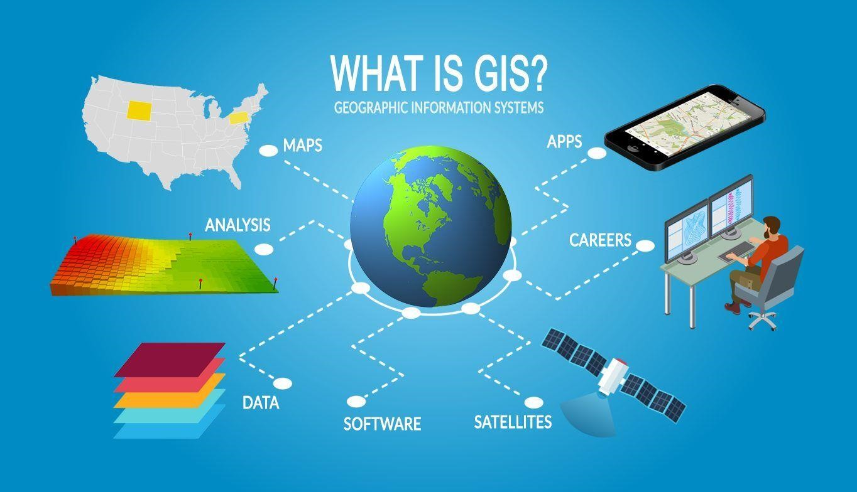

## 3. Precision Farming

**3.3. Tools of precision agriculture**

### 3.3.7 Information management

The adoption of precision agriculture requires the joint development of management skills and pertinent information databases. Effectively using information requires a farmer to have a clear idea of the business' objectives and of the crucial information necessary to make decisions. Effective information management requires more than record-keeping analysis tools or a GIS. It requires an entrepreneurial attitude toward education and experimentation.

## 3. Precision Farming

**3.3. Tools of precision agriculture**

### 3.3.8 Identifying a precision agriculture service provider

Farmers should consider the availability of custom services when making decisions about adopting site-specific crop management. Agricultural service providers may offer a variety of precision agriculture services to farmers. By distributing capital costs for specialized equipment over more land and by using the skills of precision agriculture specialists, custom services can decrease the cost and increase the efficiency of precision agriculture activities.

**4**

**. Climate**

**-**

**Smart Agriculture**

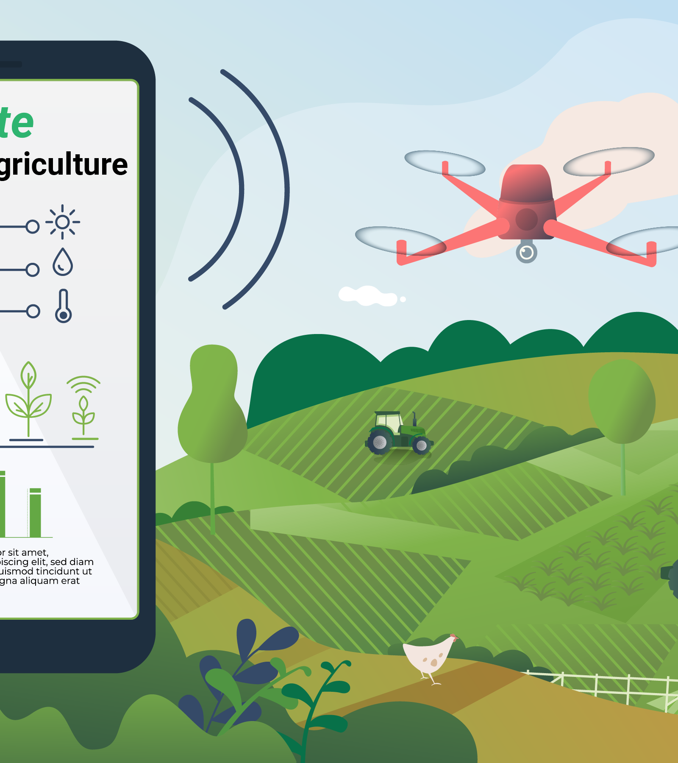

## 4. Climate-Smart Agriculture

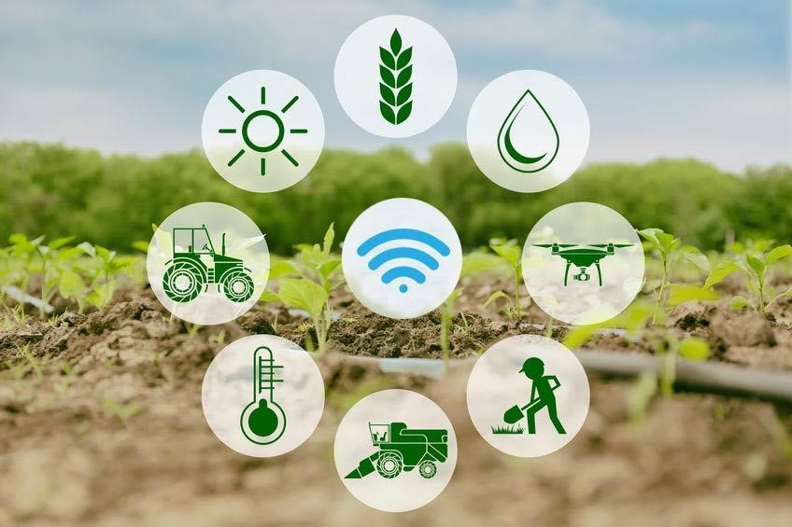**4.1. Why climate-smart agriculture, forestry and fisheries?**

Agriculture has to address simultaneously three intertwined challenges: ensuring food security through increased productivity and income, adapting to climate change and contributing to climate change mitigation (FAO, 2010a; Foresight, 2011a; Beddington et al., 2012a; Beddington et al., 2012b; HLPE, 2012a). Addressing these challenges, exacerbating global pressure on natural resources, especially water, will require radical changes in our food systems. To address these three intertwined challenges, food systems have to become, at the same time, more efficient and resilient, at every scale from the farm to the global level. They have to become more efficient in resource use (use less land, water, and inputs to produce more food sustainably) and become more resilient to changes and shocks.

It is precisely to articulate these changes that FAO has forged the concept of climate-smart agriculture (CSA) as a way forward for food security in a changing climate. CSA aims to improve **food security**, **help communities adapt to climate change and contribute to climate change mitigation** by **adopting appropriate practices**, **developing enabling policies** and **institutions and mobilizing needed finances**.

## 4. Climate-Smart Agriculture

**4.1. Why climate-smart agriculture, forestry and fisheries?**

**Key messages:**

* Agriculture and food systems must undergo significant transformations in order to meet the related challenges of food security and climate change.
* Increasing resource efficiency is essential both to increase and ensure food security on the long term and to contribute to mitigate climate change.
* Building resilience to every type of risk is essential to be prepared for uncertainty and change.
* Efficiency and resilience have to be considered together, at every scale and from both environmental, economic and social perspectives.
* Implementing climate-smart agriculture can be a major driver of a Green Economy and a concrete way to operationalize sustainable development.
* Addressing food security and climate change requires concerted and coordinated involvement and action of all stakeholders on a long term perspective.
* Climate smart agriculture is not a new agricultural system, nor a set of practices. It is a new approach, a way to guide the needed changes of agricultural systems, given the necessity to jointly address food security and climate change.

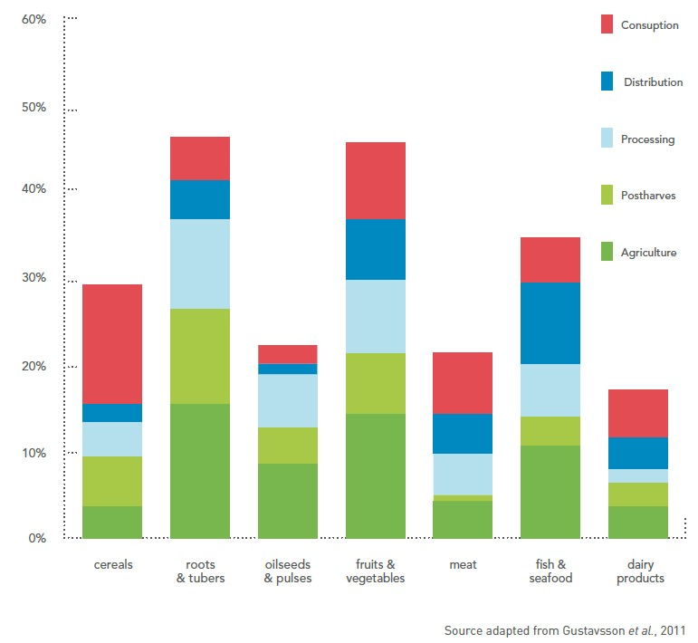

Global food losses.

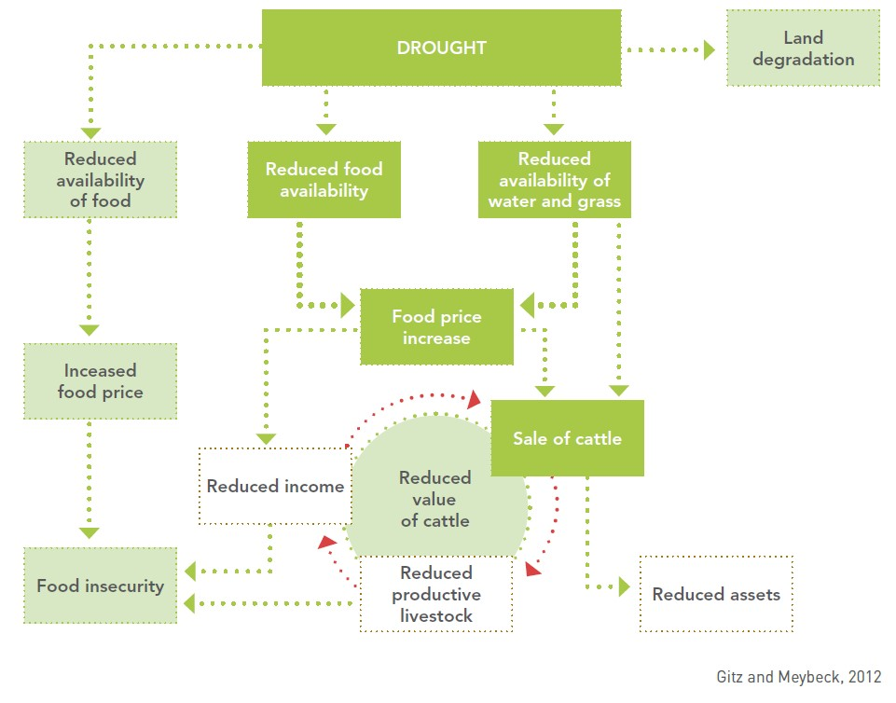

Impacts of drought.

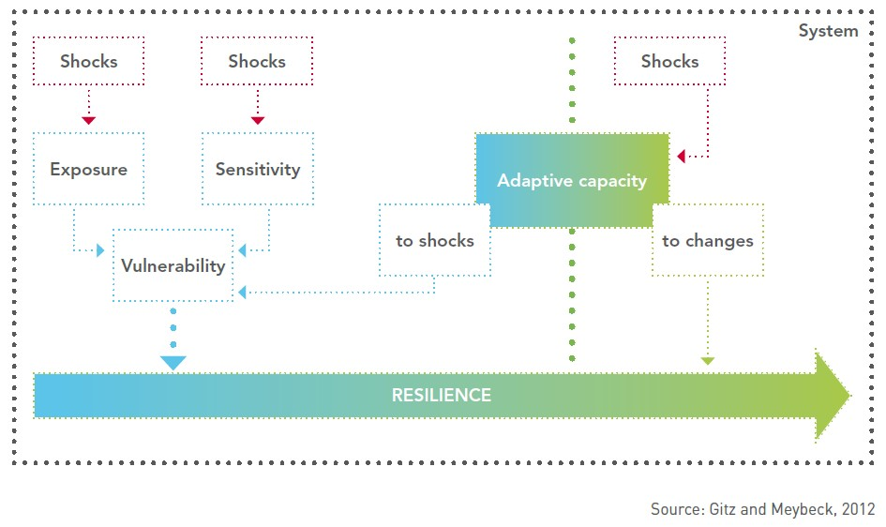

Components of resilience

## 4. Climate-Smart Agriculture

### 4.2. Water management

This section examines the overall development context in which water is managed in agriculture and provides an overview of the current status, trends and challenges. It also reviews the current state of knowledge of the impact of climate change on water for agriculture and the vulnerability of rural populations and farming systems to climate change. This is followed by an examination of possible response options for addressing these impacts. These options can be applied at various scales, on individual farms, in larger irrigation schemes, throughout entire river basins and at the national level. The module also presents criteria for prioritizing response options, examines conditions for climate change adaptation and reviews opportunities for climate change mitigation.

## 4. Climate-Smart Agriculture

**4.2. Water management Key messages:**

* Most of the impacts of climate change on agriculture are expected to result from changes in the water cycle. Because of this, the design of climate-smart agriculture (CSA) strategies will need to be viewed though a ‘water lens’.
* Climate change will affect both rainfed and irrigated agriculture through increased crop evapotranspiration, changes in the amount of rainfall, and variations in river runoff and groundwater recharge. The impact of climate change on water use in agriculture must be considered within a wider context in which a number of issues are taken into account including: increased water demand by all sectors; the degradation of water quality; and heightened competition for water at various levels (community, river basin and aquifer).
* Climate change adaptation in water includes a range of response options related to policies, investments, water management, and institutional and technical factors. These options will need to be applied at different scales: on fields and farms; in irrigation schemes; in watersheds or aquifers; in river basins and at the national level.
* Climate-proofing will have to become central in the design of future investment plans in water for agriculture. It will become necessary to maintain a clear perspective on resilience when screening water development programmes. When designing development policies it will be necessary to systematically consider how the policies may be affected by climate change. In many cases, the challenge will be to combine more efficient use of water with increased resilience of production systems.

To watch the video of this slide, refer to the video presentation.



Climate change and development: how they influence water supply and demand

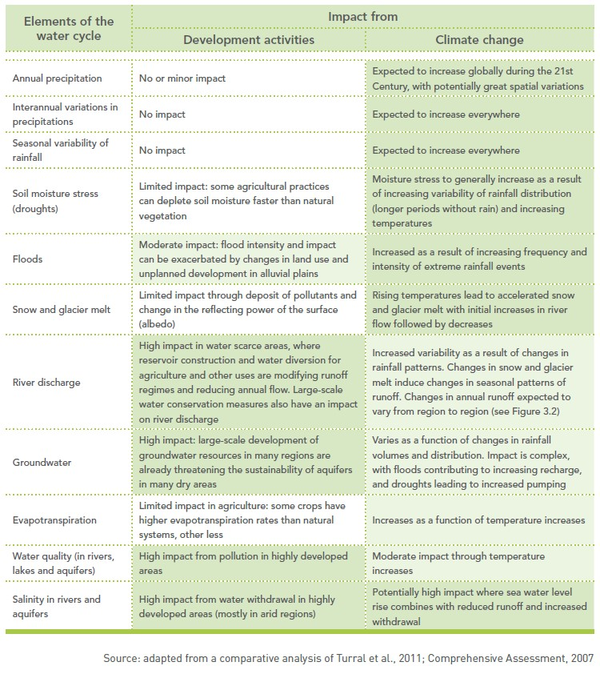

## 4. Climate-Smart Agriculture

### 4.3. Soils and their management for Climate-smart agriculture

This section looks at soil management in the context of climate change. It begins with an overview of some of the principles of soil health and the way soils interact with the atmosphere and with terrestrial and freshwater ecosystems. Sustainable soil management options are presented as “winwin-win” strategies that sequester carbon in the soil, reduce greenhouse gas (GHG) emissions and help intensify production, all while enhancing the natural resource base. The module also describes practices that contribute to climate change adaptation and mitigation, and build the resilience of agricultural ecosystems.

## 4. Climate-Smart Agriculture

**4.3. Soils and their management for Climate-smart agriculture Key messages:**

* Knowing the status and condition of soils and their properties is fundamental for making decisions about sustainable soil management practices that contribute to climate-smart land use.
* Soils that have been degraded are at much greater risk from the damaging impacts of climate change. Degraded soils are vulnerable due to serious losses of soil organic matter (SOM) and soil biodiversity, greater soil compaction and increased rates of soil erosion and landslides. In addition, land degradation is itself a major cause of climate change.
* Management practices that increase soil organic carbon (SOC) content through organic matter management rather than depleting it will bring win-win-win benefits. These practices will maintain productive soils that are rich in carbon, require fewer chemical inputs and sustain vital ecosystem functions, such as the hydrological and nutrient cycles.
* The sound management of the interrelations among soils, crops and water can increase SOM, improve the soil’s capacity to retain nutrients and water, and enhance soil biodiversity. Integrated management practices can create optimal physical and biological conditions for sustainable agricultural production (including food, fiber, fodder, bioenergy and tree crops, and livestock).

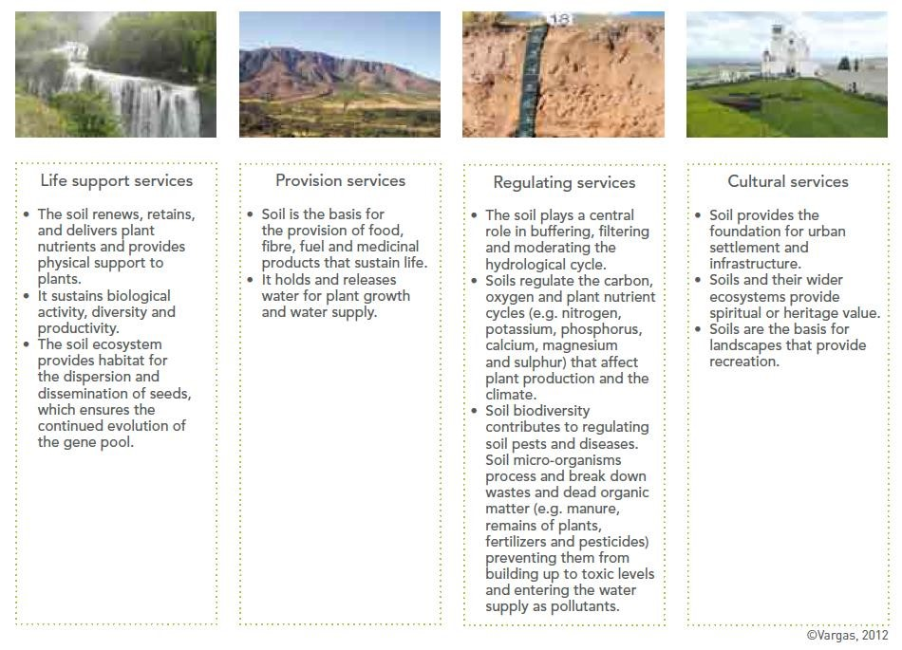

To watch the video of this slide, refer to the video presentation.



To watch the video of this slide, refer to the video presentation.



**5**

**. Smart agriculture in the Islands**

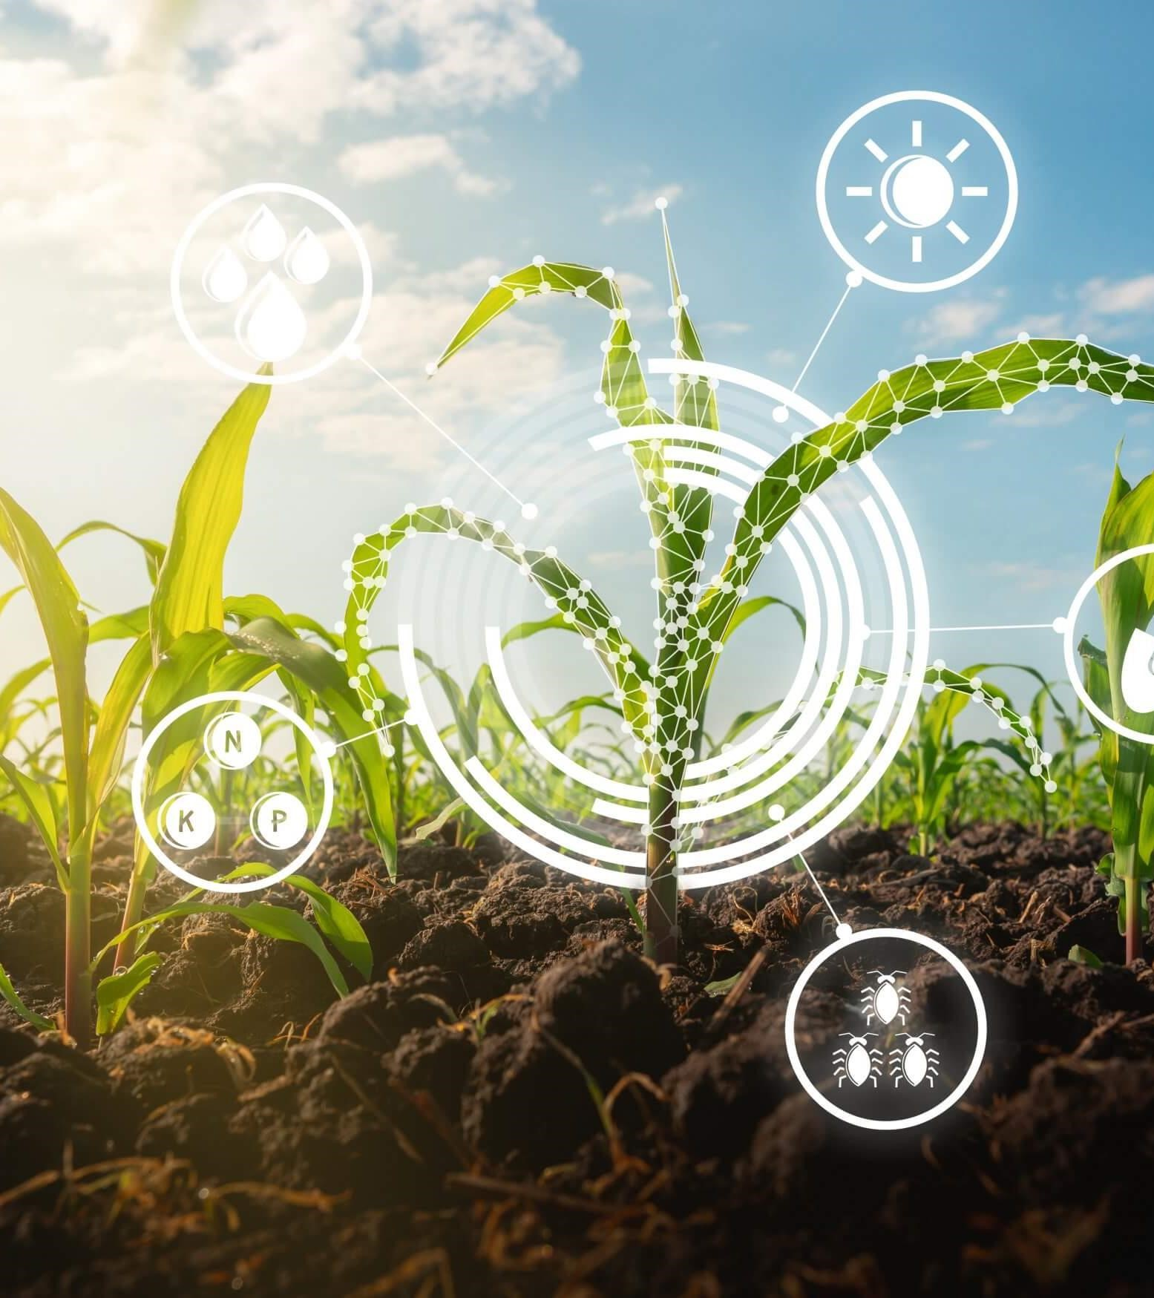

## 5. Smart agriculture in the Islands

**5.1 Smart Islands**

Smart Islands is a programme that adopts an innovative approach to deliver connectivity and scalable and sustainable services to disadvantaged island communities. The Smart Islands programme aims at transforming rural and coastal communities and improving their well-being and livelihood by connecting them to a range of digitally enabled services. The programme, built on the ITU-led Smart Villages initiative piloted in Niger and being developed in Egypt and Pakistan, adopts an innovative approach to deliver connectivity and scalable and sustainable services to disadvantaged island communities.

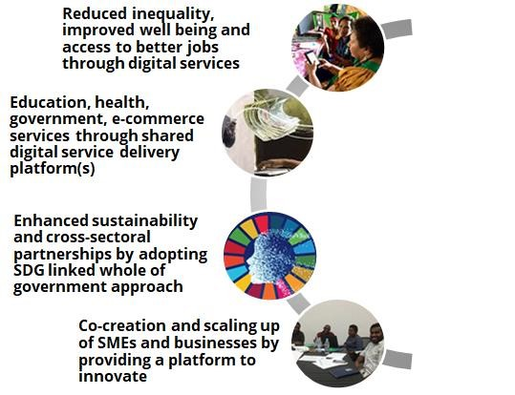

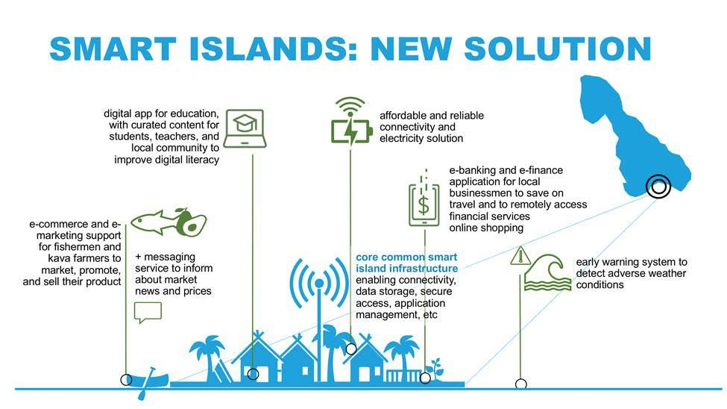

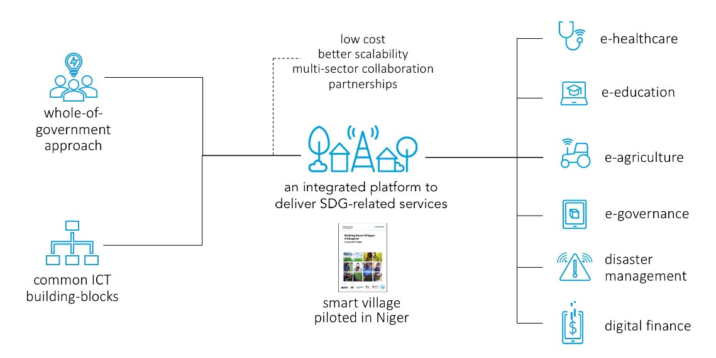

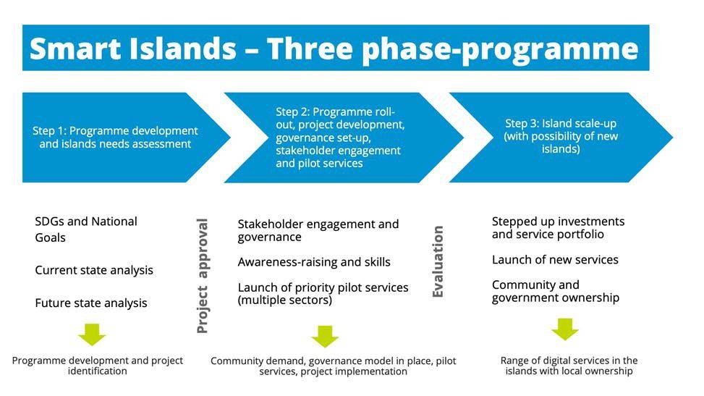

Phased approach to the Smart Islands Vanuatu Programme

## 5. Smart agriculture in the Islands

### 5.2 The capability of smart Islands for smart agriculture

Small island developing states (SIDS) are often characterized by their size, remoteness, and bountiful marine resources. Highly dependent on fisheries for food, these island nations face agricultural limitations resulting in a heavy reliance on imports. Import dependency is fraught with issues such as volatile food prices and food/nutrition insecurity. As sea-levels rise and freshwater sources diminish, island nations face increasing agricultural challenges and [food](http://www.sustainablesids.org/wp-content/uploads/2018/06/IFAD_-SIDS.pdf) [security](http://www.sustainablesids.org/wp-content/uploads/2018/06/IFAD_-SIDS.pdf) issues.

Farming is often small-scale and family-run. Limited investment in commercial agriculture and farming technology greatly impedes export markets, meaning agriculture products are simply not competitive commodities. While agriculture carries its economic issues, it also shines a light on [gender](https://sustainabledevelopment.un.org/content/documents/2231Food%20Security%20and%20Nutrition%20in%20SIDS.pdf) [inequality](https://sustainabledevelopment.un.org/content/documents/2231Food%20Security%20and%20Nutrition%20in%20SIDS.pdf). Women and girls play a large (and often invisible, unpaid) role in agriculture. Women plant, weed, harvest, and process crops, providing for their families.

## 5. Smart agriculture in the Islands

### 5.3 Climate Smart Agriculture in Small Island Developing States

As a member of SIDS, Seychelles faces these agricultural challenges. In the Seychelles, fisheries, tourism, and the seafood industry dominate much of the economy, while agriculture makes up a mere 2.07% of the nation’s gross domestic product (GDP). In terms of food-related commodities, the Seychelles’ total exports is USD 8 million while their total imports are USD 126 million. The country is highly dependent on food imports, with 80% of food being imported. This means that the local agriculture productions are too small for the nation to be self-reliant.

## 5. Smart agriculture in the Islands

**5.3 Climate Smart Agriculture in Small Island**

### Developing States

Although completely surrounded by water, the Seychelles has about 1,540 hectares (or roughly 3,805 acres) of agricultural land, representing 3.4% of the total land area in the county. Of that land, only 0.3% is considered arable and 3% of land area constitutes permanent crops. The food production includes tropical fruits, such as bananas and mangoes, and root vegetables such as yams and cabbages. A majority of agriculture in the Seychelles relies on rainfall, although there are irrigations systems. The agriculture input is further lowered through a limited use of fertilizers and pesticides.

## 5. Smart agriculture in the Islands

### 5.3 Climate Smart Agriculture in Small Island Developing States

Inter cropping refers to planting crops in between rows of trees. In the Seychelles, intercropping works as a natural pest repellant, improves soil structure, and balances fertility levels of the soil. Anti-erosion measures refer to practices that mitigate erosion. Examples of such include planting grasses along the outer areas of farms as a means of filtering sediments, excess nutrients, or pesticides from water runoff.

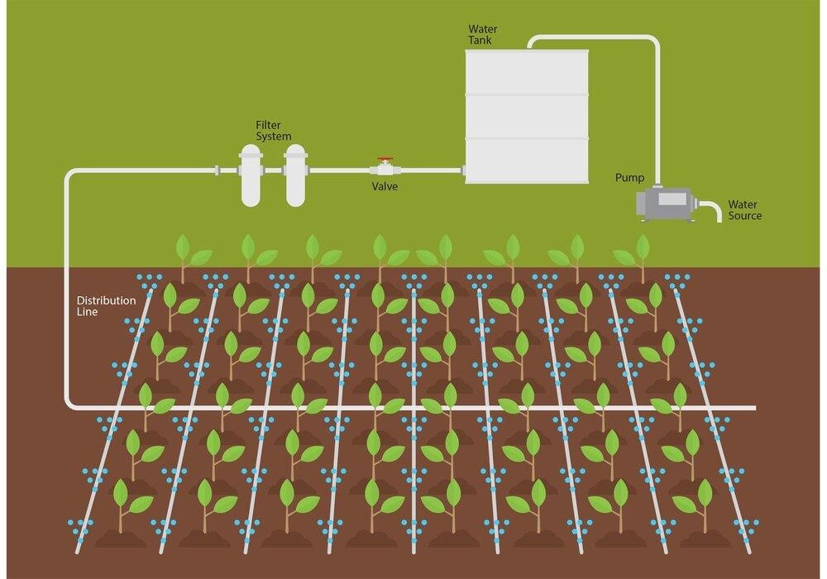

### SMART WATER MANAGEMENT AS CLIMATE CHANGE ADAPTATION



**Digital Transformation: Enhancing IoT**

**-**

**driven Solutions for Smart Islands**

___________________________

Alfredo Ronchi

Professor, Head of S2D2 JRC

alfredo.ronchi@polimi.it



The role of sustainable tourism in enhancing the smart islands



**Alfredo Ronchi**

Professor at Politecnico di Milano, Engineering Faculty

Head of S2D2 JRC (ICTs for Safety & Security)

Secretary General EC MEDICI Framework

Active member of WSIS since the inception

MEDICI delegate at UNESCO IFAP

OCCAM Delegate at Vienna UN international Centre (1996-2001), UN Geneva (2002-2016)

Expert / Advisor in e-Services



Member BoD Global Forum, World Summit Award, European New Society Association,

Sacred World foundation, FINC

Member of Keio University NoE

Appointed as Expert by; European Commission, Council of Europe, Italian Association of banks, National Research Council.

Organize or program chair in W3C, ACM, IEEE events

Author/contributor of more than 400 papers and various books: e-Culture, IPR, e-Government, e-Health, e-Learning, e-Citizens, e-Services, and e-Democracy. International projects coordinator.

# Smart Island concept

The population is growing quickly generating behaviors that force us to face difficult challenges analysis and decision making. Given this scenario, tourist destinations have to deal with a complex environment that makes their competitive position can be maintained or changed, playing a key role in the Information and Communications Technology (ICT), whose function, as a strategic axis, has been consolidated, and therefore it is become as a coordinator of all activities and services, so that all citizens can be connected, better informed and engaged. The concept of Smart Destination is meant by a tourist area which integrates tourism planning and territory in the service of the visitor. Therefore, this will influence the motivation of tourists when they choose their holiday destination.

Integrally, related to the discussion in previous lines, the concept of Smart Islands is born.

# The role of sustainable tourism in enhancing the smart islands - 1

**Concepts like technology, communication, innovation or quality come to mind when we think in «Smart»**

Tourism is an important part of the service sector.

Developments in new technologies reinforce organizational and structural innovations.

The effort in tourism has concentrated in the exploitation of Information and Communication Technologies (ICTs).

«ICT could contributes in terms of generating value-added experiences for tourists, while also improving efficiency and supporting process automation for the related organizations».

Concepts such as Smart Destinations, and Smart Islands are being studied and applied in the territory improve the quality of life for residents and tourists and to encourage responsible and sustainable management of the territories that promote human devel- opment criteria (UNDP)

# The role of sustainable tourism in enhancing the smart islands - 2

Smart Tourism destinations usually take advantage of Technology embedded environments:

* responsive processes at micro and macro levels;
* end-user devices in multiple touch-points;
* engaged stakeholders that use the platform dynamically as a neural system supports this view.

This ultimate aim is to utilize the system to enhance tourism experience and improve the effectiveness of resource management towards maximizing both destination competitiveness and consumer satisfaction while also demonstrate sustainability over an extended timeframe.

Smart City

Smart

Destination

Smart

Island

# The role of sustainable tourism in enhancing the smart islands - 3

The overall objective has been to develop a theoretical framework that englobes the three concepts of Smart, Smart City, Smart Destination and Smart Island.

1. The development of a methodology that any island could place themselves to be a Smart Island. (areas and smart indicators for verifying the implementation of Smart Island).
2. Responsible Management of islands ecosystems. The mechanism «Smart» is a tool to achieve this goal.
3. Application of philosophy «Smart» in island ecosystems (Unesco).

The ultimate goal is the management system and the approach of future scenarios to islands.

# The role of sustainable tourism in enhancing the smart islands - 4

The overlap between the production space and consumption space is logical in the tourism sector. Destination must be understood like a subsystem configured by spatial elements (land resources, infrastructures...), administrative and productive elements and for its complex interrelationships and the effects they produce (Timón, 2004).

The rapid increase of urban population worldwide has triggered intricate challenges for cities around the world. Thus, Information and Communications technology (ICT) enhance the tourist experience in cities. The concept of smart city was created from the necessity to seeking better management and more liveable cities that encourage sustainability information and the best experience of being a citizen.

From this first approach, the Smart destination concept emerges (Buhalis, 2014). Parallel to this, the concept of Smart Island is developed with the objective of enhancing the citizens’ quality of life and its services efficiency, such as optimizing the use of energy and better traffic monitoring (Vicini et al. 2012).

# Smart Destination – 1

**The Smart Destination** concept emerges from the development of Smart Cities (Boes et. al., 2014).

While the Smart City concept is focused on citizens, i.e. not contain temporal visitor, the approach of Smart Destination includes this part of population i.e. tourists and travellers (Lamsfus & Alzua-Sorzabal, 2013).

A Smart destination is a territory where «the investments in human capital and traditional transport and modern ICT communication infrastructure meet the social, cultural, economic, leisure and personal needs of visitors. Visitors are short-term citizens of a Smart City (Lamsfus & Alzua-Sorzabal, 2013).

In accordance with Shaff*e*rs et. al. (2011), «the first task that destinations must address in becoming smart is to create a rich environment of broadband networks that support intelligent applications. The second step is to provide full coverage of the characteristic tourism products and services to improve and make the competitiveness of a destination sustainable in time».

# Smart Destination – 2

There are three forms of ICT, which are crucial for setting up Smart Tourism destinations (Boes et al., 2014).

1. The Cloud Computing services are with the objective to reduce fixed costs and shift them into variable costs based on the necessities (Etro, 2009).
2. Secondly, ICT support smart destinations by providing information and analysis as well as automation and control (Chui et al. 2010). For instance, the chips embedded to entrance ticket allow tourism service providers to track tourist’s locations and their consumption behavior real time so that location-based advertising could be executed (Lin 2011).
3. Third place is situated the End-User Internet Service System, refers to number of applications at various levels supported by combination of Cloud Computing and ICT.

# Smart Island - 1

An island is an ecologically isolated self-contained territory (dependent on many occasions, outside energy, communications and inputs commodity) with a principal and network of smaller cities and villages. In many islands, in recent decades, tourism has formed the main source of income. The need to reduce long-term dependency, optimizing the use of resources and trying to ensure the quality of life of people, promotes the Smart motion applied to the island territories.

A generally accepted definition in the current literature of Smart Island is lacking. Nevertheless, the Smilegov (ESIN) project’s members have provided a new definition in the «Islands strategy communication paper, 2013». They point out «Smart Island is an insular area that creates sustainable local economic development and high quality of life by excelling in multiple key areas of sustainability; such as the economy, mobility, energy, environment, human capital and excellence in governance». This definition does not move away from the smart destinations and smart cities meaning. The current literature about this research line shows that the concept of smart islands can be perfectly explained by taking into account the concept of other terms before mentioned, which are the base of the theory.

# Smart Island - 2

A smart island destination is an innovative touristic destination, consolidated with a technological infrastructure, which assure the sustainable development in a touristic territory, as well as it is accessible for everybody, it makes easy the interaction with the visitors and it increases the user’s experience. In addition, citizens in smart islands have their quality of life improved and local economies, as well. The main responsible factor is the investments in sustainable solutions in a number of essential sectors of the local economy, such as energy, water, transport, tourism, agriculture, fisheries and waste management. To get good outcomes it is important to manage a Multilevel Governance system and processes in order to improve the cooperation and the decision-making process across all levels of government.

ICT is the basic infrastructure of a smart island, used not only in cyber space, but also as communicating elements of physical infrastructure, transmitting real-time data on an island’s status by way of sensors and processors applied within real-world infrastructure. However, all this technological infrastructure should have a proper connectivity that enables to run them (Romero, 2012).

# Smart Island - 3

It is important for the government supported by various stakeholders to maintain adequate network coverage within the destination to avoid gap between commercially dense area and rural area (Buhalis, Amaranggana, 2014).

The implementation of strategic actions in islands is different from other destinations. The size, geographical location and economic, social and cultural factors play an important role in the ability of an island to plan sustainable programs and actions.

The members of the Smilegov Project have proposed to classify the islands in two main categories:

* Pioneer or leading islands, which already have experience in implementing sustainable actions and projects and have the capacity and the political will to continue undergoing significant technology and organizational transformation and continue leading by example.
* Ambitious or willing to learn islands, that have the ambition and the political will to continue on the path of acquiring expertise and the capacity to improve their living condition and continue on the path of sustainability.

# Smart Island - 4

A smart island certification has been proposed, whose program is to be developed and communicated to all the islands that participate in the initiative. Thus, islands that fulfil the basic parameters will be entitled to a Smart Island certification.

Applying the Smart Tourism Destinations theory of Gretzel (2011), Smart Islands are not free from political influence, as it opens certain social options and closes others. In this regard, measuring the performance of islands as tourism destinations by attributing a higher score to specific settings could be used as a political tool considering that charts are politician’s favourite to justify their political rationales. Further, the danger of using ranking as benchmark for measuring success is to subsequently develop policies based on a single model to be applicable everywhere with limited local adaptation (McCann 2011). It is necessary to point out that there is only little room for the technologically illiterate and the poor within destinations.

Creating Smart Tourism Islands requires the engagement of community participation and public and private entities. E-governance is defined by UNESCO as the ability to governance, through electronic infrastructure. This new type of governance facilitates the process of dissemination of effective information. This process is fast and transparent to the public and other agencies, to develop effective administrative activities by the government (Rodríguez et al., 2011). Smart Governance is related to the aspect of transparency within governance system through modernization of city administration by supporting data openness and public involvement (Cohen, 2012).

# Role of ICT in Tourism on smart islands

In island contexts, technologies (ICTs) provide both get data making the intercom and relations between mainland territories and insular areas, favoring progress and resilience processes.

Being tourism a mainstay of island economies, bringing smartness into Tourism destinations requires dynamically interconnecting stakeholders through a technological platform on which information relating to tourism activities could be exchanged instantly.

Smart Tourism destinations take advantage of Technology embedded environments; responsive processes at micro and macro levels; end-user devices in multiple touch-points; and engaged stakeholders that use the platform dynamically as a neural system supports this view.

This ultimate aim is to utilize the system to enhance tourism experience and improve the effectiveness of resource management towards maximizing both destination competitiveness and consumer satisfaction while also demonstrate sustainability over an extended timeframe.

# Smart Islands: Bringing Digital Experiences To Communities

The Smart Islands programme adopts an innovative approach to deliver connectivity and digital services to disadvantaged island communities in a scalable and sustainable manner. It aims to transform rural and coastal communities, improving their livelihood and well-being by connecting them to a range of digitally enabled services. The programme, built on the ITU-led [Smart](https://www.itu.int/en/ITU-D/ICT-Applications/Pages/smart-village.aspx) [Villages](https://www.itu.int/en/ITU-D/ICT-Applications/Pages/smart-village.aspx) [initiative](https://www.itu.int/en/ITU-D/ICT-Applications/Pages/smart-village.aspx) (piloted in Niger and under development in Egypt and Pakistan), leverages shared services delivery infrastructure capabilities to provide digital services over connected devices (tablet, mobile phone, computer etc.).

Small Island Developing States (SIDS) face a host of challenges, including geographic isolation, lack of human resources, low availability and quality of infrastructure, and vulnerability to external shocks. In remote areas and in outlying islands, access to information, government services, transport, health, finance, commerce, and education needs prioritized attention. The high costs of electricity and lack of affordable connectivity exacerbate the above challenges for SIDS. Not only does the absence of digital technology contribute to the digital divide, but it also deprives small island communities of the opportunity to leverage digital solutions to obtain better access to essential services. The Smart Islands programme adopts a whole-of-government approach that accelerates progress towards the Sustainable Development Goals (SDGs) through digital transformation.

# Characteristics of the digital economy and society - 1

What are the characteristics of the digital economy and society? One way to form an answer to this question is to consider the historical evolution of information and communications technologies.

The earliest digital computers – used for code breaking in the Second World War – performed calculations on digital data. It was the **digitisation** of input data that enabled high-speed electronic processing of data. So, it is arguable that the first and most important characteristic of the digital economy is the digitisation of information and data. In the late 1950s, the U.S. Air Force created networking systems for its radar defence system computers. By 1965 packet switching was developed and reliable scalable computer networking was enabled and in 1974 team working under Vinton Cerf together with the team led by Louis Pouzin developed protocols on which the Internet is based. This enabled the second key characteristic of the digital economy: **connectivity** – the ability of digital processing systems to communicate digitally.

Digitisation and connectivity are fundamental to the digital economy and society. From these characteristics emerge others: **automation, accessibility** and **efficiency**. Ultimately, all of these characteristics contribute to greater efficiency in the creation, collection, storage, manipulation, processing, communication, presentation and publishing of information. The digital economy and society is driven by the ever increasing performance and ever falling cost of these information management functions.

# Characteristics of the digital economy and society - 2

Each of these characteristics interacts with the other and together they drive economic development, productivity and competitiveness in the following ways:

**Digitisation:** essentially, when information is digitised it becomes readable and processable by electronic computers and this means data management and processing tasks that were previously undertaken manually can now be automated. The first types of information to be digitised were numerical but now all forms of information can be converted to digital formats and managed digitally including high resolution audiovisual content. Google has digitised many of the world’s books in the process of digitising government records is ongoing and enables significant innovation in the provision of government services.

**Connectivity:** When computers are connected by increasingly fast and reliable networks, digitised data can be shared across multiple systems leading to further efficiency gains this means. Connectivity occurs at many levels: person-to-person, person to machine, and machine to machine. One of the results of the smart phone revolution has been the ‘personalisation’ of computing nodes at the edge of the network. Smart phone is an intensely personal device and this means that the user experience can be personalised and optimised and that an enormous amount of data reference to individuals can be collected at low cost.

# Characteristics of the digital economy and society - 3

**Accessibility:** accessibility arises from a combination of digitisation in connectivity. Access to a vast landscape of data, information and content, often mediated by search engines, was essential characteristic of the explosion in public use of the World Wide Web that occurred in the 1990s. Access to digitised information over networks vastly decreases the cost of access and leads to further automation and new business models. For example, when a smart phone user calls for a ride on a ride sharing platform, all the user needs to do is specify a destination – the user’s identity, location and payment method are all accessible to the ridesharing platform automatically.

**Automation:** automation is a core goal of the digital economy and, in addition to the examples described above, industry observers are now expecting a revolutionary era of automation in which increasingly sophisticated processes will be undertaken through extensive networks of cloud computing resources that are process using AI and machine learning techniques.

**Efficiency:** automation is not an end goal in its own right; what it achieves is higher levels of efficiency. Higher efficiency or productivity is ultimately directed to transforming scarce resources or inputs into products and services that consumers value. While greater efficiency clearly serves economic goals, it can also be a powerful contributor to the achievement of environmental sustainability. Because these digital economy characteristics drive productivity, they also drive national competitiveness which in turn drives economic growth and improvements in living standards.

# Possibilities and risks in the digital economy and society - 1

What are the differences between the digital economy and society and the traditional world?

How does the transition to a digital connected world affect business, the functions of government and people’s lives?

These are complex questions and refer to changes in the socio-economic fabric that go beyond the advent of connected digital technologies. All societies change over time with profound implications for individuals. For example, the transition from rural life in small communities to large anonymous cities represents a significant change in the human experience. Likewise the percent of total transactions conducted in cash in a country would seem to fall as country Internet penetration increases. This fundamentally changes the medium of exchange of the region’s economies creating new opportunities for financial participation by groups who previously had no access to financial services.

# Possibilities and risks in the digital economy and society - 2

The digital connected economy is the latest phase of humanity’s ongoing drive to achieve improved living standards through technological change. Previous changes in technologies such as the steam engine in the English Industrial Revolution or the diffusion of electricity in the early 20th century have involved changes in physical production processes – processes that have to do with ‘atoms’, in the terminology of Nicholas Negroponte of MIT.

The digital revolution is to do with the manipulation of information or ‘bits’. In fact, the digital revolution has shone a light on the, perhaps unexpected, extent to which traditional physical production and economic activity are underpinned by significant information manipulation processes. These technology-driven change processes are, however, by no means restricted to the commercial dimensions of society and economy – they also encompass governments and the ways that citizens with our lives.

# Possibilities and risks in the digital economy and society - 3

Iimportantly as highlighted recently in GSR-19 digital connectivity can provide the canvas for achieving UN Sustainable Development Goals (SDGs) in our societies by 2030. Thus:

*Technology paradigms and business models challenge existing regulatory patterns and frameworks. From the imminent entry in markets of 5G and the Internet of Things, to the profusion of cloud services and artificial intelligence, regulatory response requires a new perspective. Unleashing the full potential of digital will require an actionable, agile, collaborative, innovative, and outcome-based approach to regulation. In the increasingly complex and dynamic digital transformation, it is important to agree on common principles and put forward clear and simple rules – and follow them forward.*

# Digitisation and Business - 1

What factors influence nature and extent of the impact of digitisation on businesses? The impact of the shift to digital economy on any particular business will depend on many factors:

* what extent is the business dependent on information processing rather than executing physical processes?
* is the business willing or able to incorporate new technologies to boost its competitiveness?
* to what extent is the business vulnerable to new disrupting businesses adopting alternative business models?
* what are the skill sets of the existing owners, managers and workers in the business how quickly can these be adapted to the required forward-looking digital skill sets?
* does the business have the resources to transform its business model and require digital skills and assets quickly enough?
* does the business have a viable value creation business model in the digital world?

# Digitisation and Business - 2

These are the challenges faced by almost all businesses in the transition to the digital economy. The disruptive power of digitisation is now so well established that some consulting organisations are claiming that the post digital era has already arrived the underlying concept being that, digitisation of business is universally compulsory and that now competitive advantage has shifted that operate within the context of a universally digitised marketplace.

*Companies already face a new level of expectations from consumers, employees and business partners. Businesses have used the power of digitally driven mass customization to sell two different options of a good or service, then 10 different options, then 100 different options. Companies’ success with this approach has fostered for them the illusion that they can meet any need, no matter how personal or custom.*

*Businesses will need to turn that illusion into reality if they want to meet rising expectations. The coming era will be characterized by massive pressure as customers, employees and society make their demands known. But it will also provide tremendous opportunities for those companies that can deliver the appropriate experience at just the right time.*

# Digitisation and Business - 3

In this vision of digital or post-digital business era, the consumer is the big winner. From a business perspective, the outcome is heightened and unrelenting competition. This perspective of benefits to consumers, however, needs to be balanced against potential increases in potential for market power in the digital economy. Large-scale digital businesses have the potential to realise significant economies of scale, network economies and financial power which can be used to resist competitive pressures.

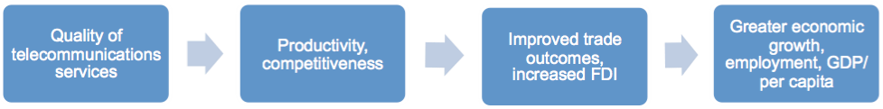

Source: Windsor Place Consulting

In 2017, regulators around the world began to appreciate and act on competitive threats arising from the growth of ‘big tech’ companies such as Facebook, Google, Amazon and Apple. While the threat to consumers through a loss of competitive pressure is obvious in the case of these very large companies, loss of competition can also occur less obviously on a smaller scale in smaller industries or sectors. For example, a single vendor in a particular nation may dominate advertising for job vacancies. Governments and regulators need to be alert to potential for digital technologies to create greater returns to scale as well as greater competitive pressures.

# Digitisation and Government - 1

Obviously, if it is possible for the private sector to execute its information-based business processes more efficiently using digital technologies the same is possible for governments. Indeed, it is arguable that many government processes are almost entirely based on information management processing storage and publishing. It is critical that governments investigate and adopt a proactive footing for the adoption of digital technologies that enable the cost of government services to be reduced over time. This is not only because efficiency is desirable in its own right, but also because there are a range of government funded activities which are extremely resistant to increases in productivity in general and increases in labour productivity in particular.

This tendency for productivity in government services to lag productivity in the private sector was first noted by US economist William Baumol who noted that there were large differences in productivity improvement across industries in the modern economy. He observed, for example, for string players are required to play a Beethoven string quartet today as was the case in the 19th century. Many services that are often government funded such as education and health care require relatively high labour inputs and are not as amenable to labour productivity increases as for example private sector manufacturing. Therefore, over time as real incomes increase in the public sector needs to compete with the private sector to attract labour, the relative cost of providing government services will tend to rise.

# Digitisation and Government - 2

Digital technologies offer an important opportunity to offset the labour productivity challenges of the private sector. Again, the more cost-effective delivery of government services will benefit consumers the most, or in this case, citizens. Digital governments will enable their citizens to have better cheaper and easier access to a wide range of government services and information. This will inevitably lead to more of a ‘self-service’ delivery model but this does not mean that consumers overall will not be able to access government information and services more easily overall and in the non-digital world.

Such developments do, however, raise issues of digital literacy, access and the digital divide. Governments need to ensure that they continue to operate systems and services that enable non-digital access to essential services for those with insufficient skills or access to use digital channels.

Another obvious but sometimes overlooked benefit of digital government is that, if governments can operate services at lower cost it will be possible for these cost savings to be passed on at least in part to citizens in the form of lower taxation past, thus, a move to efficient digital government has the potential to increase real after-tax incomes.

Online Training Course on “Digital Transformation: Enhancing IoT driven Solutions for Smart Islands”, 18-31 July 2022

# Digitisation and Government - 3

There are other significant issues in relation to digital government for example security and privacy including the potential of governments to use access to citizens’ digital information to subvert democratic political processes.

Beyond these general high-level comments, there is an enormous literature on opportunities for innovation in digital government which includes ideas such as government opening access to anonymized datasets for use by the private sector both by individuals and corporations. This is a field which remain an ongoing and open-ended area for innovation and development.

# Digitisation and the Individual - 1

As in the previous cases above, the transition to the digital economy and society presents gains, losses, opportunities and risks. The sum of the effects of digitisation on individual lives is complex and ambiguous but is, nonetheless driven, by the idea of improved living standards in the broader sense.

The digitally connected world enables individuals to more easily communicate with each other. Communication is not only one-to-one, but also one-to-many and many-to-one and, in this way, communication blurs with the traditional concept of publishing. Consumers have cheaper faster access to a broad range of information on which to base decisions and choices. Consumers also have access to much larger catalogues of digital content for example movies, television shows and music and as well, access to new kinds of content such as podcasts, user generated content, instructional videos on YouTube.

Nonetheless, paradoxes arise in the individual’s experience of the digital economy and society which are fundamental and intrinsic to digitisation and connectivity. For example, the flipside of enhanced connectivity, communication and increased capacity for sharing is inevitably some loss of privacy. Also, an increased use of digital channels for communication which displaces face-to- face communication appears to have significant deleterious effects on the skills for social interaction.

# Digitisation and the Individual - 2

The principle of consumer sovereignty asserts that consumers know their own best interests and should be left alone to pursue them. The evidence suggests overwhelmingly that consumers and citizens have enthusiastically embraced the digital world. While consumer sovereignty is an accepted fundamental principle of market-based economies, there are broadly accepted limits or exceptions. The state intervenes in many instances to limit access to dangerous substances, for example, access to alcohol by children. The state also intervenes in relation to complex products such as pharmaceuticals to protect consumers.

Recently, particularly in Europe, there has been significant state intervention to protect individuals’ privacy and misuse of their data. In the longer term, other negative consequences for individuals of the digital world may become apparent and governments need to be alert to wear further interventions may

be required. In general though, the digital era has fully arrived and interventions are likely to be marginal in nature rather than deflecting now deeply entrenched trends.

# Digitisation and Institutions - 1

‘Institutions’ is a somewhat ambiguous term but is a concept that has large significance for the ways in which economies and societies evolve and for the path that improvements in living standards take in various nations. There is a branch of economics – ‘institutional economics – entirely devoted to study of how institutions influence economic development. Within the framework of institutional economics, institutions include not only the arms of the state such as the courts, reserve banks, and regulatory organisations, but also state processes such as democratic political processes and, in addition, social conventions such as, for example, a tendency for a particular culture to be thrifty or not. Particularly over the long-term, such institutions have profound impacts on the economic development path of nations. If for example the rule of law is weak and the enforcements of contracts is ineffective, investment will be suppressed productivity will be stagnant and economic development slow.

An important development in the evolution of Western societies was the sharing of power between various groups. This sharing of power included democratic processes themselves, which granted executive power to elected representatives, the offsetting power of the courts and judiciary and the importance of ‘the fourth estate’ – the various organisations which make up what is now typically called ‘the media’.

# Digitisation and Institutions - 2

It is only recently that the extent to which the transition to a digital economy and society disrupts these institutions has become better understood. We now understand, for example, that the structure of the newspaper publishing industry arose from a particular set of technologically driven cost structures that led to a relatively large scale oligopolistic or monopolistic market structure in which these large publishing companies were required to ensure veracity of their content or face legal consequences. It is only after the relative decline of the publishing industry in the recognition of the problem of ‘fake news’ that the importance of these structures become more apparent in the need for analogous mechanisms in the digital publishing world become more obvious.

These changes are also made more obvious the role of responsible publishing as core democratic processes. Global elections especially since 2016 have now brought home to governments and regulators the importance of increased regulatory oversight in the digital economy.

# Digitisation and Institutions - 3

It is often claimed that technology moves faster than the regulators. To some extent, this is inevitable – regulators can’t be expected to respond to something that hasn’t happened yet – but the idea that regulators will always be responding insufficiently to technological change can easily be overstated.

For example, if the basic principle of Section 230 of the US *Communications Decency Act* – that platform providers are not publishers and are not responsible for the content of their users – were substantively overturned, this would mark a substantive and permanent change in the digital landscape.

Overall, regulatory and institutional responses to the digital economy and society are one of the most important areas for government focus in maximising the opportunities and limiting the risks and harms in the transition to digital world.

Policy design principles are at hand for regulators to help develop an understanding of new technology paradigms and guide them towards appropriate regulation. Led by these principles, regulators can fine- tune their regulatory response, ensuring optimal impact on the market. The recent GSR-19 identified the key design principles to respond to new technology paradigms and business models stemming from collaborative regulation as detailed in Core design principles for collaborative regulation.

# Digitisation and Institutions - 4

* **To achieve digital transformation, policy and regulation should be more holistic.** Cross-sectoral collaboration along with revisited regulatory approaches such as co-regulation and self- regulation, can lead to new forms of collaborative regulation based on common goals such as social and economic good, and innovation.
* **Policy and regulation should be consultation and collaboration based**. In the same way digital cuts across economic sectors, markets and geographies, regulatory decision making should include the expectations, ideas and expertise of all market stakeholders, market players, academia, civil society, consumer associations, data scientists, end-users, and relevant government agencies from different sectors.
* **Policy and regulation should be evidence-based:** Evidence matters for creating a sound understanding of the issues at stake and identifying the options going forward, as well as their impact. Appropriate authoritative benchmarks and metrics can guide regulators in rule-making and enforcement, enhancing the quality of regulatory decisions.
* **Policy and regulation should focus on building trust and engagement:** Collaborative regulation provides the space for cocreating win-win propositions, working towards regulatory objectives while increasing the engagement of industry. Trust becomes the foundation of the regulatory process, underpinning the growth of digital.

# Digitisation and Institutions - 5

* **Policy and regulation should be outcome-based:** Regulators need to address the most pressing issues, for example market barriers and enabling synergies. The rationale for any regulatory response to new technologies should be grounded in the impact on consumers, societies, market players and investment flows as well as on national development as a whole.
* **Policy and regulation should be incentive-based:** Collaborative regulation is driven by leadership, incentive and reward. Regulators should keep a wide array of investment incentives at hand to provide impetus for markets to innovate and transform while maximizing benefits to consumers.
* **Policy and regulation should be adaptive, balanced and fit for purpose:** Regulation-making is about flexibility – continually improving, refining, and adjusting regulatory practices. The balance in regulatory treatment of new services is more delicate than ever. A close, continuous link to markets and consumers is important to get digital on the right glide path to achieving social and economic goals.

# What is digital infrastructure? - 1

Digital infrastructure is the key to enabling the benefits of the digital economy and society. Digital infrastructure is the physical hardware and associated software that enables end-to-end information and communications system to operate. Digital infrastructure includes:

* Internet backbone including national and trans-oceanic fibre cables;
* Fixed broadband infrastructure such as analogue coaxial and optic fibre cable networks;
* Mobile communications infrastructure and networks including Fixed Wireless Acces, transmission towers, radio and optic fiber backhaul networks;
* Broadband communications satellites;
* Data and cloud computing facilities;
* End user equipment such as mobile handsets, PCs, modems and local Wi-Fi and Bluetooth networks;
* Software platforms including computer and mobile device operating systems as well as application programming interfaces; and
* Network edge devices such as sensors, robots, autonomous and semiautonomous vehicles, and other Internet of things facilitating devices and software.

# What is digital infrastructure? - 2

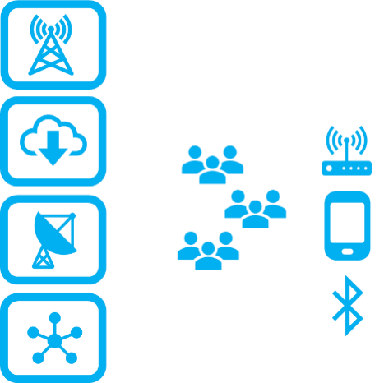**Communications End user**

**system equipment and infrastructurenetworks**

**Source: Windsor Place Consulting, 2019**

# What is digital infrastructure? - 3

At any point in time, different parts of the system a digital infrastructure will be at different stages of development compared to other parts and bottlenecks will be being experienced at various points. This means that areas of priority development will shift around the network as technologies change and network build-outs and upgrades occur. For example, as greater numbers of mobile communications towers are established, the demand for backhaul fibre will increase. Another example is the need to replace legacy copper networks with fibre networks as consumers demand faster and higher speed broadband services which are beyond the capacity of copper to provide.

Private sector communications companies can be expected to undertake much of the work associated with developing the network but governments have an important role to play in:

* setting the broader strategic context for digital economy and society development including areas such as spectrum policy, skills development, digital literacy, access for less advantaged groups and so on
* developing effective pro infrastructure deployment regulatory frameworks
* directly investing or undertaking private public partnerships to deploy major digital infrastructure systems.

# What is digital infrastructure? - 4

While it is almost impossible to completely ‘future proof’ digital infrastructure systems and strategies, governments need to be alert to evolving technologies in order to optimise their infrastructure development pathways. Forward-looking spectrum policy is a critical area in which governments need to incorporate expectations about the capabilities of emerging wireless technologies.

# Developing an optimal infrastructure development strategy - 1

It is obvious that the quality, quantity and extent of digital infrastructure plays a decisive role in a nation’s capacity to realise the benefits of the digital economy and society. The problem of digital infrastructure strategy, however, is much more complex than simply defining the characteristics of what type of digital infrastructure a country requires at a particular point in time. What is required is a dynamic infrastructure deployment strategy that takes into account:

* each country’s history and current circumstances
* average levels of per capita income and likely levels of average revenue per user
* current and possible future regulatory settings
* population, country size including geographic characteristics
* the state of communications technology and its expected development pathway.

Such a dynamic infrastructure deployment strategy will consider all of these factors and chart a pathway to best practice infrastructure for each particular country over the relevant planning period. This deployment strategy should be thought of as an evolutionary path from the present to a future planning horizon.

Online Training Course on “Digital Transformation: Enhancing IoT driven Solutions for Smart Islands”, 18-31 July 2022

# Developing an optimal infrastructure development strategy - 2

While the optimal infrastructure development path will be different for each nation, we can broadly characterise these development pathways for developed and emerging nations. Developed and emerging nations have very different starting points: develop nations have much greater fixed network infrastructure, higher levels of income, more capital for investment and better developed regulatory systems and structures.

A critical point to emphasise is that emerging nations are making major investments and infrastructure in an entirely different historical and technological context from the developed nations. Develop nations have been making investments in telecommunications infrastructure for over a century and much of this investment was in the form of last mile copper infrastructure.

It is often pointed out that developing nations have been able to ‘leapfrog’ almost entirely the era of fixed line infrastructure deployment. While this idea may have been relatively true in the period when mobile voice was the predominant service, this era has undoubtedly finished.

# Developing an optimal infrastructure development strategy – 3

|  |
| --- |
| **2025 Targets: Connecting the Other Half** |
| **#1** All countries should have a funded national broadband plan or strategy, or include broadband in their universal access and services definition |
| **#2** Entry-level broadband services should be made affordable in developing countries, at less than 2% of monthly gross national income per capita |
| **#3** Broadband-Internet user penetration should reach: 75% worldwide, 65% in developing countries, and 35% in least developed countries |
| **#4** 60% of youth and adults should have achieved at least a minimum level of proficiency in sustainable digital skills |
| **#5** 40% of the world's population should be using digital financial services. |
| **#6** Un-connectedness of Micro-, Small- and Medium-sized Enterprises should be reduced by 50%, by sector |
| **#7** Gender equality should be achieved across all targets |

Source: Broadband Commission, 2018

Online Training Course on “Digital Transformation: Enhancing IoT driven Solutions for Smart Islands”, 18-31 July 2022

# Developing an optimal infrastructure development strategy - 4

These targets which intended to be both aspirational and achievable should also be embraced by the Asia-Pacific region. In doing so they ought to adopt a digital agenda or strategy to achieve such targets. Such strategies will require all stakeholders to commit to them and to take positive actions towards their achievement.

There is also considerable value especially in Asian markets with large urban areas (with generally lower costs of provisioning) to set even more challenging targets for high speed Internet access (ie gigabit access). For example, ASEAN markets could have common broadband objective in major urban areas such that there is universal residential broadband of 30Mbps and mandate all households in major urban areas should be connected by 100Mbps broadband services with the capability to upgrade to further by 2025. FWA for regional and rural customers should also be a policy priority because reusing existing wireless networks and tower resources could reduce the costs of broadband construction and provide affordable Internet access to regional and rural populations. It is also critical that broadband services be affordable especially for whom live in rural areas and income below the poverty line. In areas where infrastructure is available to support broadband services, services must be priced at affordable levels. Such affordable pricing must also take into account the cost of a user device, e.g., smart phone or tablet, installation charges (where they may apply) and the financial impact of a minimum term contract for fixed services.

# Developing an optimal infrastructure development strategy - 5

Affordability is particularly problematic for many Asia-Pacific countries given their relatively low GDP and GNI per capita. The ITU’s objective of 25 percent more affordable of Internet access compared to 2017 and 3 percent of average monthly income for the entry level broadband service in developing countries by 2023 are achievable with effort of all sector stakeholders. Entry-level broadband services should be made even more affordable in developing countries with the pricing of such services, falling to less than 2 percent of monthly gross national income per capita by 2025.

Further, governments in all countries should enable environments ensuring accessible telecommunications and ICTs for person with disabilities and gender equality in Internet usage and mobile phone ownership.

Although the licensing schedule of 3G and 4G services varied from country to country across Asia-Pacific, facilitating

5G deployment forward (including making key IMT spectrum available) and encouraging its deployment by Mobile Net Operators is a must. While some countries are aiming for timeline of 2021, all countries, depending on demand, should aim to their licensed MNOs to deploy 5G by 2023 to 2025 in line with their national aspirations.

Online Training Course on “Digital Transformation: Enhancing IoT driven Solutions for Smart Islands”, 18-31 July 2022

# The Demand for Bandwidth Always Grows - 1

A defining characteristic of the digital economy and society is increasing connectivity and bandwidth. There is the ongoing interplay between bandwidth supply and demand. Each time there is an improvement in the quality, capacity and availability of broadband, new opportunities emerge to make use of this improved connectivity. There are many historical examples of this phenomenon:

* in the mid-90s, development of ADSL technology made broadband connections possible over existing copper telephone lines to households which led to the explosion in access to the World Wide Web and the dot com boom which encouraged the development of new higher-bandwidth services
* in the mid-2000 3G and 4G connectivity made the era of the smart phone possible by providing widespread mobile access to data – consumers quickly responded, demanding more sophisticated bandwidth hungry mobile applications
* over the past decade up to 2019, improvements in household broadband speeds and data allowances, associated with fibre reaching or coming closer to homes, have enabled the TV streaming revolution.

# The Demand for Bandwidth Always Grows - 2

There is no obvious end in sight to this process. For example, new 5G technology is desirable because of its very low latency is a requirement for enabling autonomous vehicles and complex time-critical telepresence applications such as remote surgery. Thus, each generation of new broadband technology enables new digitally based economic activity, enables new business models, and creates the increasing national competitiveness that drives economic growth and rising living standards.

The challenge for governments is to design policy and regulation that encourages sufficient investment in digital infrastructure to ensure that the nations digital services remain globally competitive. This is an on-going process.

# Setting of Broadband Targets

The Broadband Commission was established in May 2010 as a joint initiative between the ITU and the United Nations Educational, Scientific and Cultural Organization (‘UNESCO’) to promote Internet access. The Broadband Commission was initially working towards achieving the United Nation’s (‘UN’) Millennium Development Goals (‘MDGs’) by 2015 through digital development.

However, in September 2015, the Sustainable Development Goals (‘SDGs’) were adopted and superseded the MDGs. Considering the more recent SDGs, in 2018 the Broadband Commission launched a revised framework *2025 Targets: “Connecting the Other Half”*, which outlines seven targets.

The report also highlights that based on data for 196 countries, as at 2018, 159 countries have adopted a broadband plan or strategy or are planning to.8This is a huge increase from 2006 when only 31 countries had such broadband plans.

# Conclusions and Recommended regulatory policies and measures in order to ensure optimal national outcomes - 1

Digital infrastructure is the key to enabling the benefits of the digital economy and society. Digital infrastructure is the physical hardware and associated software that enables end-to-end information and communications system to operate. Digital infrastructure includes:

* Internet backbone including national and trans-oceanic fibre cables;
* Fixed broadband infrastructure such as analogue coaxial and optic fibre cable networks;
* Mobile communications infrastructure and networks including FWA, transmission towers, radio and optic fiber backhaul networks;
* Broadband communications satellites;
* Data and cloud computing facilities;
* End user equipment such as mobile handsets, PCs, modems and local Wi-Fi and Bluetooth networks;
* software platforms including computer and mobile device operating systems as well as application programming interfaces; and
* network edge devices such as sensors, robots, autonomous and semiautonomous vehicles, and other Internet of things facilitating devices and software.

# Conclusions and Recommended regulatory policies and measures in order to ensure optimal national outcomes - 2

It is obvious that the quality, quantity and extent of digital infrastructure plays a decisive role in any nation’s capacity to realise the benefits of the digital economy and society. Improving on digital infrastructure in order to secure the maximum benefits of the digital economy and society is the central focus of this ITU Discussion Paper on Digital Infrastructure Policy and Regulation in Asia-Pacific Region.

The key recommended regulatory policies and measures needed include specific recommendations on *inter alia* :

* The key challenges and bottlenecks to the deployment of digital infrastructure already identified;
* Driving national competitiveness and productivity in emerging Asia-Pacific markets;
* The need for flexible sector legislation and regulation to respond to quick moving industry and technology. In addition, there is a need for agile regulation which facilitates partnering with the industry playing a collaborative / facilitator role.

# Conclusions and Recommended regulatory policies and measures in order to ensure optimal national outcomes - 3

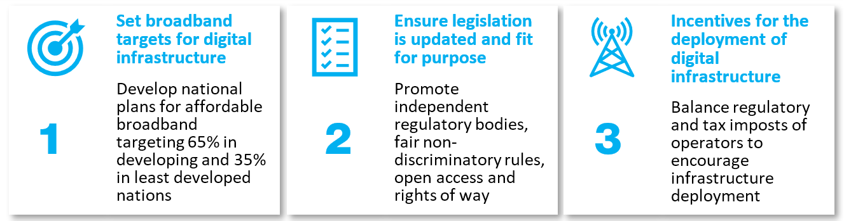

# Conclusions and Recommended regulatory policies and measures in order to ensure optimal national outcomes - 4

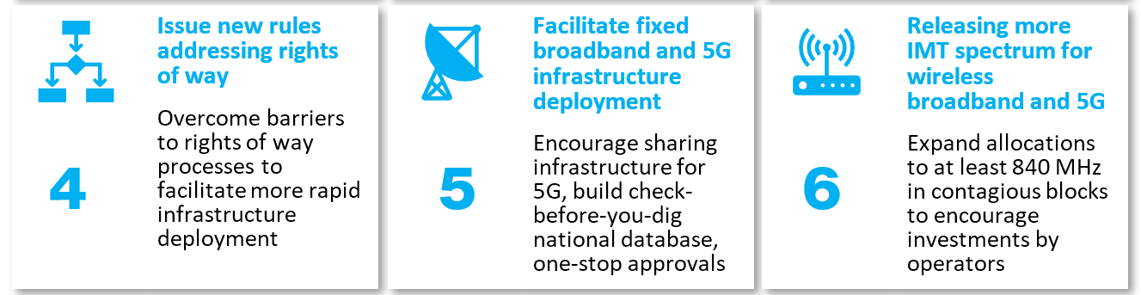

# Conclusions and Recommended regulatory policies and measures in order to ensure optimal national outcomes - 5

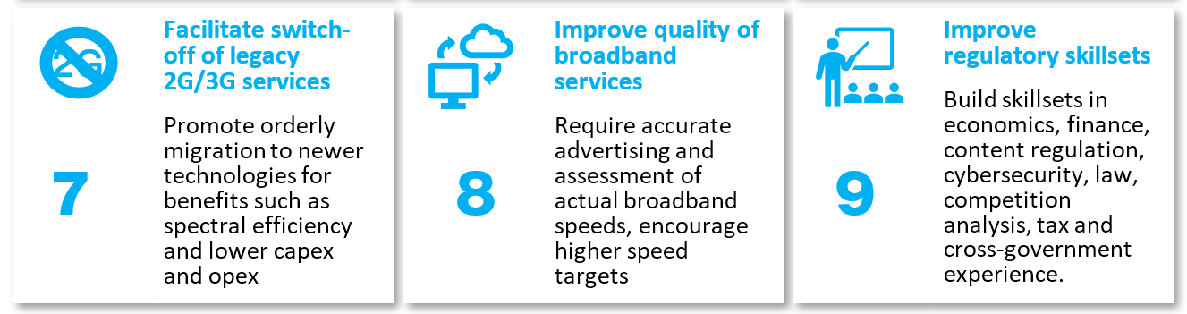

# Conclusions and Recommended regulatory policies and measures in order to ensure optimal national outcomes - 6

The final comment is that open competition is the best mechanism to ensure affordability and quality of broadband services.

Regulatory measures should be carefully enforced to ensure sufficient and fair competition to avoid market monopoly and oligopoly, in the same time also protect private sector investment on the digital infrastructure.

Regulation on network wholesale prices may be required but heavy-handed regulatory control on retail prices, especially price floor regulation is typically unnecessary and may be counter-productive.

**Some examples of Smart Island – European Small Islands Network – ESIN**

# Big data and tourism : Palma de Mallorca

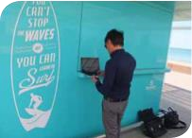The municipality of Palma de **Mallorca** is currently the second largest “wifi” city, after Miami (USA).Wi- Fi Palma is a project run by Universitat de les Illes Balears on big data and tourism. The project is being developed in cooperation with the Supercomputing Centre in Barcelona, the most powerful supercomputer in Spain. In order to increase its attractiveness as a tourism centre, the Majorcan authorities have provided free WIFI access across the entire island since 2014. In some areas work is still under way, but in Palma de Mallorca, especially in the city centre, and on Playa de Palma, people have free WIFI access. The hotspots were technically improved so everyone could move around the city without losing connection.

# Big data and tourism : Palma de Mallorca

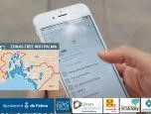Providing wifi on the beach promenade of Playa de Palma is intended to identify new trends (shopping, cultural and sport activities), which will help Palma to propose tailored activities for tourists. The project also has considerable potential for user groups who need special attention (i.e. people with mobility impairments), as users’ behaviour can be monitored. Potentially, it may be possible to see whether fully accessible venues (i.e. for people with disabilities, elderly people using mobility devices, families with baby strollers) are more likely to be visited than venues which are not accessible to these target groups.

The project processes data confidentially. Data protection is a key topic in such projects and needs to be addressed considering that, if handled carelessly, online storage of data can have serious and undesired implications.

*Website for the smart project developed by Palma: http://smartoffice.palma.cat*

**Big data and tourism : Palma de Mallorca**

# Emergency Quick Response Code

**The Balearic Islands** have a long tradition of tourism, which is reflected in its wide range of tourist facilities and services. In August alone at the peak of the tourist season, Mallorca usually has over 13 million tourists. The emergency and police authorities are involved daily in 150 to 200 interventions, of which 50 to 80 can be resolved swiftly. The main problems are lost children, people who have lost their bearings and injured cyclists. In order to promote the Balearic Islands as a destination, the Balearic authorities, including the port authorities, are giving due consideration to the issue of security, combining public, medical and environmental safety.

To improve the security and safety of tourists, the port authorities and the authorities of the Balearic Islands asked the University of Palma to develop an emergency system. A QR code (abbreviation for Quick Response Code) system is being developed for this purpose. The QR code is a machine readable optical label that contains information about the item to which it is attached. It consists of black modules (square dots) arranged in a square grid on a white background, which can be read by an imaging device (such as a camera or scanner).

**Big data and tourism : Palma de Mallorca**

# Emergency Quick Response Code

In practice, the system has been used from summer 2016 for cruise tourists disembarking for a short period in Palma. The MSC Company will include the QR code in the medical questionnaire shared with the Spanish emergency system (112, hospitals, doctors). The QR emergency system is particularly suitable for groups with special needs (people with disabilities, minors and senior citizens, sportsmen, etc.). 2 045 characters can be stored on the square code. The system is totally safe since the information (identity, medical information, contacts and GPS location) is not stored online but encrypted and printed in the square. The information is only readable using the requisite application and can always be updated by the person providing data about him/herself.

Using the QR code is also better than calling an ambulance or the police in all cases, as that will cause a serious disturbance in a tourist area. One challenge is to convince visitors to start using the QR codes on themselves, as this cannot be made compulsory. The project has great potential for island destinations which receive many seasonal visitors, often by cruise ships, who stay for a short time and would not become sufficiently familiar with the destination to be able to help themselves easily in an emergency.

*Website de Ports de Balears: http://www.portsdebalears.com/es*

# Tourism development - Redevelopment of the old processing factory

The Tonnara of **Favignana** was a tuna processing plant, with an adjoining facility for storage, boiling and canning located in Favignana. With its 40 000 square meters, of which 3/4 are covered, it is one of the largest tuna processing plants ever built in the Mediterranean. All the surface of the former tuna processing factory has potential for many more functions. Apart from the building, the most remarkable features of the project - run since 2015 by the municipality and co-financed by the Region of Sicily - are the exhibition on the tuna processing plant, the part of the building documenting the ancient practice of “mattanza”, an old tuna fishing method which ended in 2005; and the “antiquarium of Favignana”. The antiquarium combines displays of archaeological remains, in particular of the Battle of the Egadi during the Punic Wars, with the latest interactive technologies to capture the attention of visitors. It is designed as a museum inside, with multimedia rooms, video accounts , and also shows historical films provided by the Istituto Luce. The municipality aims to attract 57 000 visitors here from June to November. During the 2016 summer season, the museum will remain open until 11 p.m. This project will raise the profile of the Egadi Islands and attract tourists. This is a very interesting project for the protection of cultural and architectural heritage.

*More information on the Florio di Favignana facility: http://www.comune.favignana.tp.gov.it/po/mostra_news.php?id=623&area=H*

# Tourism development - Hiking and exploration trails

The development of sustainable tourism throughout the year is something the **island of Yeu** has been working on for several years by safeguarding natural areas and, very recently, creating a 23km long coastal footpath around the island and five shorter (two and a half hour) routes for hikers, taking in the island’s interior, architectural heritage and economic activities (fishing, crafts and agriculture). Other projects are currently being studied, such as the development of cycling on the island (establishing dedicated cycle paths, setting up cycling events, etc.), economic discovery tourism and the development of tourist packages. The last two years have seen the development of many originally themed tours to promote the discovery of local heritage (tasting tours, nature discovery tours with specialised guides, etc.).

These tours could be further developed and others set up. There are many sites of interest on the island that are not given any attention due to lack of financial support (e.g. the moulin du grand chemin windmill, the Pointe du But foghorn and the citadelle). Moreover, there are no real educational spaces on the island, except for the ‘little’ fishing museum, which however needs extensive renovation work to meet current norms and the needs of today’s clientèle. Île d’Yeu has been successful in preserving its natural areas, but it needs to do more if it is to become a real ‘green tourism’ destination adapted to both long and short stays.

*More information on the project: http://www.ile-yeu.fr/Visite-de-l-ile/Randonnee-pedestre*

# Tourism development - Recreational fishing

On **Île d’Yeu**, several fishermen have started to diversify by adapting their boat for recreational fishing and a dozen of SMEs have been set up. This activity takes place during peak season. The municipality is also encouraging tourists and hikers to enjoy beachcombing.

*More information on beachcombing: http://mairie.ile-yeu.fr/wpcontent/uploads/2016/07/brochurevisitespatrimoineinternet-1.pdf*

# Tourism development - Ecotourism, preserving the heritage of renewable energy

The island of **Kythnos** set up the first wind farm in Europe in 1982. Few people know about that and that is a heritage that can and should be highlighted. With the support of the Aegean Energy Agency, the islanders are planning to set up a Renewable Energy Sources Museum and a Smart Training Centre. The initiative will present the technical solutions of the very first wind farm in Europe, show the remaining facility from 1982 and demonstrate the renewable energy solutions which are currently in use.

The museum and exhibition centre could be located in the old power station, part of the industrial heritage of Kythnos main town Chora, along with a training centre to be located in a neoclassical building in the very centre of the town.

The project would combine preservation of architectural heritage with highlighting the history of Kythnos in the field of renewable energy. Similarly to the Samsø Energy Academy, the planned exhibition and visitor centre on Kythnos will be a competence centre for people interested in energy, environmental protection and renewables. As the island is not too far from the mainland, visitors from Athens could reach the island and the centre’s training programmes could focus on training and educating young people.

# Tourism development - Preservation of the local architecture

In all island communities the preservation of local architecture is key for attracting visitors, keeping the islanders in their environment and keeping up crafts skills. Strict rules are applied to keep the roofing, size and colours of the houses close to the original. In several locations, heritage protected buildings have been or will be adapted for new, modern use for tourist or business development purposes.

On the island of **Kythnos**, a tourism project to promote the island’s sustainable energy history is planned to be housed in currently abandoned venues, which will be redeveloped and demonstrate the island’s heritage. Ideas for adapting the old windmills of **Mallorca**, which transported water, to renewable energy windmills are emerging. The project would not be only about renewable energy, but also about landscape conservation.

On **Favignana**, the old tuna factory has been redeveloped to house a museum and possibly other relevant functions in the future. This example could be useful for Île d’Yeu that also owns an old canning factory in the harbour, which is currently not in use.

# Tourism development - Cultural and heritage centre

Wind has been used for economic purposes on most islands. On Saaremaa, on Angla, the wind has been used for milling. Several farmers set up their windmills in the same windy setting. All the windmills were built to catch the wind, as wind direction changes from winter to summer.

Four of the five Angla windmills are typical trestle windmills characteristic of Saaremaa. They were built at the beginning of the 20th century. A Dutch-style windmill, slightly taller than the others and built in 1927, stands in the middle of the group. All the five windmills, which were on the verge of vanishing, have been restored and are open to the public.

Angla Windmill Park and the Heritage Culture Centre are operated as a single unit.

*Website for the initiative: www.anglatuulik.eu*

# Tourism development - Geoparks

A geopark is a unified area that promotes the protection and use of geological heritage in a sustainable way, along with the economic well-being of the people who live there. There are global geoparks and national geoparks. Around the world, there are 120 global geoparks and many national geoparks, including Saarte Geopark on Saaremaa island.

“Geoconnect” is a set of tools enabling geoparks to communicate with each other. A geographical system is being developed to get the information using one single application. Saarte Geopark is the geological park on Saaremaa, which is leading the development of linking up the world’s geoparks. The tested and developed application may bring more visitors to Saaremaa, as the linked up information would encourage geopark visitors to seek out the one on Saaremaa.

*Website for the initiative: www.saartegeopark.ee*

# Smart island tourism and strategic marketing: the case of the island of El Hierro

Tourism and technology grow quickly generating behaviors that force challenges and dynamic decisionmaking. Tourist destinations have to deal with a complex environ- ment that makes their competitive position dependent on Information and Communications Technology (ICT). As all citizens can be connected, better informed and engaged, the concept of Smart Destination needs to integrate tourism planning and territory services for the visitor. This will influence the motivation of tourists when they choose their holiday destination. The aim of this work is to create a theoretical and practical conceptualization of Smart Island, using the case of El Hierro (Canary Islands, Spain), one of the first Smart Island in the world.

# The case of the island of El Hierro - 1

Tourism is an important part of the service sector. Developments in new technologies reinforce organizational and structural innovations. During the last years, the effort in tourism has concentrated in the exploitation of Information and Communication Technologies (ICTs) (Buhalis, 2003). More and more people live in cities and more and more people travel to enjoy it. Werthner (2003), suggest that «ICT could contributes in terms of generating value-added experiences for tourists, while also improving efficiency and supporting process automation for the related organizations». Concepts like technology, communication, innovation or quality come to mind when we think in «Smart». Nowadays concepts such as Smart Destinations, Smart Cities and Smart Islands are being studied and applied in the territory improve the quality of life for residents and tourists and to encourage responsible and sustainable management of the territories that promote human development criteria (UNDP) (Malik, 2014).

# The case of the island of El Hierro - 2

In island contexts, technologies (ICTs) provide both get data making the intercom and relations between mainland territories and insular areas, favoring progress and resilience processes. Being tourism a mainstay of island economies, bringing smartness into Tourism destinations requires dynamically interconnecting stakeholders through a technological platform on which information relating to tourism activities could be exchanged instantly. Zheng Xiang (2014) who writes that smart Tourism destinations take advan- tage of Technology embedded environments; responsive processes at micro and macro levels; end-user devices in multiple touch-points; and engaged stakeholders that use the platform dynamically as a neural system supports this view. This ultimate aim is to utilize the system to enhance tourism experience and improve the effectiveness of resource management towards maximizing both destination competitiveness and consumer satisfaction while also demonstrate sustainability over an extended timeframe (Boes, Buhalis and Amaranggana, 2014; Boes, Buhalis and Inversini, 2015)

# The case of the island of El Hierro - 3

This work takes as a case study the island of El Hierro, for being considered the first island Smart even without implementing an important part of the operational indicators defined and applied in Integral Revitalization Plan of Tourism of the island of El Hierro (PRITIEH 2013) conducted by the authors of this paper. The paper reviews conceptually the construct Smart City and its various applications (Smart destination, Smart Island). It was taken as a starting point to Cohen (2012) and the consequent development enhanced by European Smart City. While important areas of implementation Smart used, it was considered necessary to conduct a more thorough review of the literature, establishing a set of Smart factors applied to island ecosystems. It is from them that these factors proceeded to contrast with BRSmart program, leading to the definition of a set of 80 operational indicators and sensors 209 information.

# Mass tourism and globalisation

The process of diffusion or “democratisation” of tourism originated at the beginning of the twentieth century, the growth of population wealth and the consequent increase in consumption were the basic signals of the birth of mass tourism.

Over several decades this mass tourism has consumed, without discernment, without respecting the bathing areas, the urban and heritage areas and even the natural reserves and mountain areas.

In the last decades under the “tourism umbrella” many other branches arose like: spa, surgical, dentistry, even criminal and more.

The typical approach of city managers was mainly oriented to increase the number of tourists visiting the area; no specific focus was posed on excursionists (daily tourists) and resident tourists as well as on the typology of tourists involved. Few locations carefully planned which “typology” of tourists to attract thanks to: facilities, accommodation and attractions or sport opportunities.

Some authors consider this trend as the birth of “overtourism”

# Understanding Overtourism Drivers - The phenomenon

* The origin of this was associated to mass tourism, globalisation, low cost air-carriers and tour operators, AirBnB
* Recent analysis showed that almost 50% of the tourists is due locals and a relevant part of tourists are daily excursionists.
* Tour operators trends shows that they prefer to use minor destinations close to key destinations both for airports and hospitality moving daily to key destinations.
* The phenomenon impacts different fields:
* Infrastructures
* Points of interest
* Citizens lifestyle
* Is the defining characteristic of overtourism the existence of resident protest?

# Understanding Overtourism Drivers - Terminology

* Carring capacity
* Tourismphobia
* Resilence
* Anti tourism
* loving places to death
* dealing with success
* levels of acceptable change framework (LAC)
* visitor pressure

An exclusion of residents and other local stakeholders and the touristification and museumfication of popular tourist areas

**“Overtourism: Will the World be able to Handle Two Billion Tourists?”**

This term was probably invented in 2016 by the travel magazine Skift to depict the touristic situation of Iceland! [https://skift.com](https://skift.com/)

We use to term overtourism a phenomenon that far broader

# Understanding Overtourism Drivers - Overtourism Myths

1. Overtourism is not a recent phenomenon
2. Overtourism is not the same as mass tourism
3. Overtourism impacts are not city-wide
4. Overtourism is not a tourism-only problem
5. Technological or smart solutions alone will not solve overtourism
6. There is no one-size-fits-all solution for overtourism
7. Overtourism is not just an issue in cities

# Overtourism enablers - 1

If we focus on the enablers of the increasing number of people visiting touristic locations we can refer to:

* Travel has become more affordable
* Tourism has become a new opportunity in some countries
* The number of travellers is growing constantly
* Wider access to online media and information
* Destination management platforms and related offers
* Lack of common policy among different tourism stakeholders
* Competition for amenities, services and accommodations
* Dominance of traditional grow-focused approach

The offer, due mainly to low cost air carriers and low-cost bus services, sometimes together with better economic conditions, acted as a driver for the growth of tourism all over the world.

# Overtourism enablers - 2

The competition among destination manager platforms, digital travel agencies, with multiplication due to online touristic teasers , photo albums shared by travellers, social media and performance indexes like TripAdvisor, did the rest.

The diffusion of the Internet boosted the DIY (do it yourself) tourism once limited to the “Lonely planet” addicted travellers.

Sea and river cruise tourism is seen as a potential problem in cities like Venice, Barcelona, Cannes, Genova, Amsterdam, Copenhagen, Lisbon, Salzburg and Tallinn. Ships are becoming bigger and bigger, MsC and Royal Caribbean cruise line ships have a typical capacity of nearly 5,000 passengers. This increase in size of cruise ships caused negative side effects on harbours and maritime infrastructures and, last but not least, accidents.

As cruise ships get larger, more people can flow into a destination at one time causing negative effects on local population. In this specific case there are not so many economic benefits for locals due to the fact that cruises are accommodated and have meals on the ship.

The extremisation of such an effect is usually termed bio-piracy when tourists use and consume local resources without compensation. Findings like this confirm criticism on using carrying capacity as an “objective” means for measuring tourism impacts.

Online Training Course on “Digital Transformation: Enhancing IoT driven Solutions for Smart Islands”, 18-31 July 2022

# Overtourism enablers - 3

Tourism is considered by many stakeholders, including governments, a relevant source of incomes; countries having reduced opportunities to rely on industrial production or trade, if possible, they focus on tourism as one of or the key income generator.

When profit is the key objective of the strategic agenda very often there are no specific plans concerning job creation, increasing quality of life, poverty alleviation and community well-being. Profit-oriented tourism plans the objective is almost always focused on increasing the number of tourists instead to further develop third parts related business.

The increasing number of tourists is due to the easing of visa restrictions for many travellers and the better economic situation of some countries. New tourists’ segments are emerging e.g., before the Olympics Chinese airports were populated mainly by foreigners and few locals, after this event the situation is reversed: airports are crowded by Chinese travellers.

# Is overtourism due to tourism? - 1

Referring to the typical effects of overtourism is it correct considering overtourism only as a tourist problem, rather than a social and urban one?

Numbers without the contexts and effects are meaningless, the focus must be shifted from numbers to the perception of benefits and drawbacks. Both benefits and drawbacks are tightly connected with the responsibilities of political managers, stake-holders and tourists themselves.

We prefer to speak of visitor pressure or overcrowding typical of the spring months, while in the summer peak the cities empty themselves of the residents. Getting more in detail, looking at stats and data collected by local authorities we discover that “visitor pressure” or overcrowding is not only due to foreign tourists but even to locals and neighbours exceeding the resilience of the location.

This phenomenon is favoured by the extension of the tourist season, more flexible work arrangements, the dilution of holidays in shorter and more repeated periods during the whole year, so it makes the inhabitants of some cities perceive the phenomenon throughout the year.

Online Training Course on “Digital Transformation: Enhancing IoT driven Solutions for Smart Islands”, 18-31 July 2022

# Is overtourism due to tourism? - 2

Analysing the “pressure” in detail:

* It is relatively easy and reliable to foresee the impact of tourists on the physical environment,
* It is much more difficult and less reliable to estimate the impact on the social side, due to different perception of disturbance in different areas and different level of tolerance of the host community.

Some case study outline that the top-down promotion of a touristic point of interest may impact the level of tolerance of the local population, they may suffer because of the “invasion” of their territories and impact on their life style due to others will.

Overtourism describes an exclusion of residents and other local stakeholders and the touristification and museumfication of popular tourist areas.

# Is overtourism due to tourism? - 3

Key aspects characterising “pressure” are concentration, timing, visitor behaviour, location, experience with tourism, local etiquette and more.

Analysing the “pressure” in detail, on the one side, it is relatively easy and reliable to foresee the impact of tourists on the physical environment, while it is much more difficult and less reliable to estimate the impact on the social side, due to different perception of disturbance in different areas and different level of tolerance of the host community. Some case study outlines that the top-down promotion of a touristic point of interest may impact the level of tolerance of the local population, they may suffer because of the “invasion” of their territories and impact on their life style due to others will.

Displacement due to Airbnb and similar platforms and excessive pressure on the local environment are separate causes of concern. Airbnb looks like an appealing source of revenues, real estate owners increasingly prefer to rent their properties for a short period of time through Airbnb than to rent it to locals.

# Is overtourism due to tourism? - 4

This trend induced two main effects: a quick increase of real estate value and displacement of locals outside the “hot” areas.

If residents are forced to move out of the city due to tourism improvement, this puts further pressure on the city infrastructure: “People are leaving the city [because] rental prices are way too high. There are many people moving to the surroundings and then commute by car every day. It is a circle that never ends.

Actually, some local administrations are working on new regulations to manage this problem (e.g. Berlin, Paris) setting limitation on the number of days a property can be rented out, the fact that a house-owner needs to live in the rented place, taxation, registration systems, etc.

The “pressure” or overcrowding, looking at the stats it appears that day visitors, coming both from neighbouring cities and from abroad, constitute up to 50% of the people that visit the city for leisure purposes, they blend in relatively well and are often not viewed as tourists by residents, they also cause overcrowding and bothers.

# Is overtourism due to tourism? - 5

Drawbacks on local societies are often associated with global platforms as it happens with Uber, Amazon, Expedia, etc. The relevant increase of online shopping further impacts the perceived crowdedness, as an increasing number of different delivery vehicles blocks roads and causes congestion and pollution.

Time ago, governments and key stakeholders preferred not to regulate tourism opting to open market a kind of selfregulation. This choice powered a rush to big numbers.

In dealing with overtourism issues, recent researches emphasise the need for regulation and government leadership. Before pointing a finger at certain alleged culprits, administrators of cities should think about toilets, waste disposal, electric vehicles, parking lots and green areas, as well as optimise control and surveillance activities.

# Dealing with complexity - 1

The complexity of overtourism reveals itself again when looking at the effects of policy measures. It is revealed that these have been, at times, different from what was expected. To plan for sustainability in a tourism context is to plan to operate within the carrying capacity limits of the destination and its resilience capabilities, and avoid a state of overtourism.

Posing the focus on the concept of sustainability, the links between the level of tourism and the quality of social and environmental factors in a destination are evident with the logical conclusion that tourism levels should not exceed a point at which immitigable impacts occur and where tourism becomes “unsustainable”.

The touristification of city centres and online accommodation platforms also needs further clarification, tourism has strongly impacted city centres and suburban neighbourhoods, but this impact can at least partially be attributed to real-estate developments.

This implies the responsibility of “managers” because of the direct impact on the carrying capacity and the resilience to overtourism due to tourism management. It is evident that there are different causes that merged together to create the “overtourism” effect so the solution could not be based on tourism alone.

# Dealing with complexity - 2

There is a need for a global approach to the problem putting around the table all the stakeholders and authorities involved in the process; single initiatives, such as admission fees, expensive tickets for parking and local transportation, do not solve the problem.

In recent times there is an increasing number of decision makers and stakeholders that, driven by the anti-tourism sentiment, curbs the growth of measures to regulate traffic, creating coach free zones, or to regulate tourist behaviour, for instance, in tourism hotspots at night, taxes for daily visitors, cruise ships restrictions and more.

Nevertheless, as it usually happens, policy measures and regulations play often the role of followers, and have up to now had difficulty keeping pace with the rapid development seen within this sector.

# Understanding Overtourism Drivers - Broad view

Overtourism is caused by an overuse of the resources, infrastructure, or facilities of a destination, or parts thereof. Socio-political aspects involving:

* City managers
* Town planning
* Infrastructures design and managment
* Stakeholders (hotels, restaurants, entertainment, etc)
* Touristic Institutions
* Cultural institutions
* Destination managers
* Tour operators
* ….

# Understanding Overtourism Drivers - Management

* Politics at national and local level left the duty to manage touristic flux to the responsibility of destination managers and tour operators, allowing “the market to act as a form of governance”.
* Withdrawing government from direct involvement and instead seeking “to encourage the tourism industry to move in particular directions” through, for example, financial incentives and education
* voluntary and economic measures in managing tourism impacts (e.g., admission charges, education)

# Understanding Overtourism Drivers - Issues that are attributed to tourism

* Overcrowding in city’s public spaces
* Overcrowding on streets and pavements, as well as public transport, heavy traffic, loss of local identity
* Pervasiveness of visitor impact due to inappropriate behaviour
* Noise, disturbance, loss of local identity
* Physical touristification of city centres and other often-visited areas
* Loss of amenities for residents due to mono-culture of tourist shops and facilities
* Residents pushed out of residential areas due to AirBnB and similar platforms
* Less availability of housing, loss of sense of community and security
* Pressure on local environment
* Increased waste, water use, air pollution

# Understanding Overtourism Drivers - Developments contributing to issues related to tourism

* **Overcrowding in city’s public spaces**
* Rise of tourist numbers; cheaper flights, increase of cruise tourism
* Increase of residents and commuters; flexible work arrangements; increase of residential leisure; increase of online shopping
* **Pervasiveness of visitor impact**
* Rise of tourist numbers; tourists moving deeper into city in search for authentic experiences; increase of cruise tourism; tourism spreading policies
* Increase of residential leisure; greater connectedness of residents due to social media; popularity of Instagram and social networks

# Understanding Overtourism Drivers - Developments contributing to issues related to tourism

* **Physical touristification**
* Rise of tourist numbers; increased dominance of large tourism businesses
* Real estate speculation; city modernization; increased costs of city amenities; limitations on restrictions of urban planning
* **Residents pushed out of residential areas**
* Rise of tourist numbers; rise of online platforms like AirBnB; tourist desire for authentic experiences;
* Real-estate speculation; increase of internet holiday booking; residential gentrification; rising costs of living; limitations on restrictions of urban planning
* **Pressure on local environment**
* Rise of tourist numbers; greater use of resources per tourist
* Increase of residents and commuters; increase of extreme weather events.

# The opposite side of the coin - Undertourism

While there is still a lot of confusion about overtourism, a new keyword is on stage: undertourism.

This represents the places still little visited or not performing enough in relation with their beauties.

The risk is that the less visited destinations face too many illusions about being able to overturn their tourist fortunes with marketing campaigns and messages such as “come to us, there are fewer people, but the experience is more authentic, etc”.

The already famous ones boast about the fact that without promotion flows can calm down. Fertile ground and excellent starting points for conferences and academic articles, they are always happy to insist on concepts such as relocation and experiential tourism, but risk diverting attention once again from the real problems of hospitality and tourism.

The problems that actually limit the growth of the less visited places are the infrastructural ones, which, together with an often ineffective, if not non-existent, marketing, are the main factors of what we can define as the structural and ancestral sub-tourism. Thinking about overtourism, especially in cases like Venice, is important, but not as much as trying to really solve these critical issues.



**Digital Transformation: Enhancing IoT**

**-**

**driven Solutions for Smart Islands**

___________________________

Jamal

Sophieh

Expert

and Manager of Digital Economy Department (ICT ministry of Iran)

jsophieh@ut.ac.ir



Developing smart products and achieve sustainable Island through island

digital ecosystem



**Jamal Sophieh**

More than 20 years of experience in the ICT sector and in management and business field

PhD of Entrepreneurship and Business Creation (University of Tehran- Entrepreneurship Faculty)

University Instructor and Lecturer in University of Tehran and University of Shahid Beheshti (Tehran) for 5 years.

Senior Instructor of Digital Transformation and Digital Economy



Expert and Manager of Digital Economy Department (ICT ministry of Iran) for 5 years.

Coordinator and Expert of ITU Study Groups (Telecommunication Infrastructure Company- TIC.ir) for 3 years

Senior Analyst of Strategic and Comprehensive Planning (Telecommunication Infrastructure CompanyTIC.ir) for 5 years

Journalist and Analyst of ICT Specialized Magazines for 15 years



**Why Smart Islands are important?**

* *With about* [***11 percent of the world’s population living on islands****,*](https://newsroom.cisco.com/feature-content?articleId=1735451)
* *this becomes an issue not just for tourism, but also for the actual residents.*

# Smart Island definition

**A smart island is an island that demonstrates the following elements :**

* **smart governance, smart people, smart mobility, smart living, smart economy, and smart environment.**
* Being a smart island is also becoming synonymous with being green, sustainable, energy efficient, and climate resilient.
* Smart Island Initiatives define a smart island as *an insular territory that embarks on a climate resilient pathway, combining climate change mitigation and adaptation efforts, in order to create sustainable local economic development and a high quality of life for the local populations by implementing smart and integrated solutions for the management of infrastructure, natural resources and the environment as a whole, supported by the use of ICT, all while promoting the use of innovative and socially inclusive governance and financing schemes*.



# Smart Island definition

The term “smart islands“ is becoming almost as popular as “smart cities”.

Both are determined by what Streitz calls the “Smart-Everything Paradigm” (Streitz, 2021, 2022), a mainly technology-driven development encountered with smart cars, smart cities, and also smart islands.

It is mainly characterized by smart services based on data collected by a variety of sensors and combined with actuators as part of an Internet of Things (IoT) infrastructure, monitored and controlled by software using Artificial Intelligence (AI) or Machine Learning (ML), resulting in an increasing degree of automation and privacy infringements.

Humans are increasingly removed from being the “operator” and thus in control of their interactions and decisions in virtual and physical environments. Thus, we must ask – and answer - the question: “What kind of cities and islands do we want to live in?”

**Island’s Digital Transformation Goals**

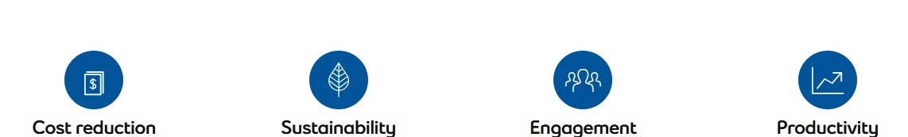

# Smart Island definition

The thematic coverage of smart islands encompasses a wide range of development sectors

➢smart governance and smart resource management

➢smart economy

➢smart mobility

➢smart environment

➢smart living and safe islands

# Smart Island definition

Based on the conducted analysis, the key areas of intervention for “smart islands” are identified below: **1. Smart governance and smart resource management**

1. e-public administration
2. ICT infrastructure
3. communication platforms for dialogue with citizens, and the civil and private sectors
4. smart planning of island development
5. encouraging social innovations
6. transparency of public data and information
7. integrated management systems for islands’ infrastructure and natural resources

# Smart Island definition

## 2. Smart economy

1. ecosystem for entrepreneurs
2. diversification of island economies
3. sustainable tourism development
4. territorial branding
5. development of creative and cultural industries and IT sector
6. expansion of opportunities for locally produced food
7. e-commerce
8. e-business and businesses networking
9. lifelong learning in line with the needs of the labour market and informatic literacy
10. development of skills related to smart specialization and entrepreneurship

# Smart Island definition

## 3. Smart mobility

1. infrastructure for clean island transport
2. alternative fuel infrastructure
3. walking, cycling and non-motorized transport infrastructure and services
4. digitalization of island transport systems
5. clean island transport vehicles
6. improving the mobility of the island population (not only tourists)
7. intermodal transport and better connectivity of islands and mainland
8. increasing the awareness of the local population and visitors about the need to preserve the environment and providing means for more rational use of resources

# Smart Island definition

## 4. Smart environment

Croatia’s islands: Making the most of their territorial capital through smart solutions 26 a) renewable energy sources and promoting self-sustainable islands

1. smart energy and water distribution systems and smart drainage
2. smart public infrastructure
3. smart buildings, homes and districts
4. smart waste management
5. control and monitoring of air, soil and water quality, noise reduction
6. smart and environmental management of industrial sites
7. smart measures for adapting to climate change
8. increasing the awareness of the local population and visitors about the need to preserve the environment and providing means for more rational use of resources

# Smart Island definition

## 5. Smart living and safe islands

1. high capacity broadband network
2. support to the development of e-citizens
3. digitalization in the field of health care (smart healthcare infrastructure)
4. and e-health services
5. smart educational infrastructure and development of educational platforms
6. social and inclusive infrastructure provision (including universal access for elderly and disabled)
7. protection, valorization and promotion of cultural heritage and cultural services
8. improvement in quality and security of public spaces
9. more effective development of a program to combat indigenous wildlife

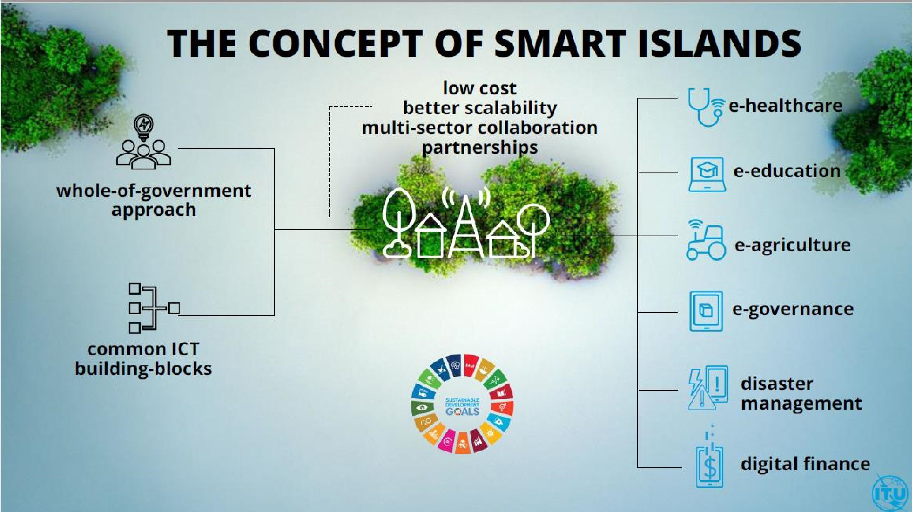

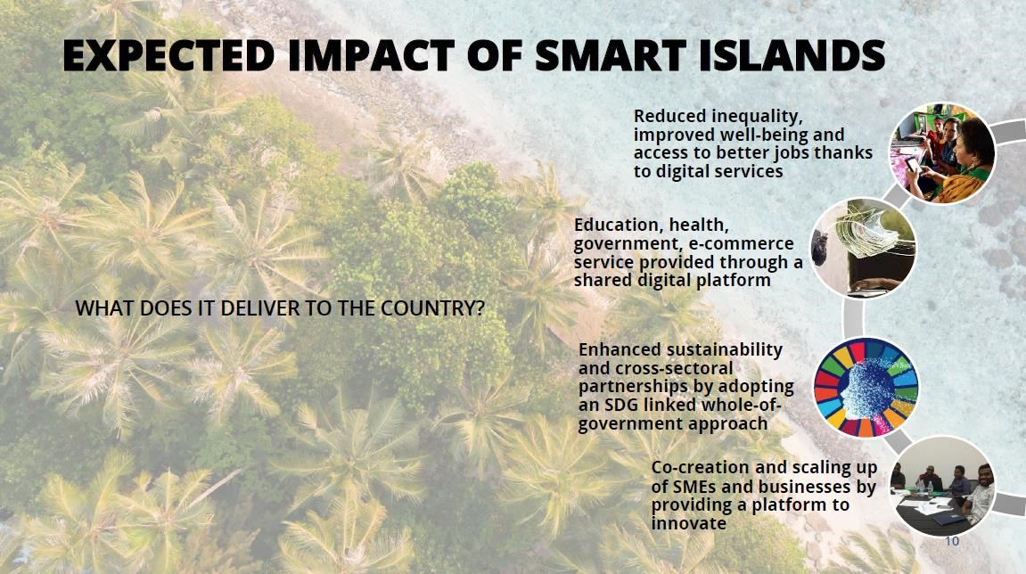

# Smart Islands Requires an Ecosystem Approach

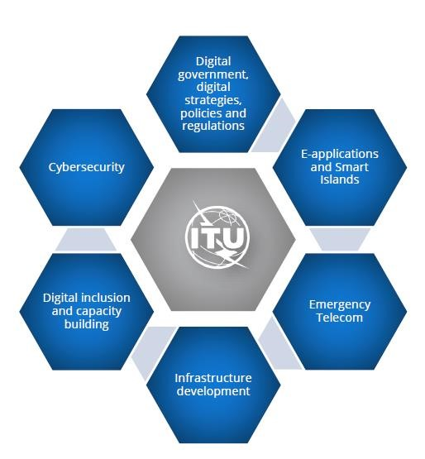

# Smart Islands Requires Long-term Partnerships

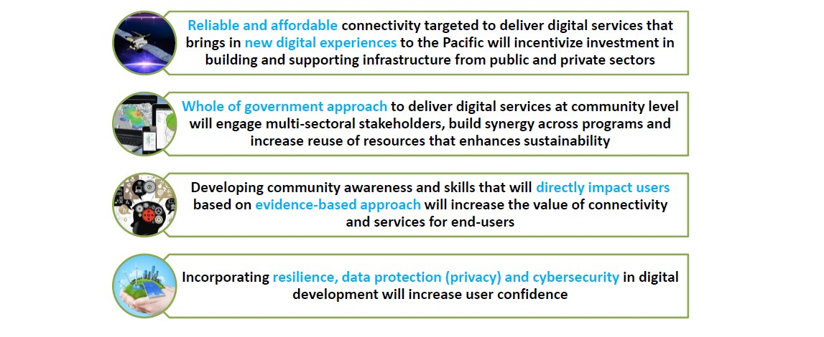

* Smart Islands is a programme that adopts an innovative approach to deliver connectivity and scalable and sustainable services to disadvantaged island communities.
* The Smart Islands programme aims at transforming rural and coastal communities and improving their well-being and livelihood by connecting them to a range of digitally enabled services.
* The programme, built on the ITU-led [Smart](https://www.itu.int/en/ITU-D/ICT-Applications/Pages/smart-village.aspx) [Villages](https://www.itu.int/en/ITU-D/ICT-Applications/Pages/smart-village.aspx) [initiative](https://www.itu.int/en/ITU-D/ICT-Applications/Pages/smart-village.aspx) piloted in Niger and being developed in Egypt and Pakistan, adopts an innovative approach to deliver connectivity and scalable and sustainable services to disadvantaged island communities.
* Small Island Developing States (SIDS) face a host of challenges, including geographic isolation, lack of human resources, low availability and quality of infrastructure, and vulnerability to external shocks. In remote areas and in outer islands access to information, government services, transport, health, finance, commerce and education needs prioritized attention.
* High costs of electricity and lack of affordable connectivity exacerbate the above challenges for SIDS. Not only does the absence of digital technology contribute to the digital divide, but it also deprives small island communities of the opportunity to leverage digital solutions to obtain better access to essential services.

# Solution

* The Smart Islands programme is based on a whole-of-government approach and it is demand-driven, user-centric, flexible, and focused on sustainability, scalability, and multi-sector collaboration.
* It is designed to manifest digital transformation at the community level, to leave no one behind. The initiative leverages the four pillars of (i) improving broadband connectivity (ii) making broadband affordable (iii) enhancing digital skills (iv) and providing digital services, to impact people's lives based on their local priorities.

# Solution

The Smart Islands programme will improve the provision of services in the following sectors:

* **Health:** the deployment of telemedicine and mHealth services to improve access to diagnosis, while also reducing the cost to the healthcare system. For example, mHealth programmes for diabetes prevention and control could be deployed on the basis of the ITU-WHO joint ‘Be Healthy Be Mobile’ initiative.
* **Education:** access to open and distance learning opportunities will enable capacity building for teachers and education administrators as well as providing equitable access to quality literacy, lifelong learning and skills programmes for children, youth, and adults. Local teachers could improve their qualifications and experiences of their students by using engaging education content, curated and uploaded on digital school units.
* **Farming:** e-Agriculture services can support efficient and productive farming capabilities among farmers, making rural communities more resilient from both economic and nutritional points of view. A specialized app could be provided that would help farmers detect and treat pests in a timely manner, based on the analysis of photos taken by conventional smartphones.
* **Multi-hazard early warning and response:** ICT systems for hazard risk monitoring, alert, and post-alert guidance and information. For example, a hurricane early warning system based on meteorological data analysis algorithms and messaging services.
* **Digital financial services:** provide access to much needed digital financial services, and accelerate financial inclusion goals.
* **Tourism and fishing:** support access to e-commerce and e-marketing to improve income opportunities and support livelihoods

# Small Islands into Smart Islands

Transformation of small islands into smart islands will bring about a positive change in local communities' quality of life by providing them with connectivity and new ICT-enabled services, while also promoting interoperability, cooperation, and holistic demand-driven response to SDG-related needs.

# Smart villages

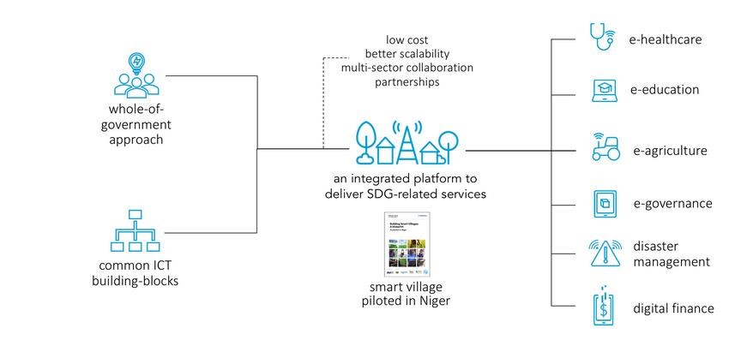

# Smartification And Sustainability’s Process

* Smart Data (need for)
* Next generation networks
* Smart mobility
* Smart Lights
* Energy efficiency / independency
* Green buildings
* Zero emissions
* Smart parking
* Smart transports
* Urban areas exploitation
* Smart citizens
* E-government
* Open gov
* Smart wastes

Main dimensions and sub-dimensions of the proposed KPI scheme for

Smart Sustainable Islands Index

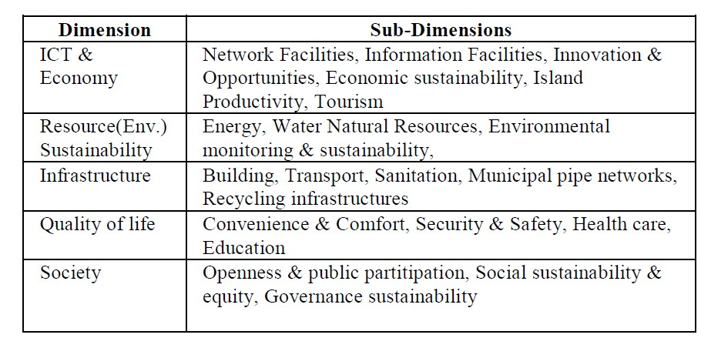

# Major Indicators of the proposed KPI scheme for Smart Sustainable Islands Index

## ICT & Economy

* Network Facilities
* Information Facilities
* Innovation & Opportunities • Economy & Production

## Resource Sustainability

* Energy
* Water
* Environment Monitoring
* Natural Resources

# Major Indicators of the proposed KPI scheme for Smart Sustainable Islands Index

## Infrastructure

* Building
* Transport
* Sanitation
* Municipal networks

# Major Indicators of the proposed KPI scheme for Smart Sustainable Islands Index

## Quality of life

* Convenience
* & Comfort
* Security
* & Safety
* Health
* Care
* Education

# Major Indicators of the proposed KPI scheme for Smart Sustainable Islands Index

## Society

* Openness & public partitip
* Social sustain & equity
* governance sustainability

**Smart Village: An IoT Based Digital Transformation**

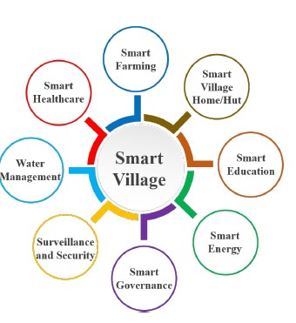

**Smart village design cycle**

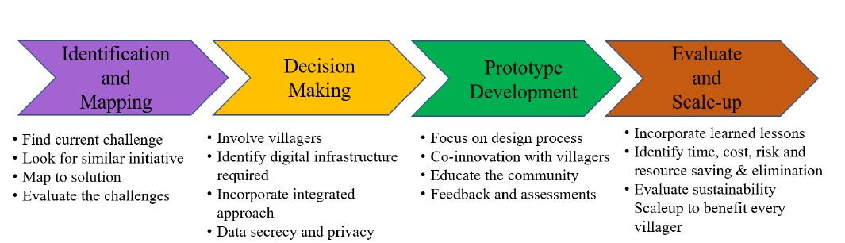

# Smart Village Key Aspects

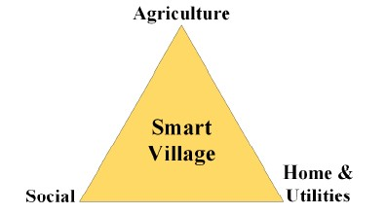

# Smart village

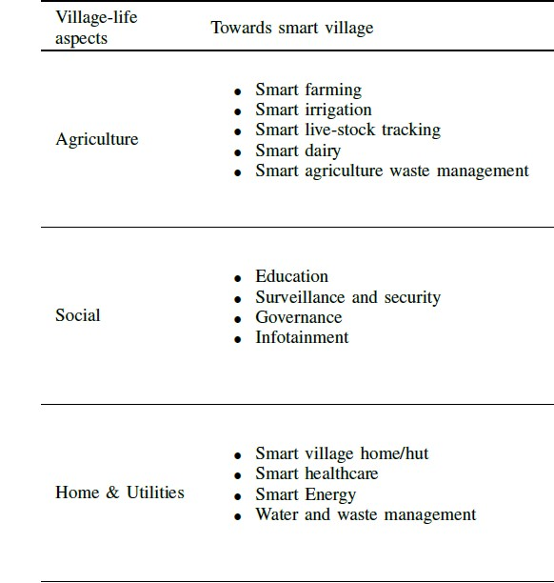

**IoT enabled digital transformation Digital transformation towards smart village**

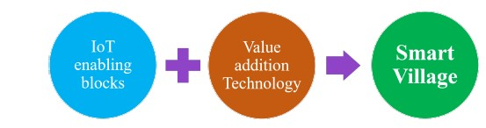

**Mapping of Smart Village Verticals to IoT Communication Technology**

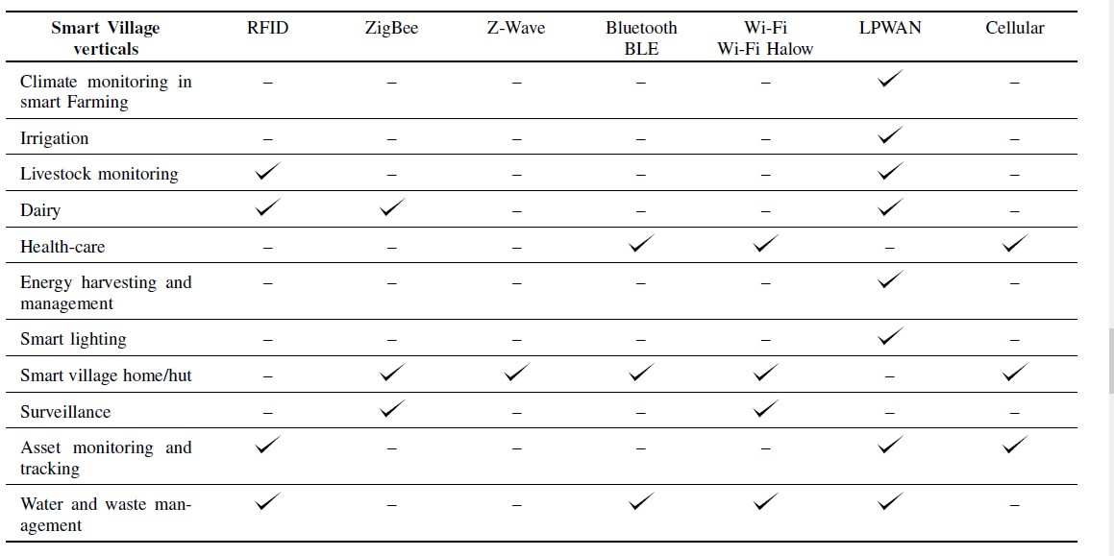

**The Evolution of IoT, from Smart Cities to Smart**

**Islands**

**The Evolution of IoT, from Smart Cities to Smart Islands**

**But can it work on islands?**

These metropolises are not the only ones that see the benefits of implementing smart strategies. The Samoa

Pathway report, issued at the Third International Conference on Small Island Developing States (SIDS) held in [Samoa in 2014 noted that “*access by Small Island Developing States to appropriate reliable, affordable, modern and environmentally sound technologies is critical to achieving their sustainable development objectives and in fostering an environment that provides incentives for innovation and entrepreneurship and that science, technology and innovation are essential enablers and drivers for sustainable development.*”.](https://news.itu.int/samoa-pathway-mid-term-review-how-tech-is-helping-small-island-countries/)

**The Evolution of IoT, from Smart Cities to Smart Islands**

* A large focus of this conference revolved around the availability and affordability of ICT (Information and Communication Technology) networks throughout the 52 countries and territories making up the group of SIDS. Significant progress has been made on this front across the small islands since the 2014 conference.
* Mobile broadband coverage had risen from 50% of the SIDS population in 2014 to 85% in 2019, while the cost of mobile data dropped from being 15% of total Gross National Income (GNI) to 8%. Regional regulatory bodies, such as ECTEL (the Eastern Caribbean Telecommunications Authority) have been set up to help recommend policies, procedures and guidelines in key areas surrounding ICT development within their member states.
* Islands, as the countries which feel the brunt of climate change effects due to their geographical isolation, lack of resources and extensive coastlines, stand much to gain by arming themselves with integrated data collection, analysis and response systems in all aspects. Even here in Grenada, local companies have been working towards the incorporation of sensor technology to track things like water consumption and weather patterns.

**The Evolution of IoT, from Smart Cities to Smart Islands**

* At this point, the main constraints facing island development are digital skills and awareness along with financial and human resources. Projects like the Smart Islands Initiative led by the EU are focused on improving island life through [“sustainable,](https://www.smartislandsinitiative.eu/en/index.php) [integrated](https://www.smartislandsinitiative.eu/en/index.php) [solutions](https://www.smartislandsinitiative.eu/en/index.php) [that](https://www.smartislandsinitiative.eu/en/index.php) [make](https://www.smartislandsinitiative.eu/en/index.php) [the](https://www.smartislandsinitiative.eu/en/index.php) [most](https://www.smartislandsinitiative.eu/en/index.php) [out](https://www.smartislandsinitiative.eu/en/index.php) [of](https://www.smartislandsinitiative.eu/en/index.php) [islands’](https://www.smartislandsinitiative.eu/en/index.php) [competitive](https://www.smartislandsinitiative.eu/en/index.php) [advantages.](https://www.smartislandsinitiative.eu/en/index.php)” Focused on the islands surrounding Europe, as well as the EU’s outlying island dependencies, the Union sees small islands as the perfect petri dish to test multiple projects in resource and infrastructure management which can later be transplanted into mainland mountain regions or scaled up to the typical urban context. This all shows that, given the right amount of attention and financial support, island states too can become global leaders in the IoT era.
* So what’s next? As multinational organizations continue to emphasize Small Island development and as governments begin to prioritize technological advancement, island populations must prepare both their ICT workforce to help develop and manage the technology, as well as their collective mindsets to adapt to the societal and infrastructural changes that will come with IoT implementation. Progress is consistent, and the future is integrated.

# The EU Initiative “Smart Islands” Islands

.

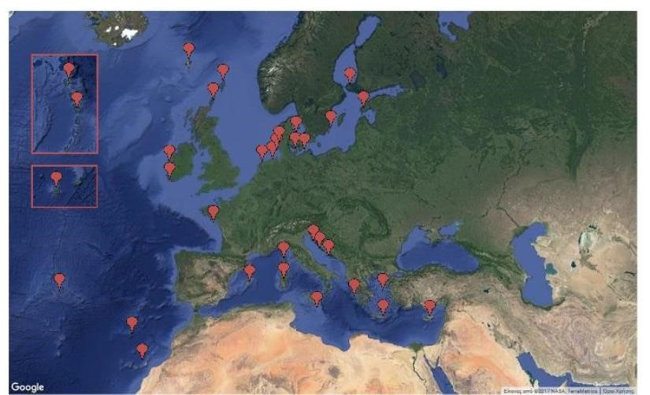

**Are Smart Islands the next step to EU sustainability success?**

* *Running an island is hard work. Sure, some like Ibiza thrive as vacation destinations and profit from tourism, but due to their insularity, many are heavily dependent on energy—especially fossil fuels.*
* *Islands are also faced with the challenge of maintaining (or creating) a sustainable local environment and ecosystem while still managing issues such as high transportation costs and pollution.*

**Are Smart Islands the next step to EU sustainability success?**

* *With about* [***11***](https://newsroom.cisco.com/feature-content?articleId=1735451)[***percent***](https://newsroom.cisco.com/feature-content?articleId=1735451)[***of***](https://newsroom.cisco.com/feature-content?articleId=1735451)[***the***](https://newsroom.cisco.com/feature-content?articleId=1735451)[***world’s***](https://newsroom.cisco.com/feature-content?articleId=1735451)[***population***](https://newsroom.cisco.com/feature-content?articleId=1735451)[***living***](https://newsroom.cisco.com/feature-content?articleId=1735451)[***on***](https://newsroom.cisco.com/feature-content?articleId=1735451)[***islands****,*](https://newsroom.cisco.com/feature-content?articleId=1735451) *this becomes an issue not just for tourism, but also for the actual residents.*
* *As the EU looks to be a driver in terms of a low carbon economy, islands in Europe are becoming more aware of their role to serve as inspiration for sustainable, integrated solutions that “make the most out of islands’ competitive advantages,” according to the* [***Smart***](http://www.smartislandsinitiative.eu/en/index.php)[***Islands***](http://www.smartislandsinitiative.eu/en/index.php)[***Initiative****.*](http://www.smartislandsinitiative.eu/en/index.php)
* *this new efforts inspired by Smart Cities and Communities shows how Europe’s islands may play a vital role in helping Europe transition into a low carbon and sustainable economy.*

**Rethinking ‘Smart’ Islands: Toward Humane, Self-Aware, and Cooperative Hybrid Islands.**

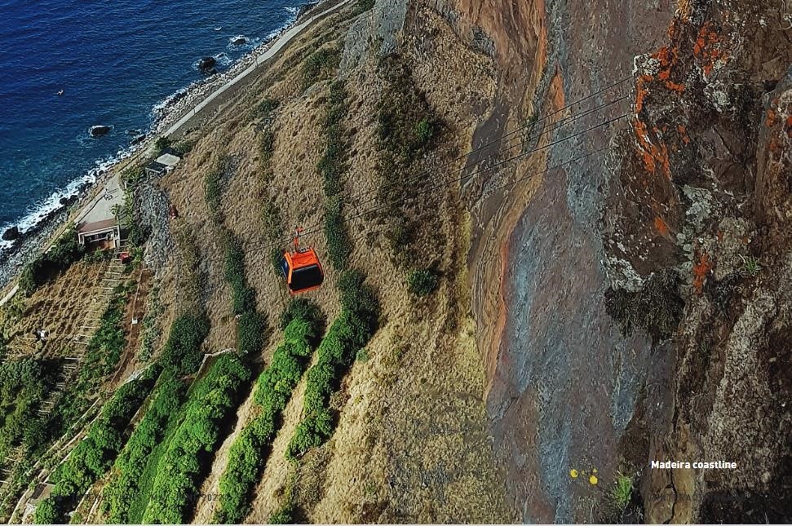

**Participatory Innovation Model.**

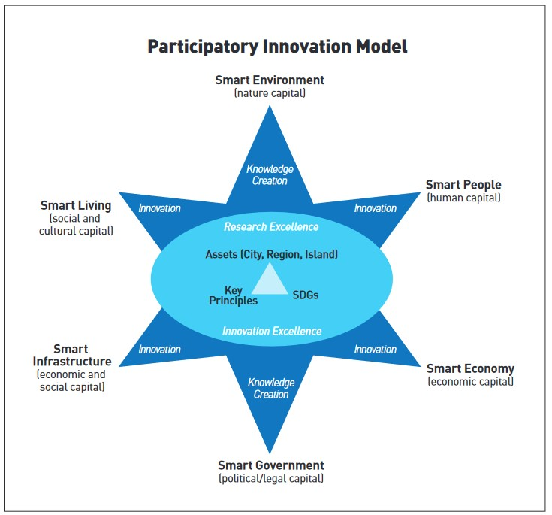

**Examples of Big Topics** 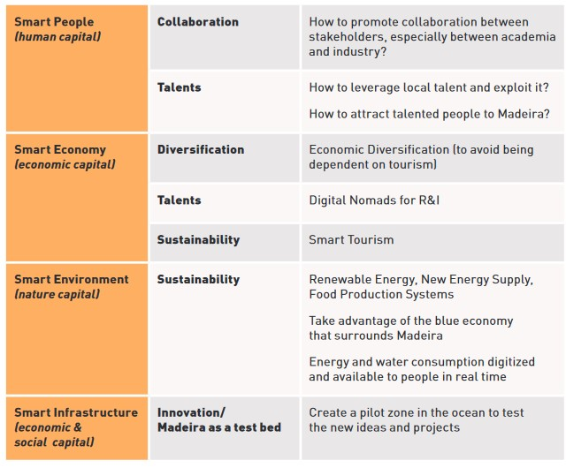

**Data sources**

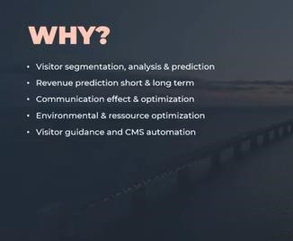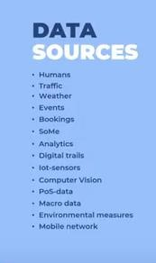

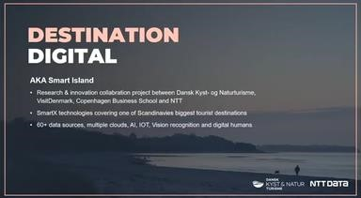

Watch here: <https://www.youtube.com/watch?v=Xo4AGuo0f2M>

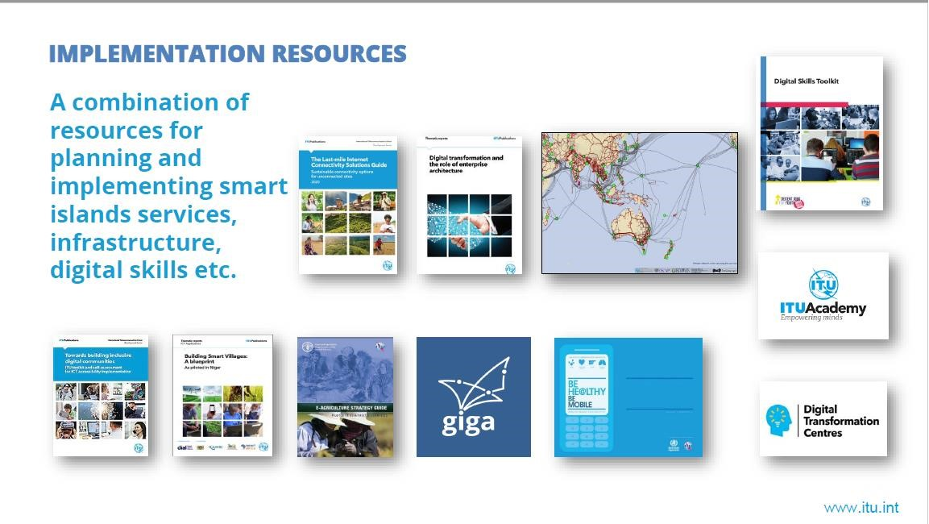



Digital Transformation: Enhancing

IoT

-

driven Solutions for Smart Islands

___________________________

**Amir**

**Vahabpour**

Researcher in Energy &

Blockchain

Email: vahabpour@ut.ac.ir



**Smart Grid, Green Energy and Energy Transition in Smart Islands**



**Amir Vahabpour**

**Education:**

* PhD Candidate – Energy Systems Engineering – Tehran University
* MSc. – Energy Systems Engineering – Sharif University of Technology ▪ BSc. – Mechanical Engineering – Khajeh Nasir Toosi University of Technology

**Professional Experience:**

* CEO at Meta-Home Company (Smart Home Solutions)



* CEO at Armaghan Kooshyaran Afrand Company (Energy Consultant)
* Former Senior Researcher at Sharif Energy Research Institute (SERI) ▪ Co-founder at Water, Environment and Energy Innovation Center (AMA)

**Areas of Interests:**

* Energy Management
* Water-Energy Nexus
* Applications of IoT and Blockchain in Energy Systems

# Overview

**Getting to know**

**renewable energies**

•

Some

facts

&

figures

•

Different

types

•

Introducing

sources

**A brief introduction**

**to smart grid**

•

Definitions

•

Essence

&

Rational

•

Benefits

•

Characteristics

**Energy transition**

**and its requirements**

•

Definitions

•

Requirements

•

Benefits

•

Actions

**Smart islands and**

**their energy pathway**

•

Challenges

•

Considerations

•

Role of REs

•

Role of SGs

•

European solution

•

American solution

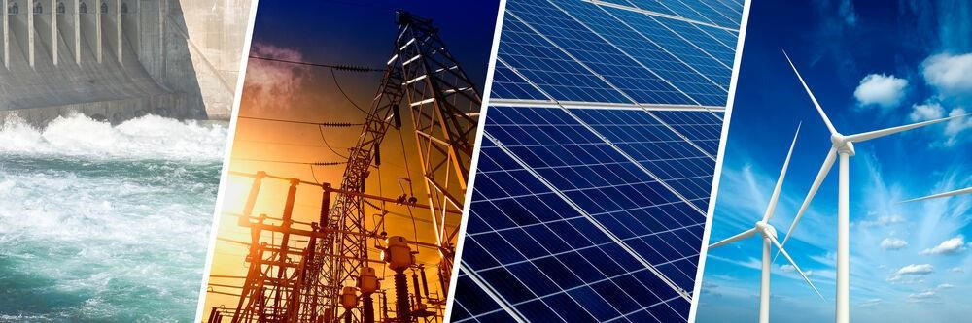**Sec 2: Renewable Energies**

# World’s renewable energy figures

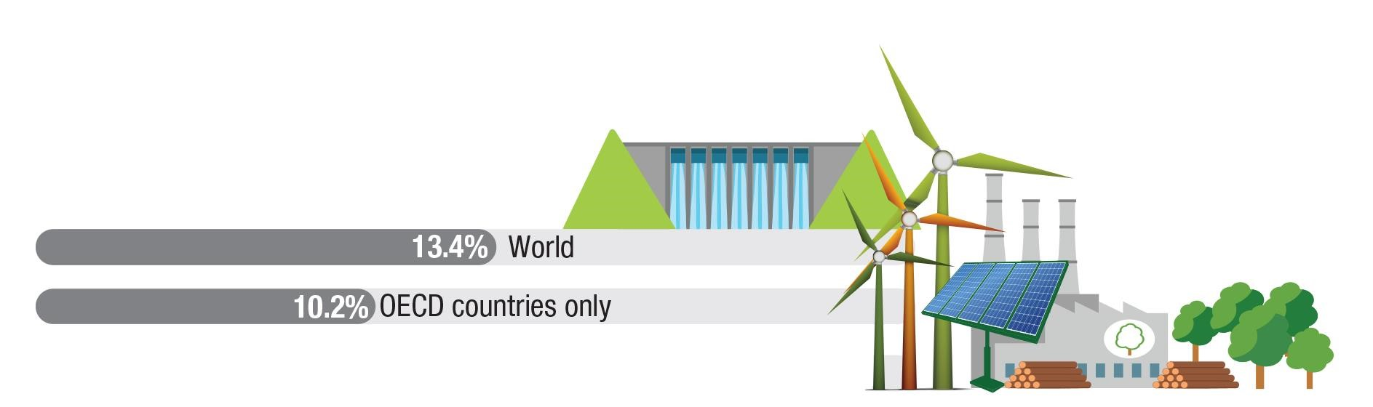● Share of energy supply from renewable resources

|  |  |  |
| --- | --- | --- |
| **Rank** | **Country** | **Percentage** |
| 1 | China | 14% |
| 2 | India | 11% |
| 3 | United States | 8% |
| 4 | Brazil | 6% |
| 5 | Nigeria | 6% |
| 6 | Indonesia | 4% |
| 7 | Canada | 3% |

Online Training Course on “Digital Transformation: Enhancing IoT driven Solutions for Smart Islands”, 18-31 July 2022

# Types of Renewable Energy

●

Major

Renewable

Resources

Wind

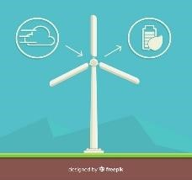

Ambient Heat

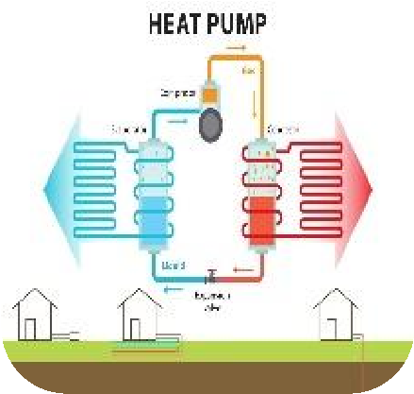

Hydro

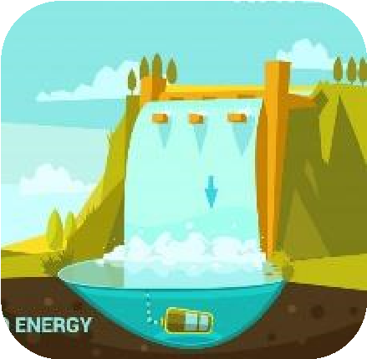

Wave

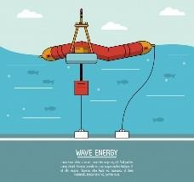

Tidal

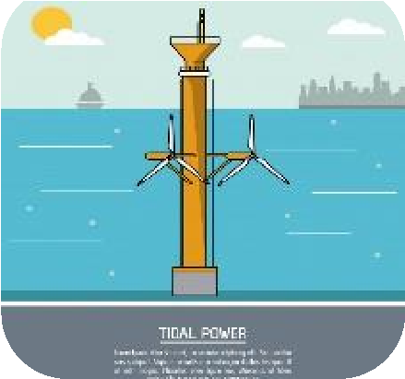

Biomass

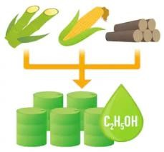

Solar

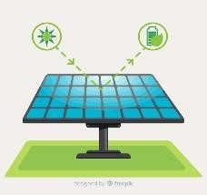

Geothermal

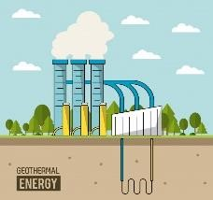

Online Training Course on “Digital Transformation: Enhancing IoT driven Solutions for Smart Islands”, 18-31 July 2022

# Types of Renewable Energy

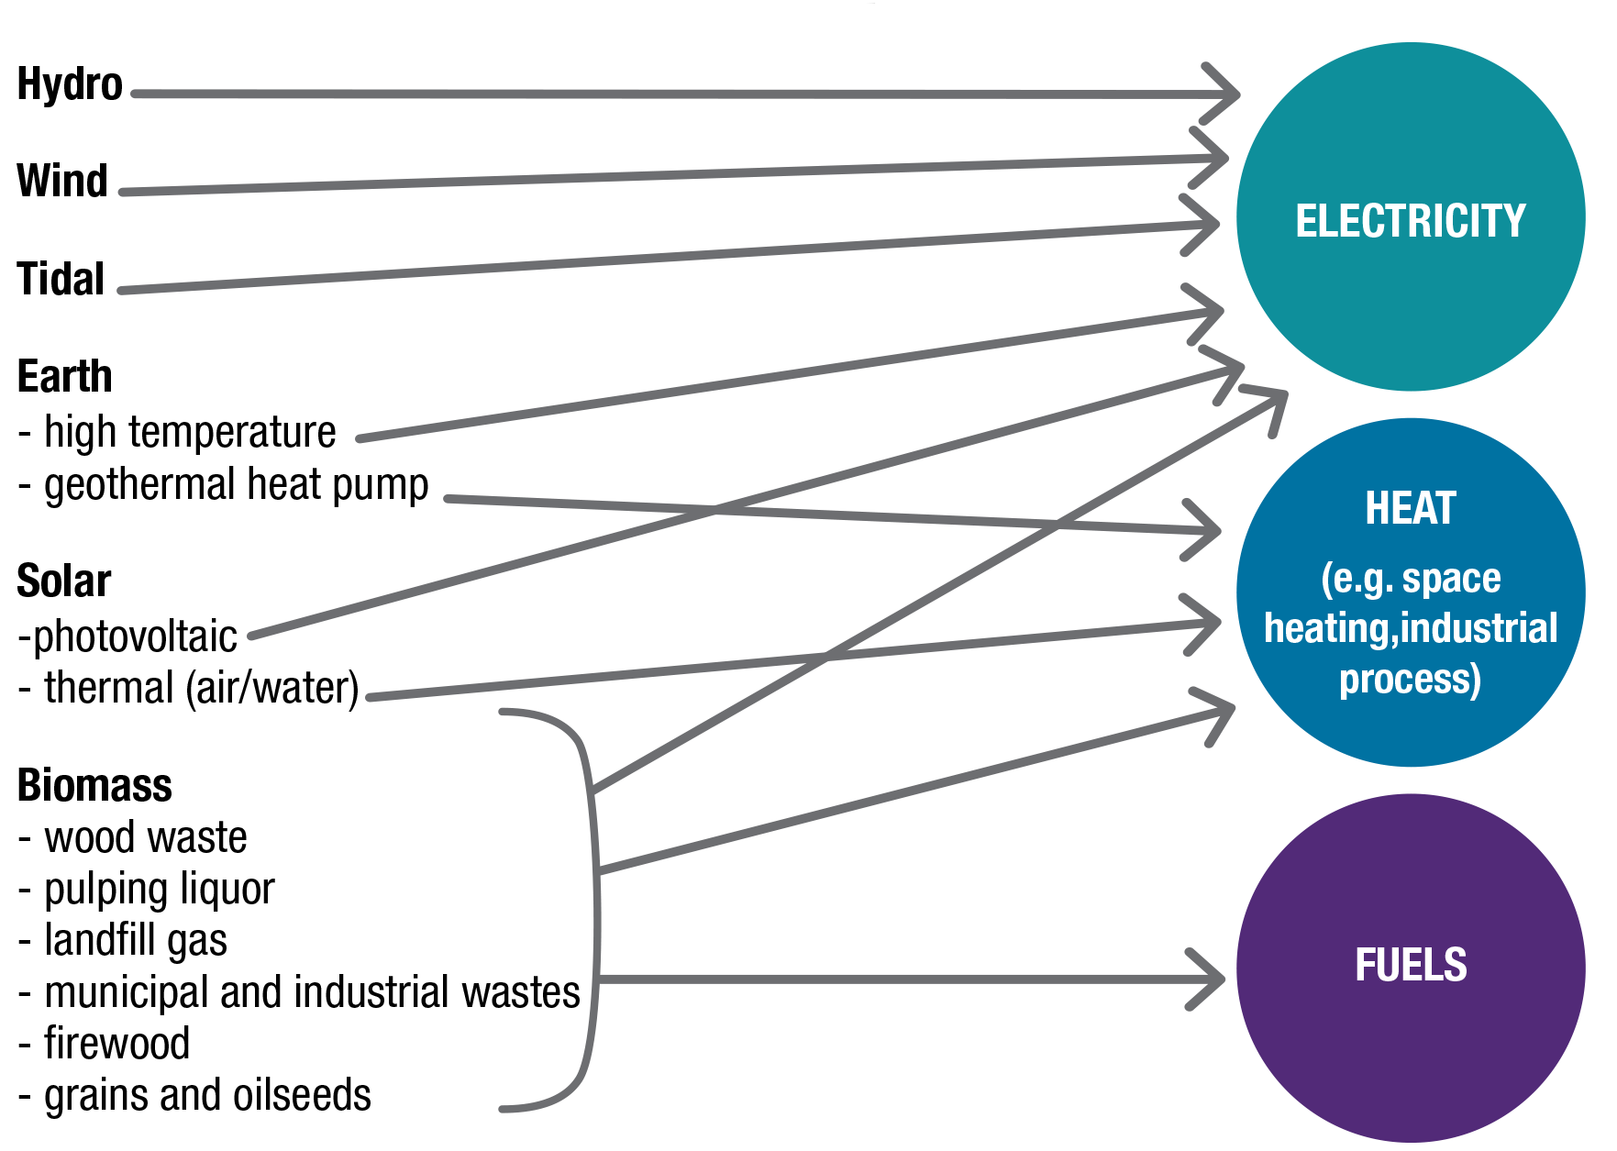● Major Renewable applications o renewable energies are majorly transformed to electricity and heat in the final use.

# Most common forms of renewable energy

● **Biomass energy:** Biomass energy is produced from nonfossilized plant materials. Wood and wood waste are the largest sources of biomass energy, followed by biofuels and municipal solid waste.

* Wood biomass includes wood pellets; wood chips from forestry operations; residues from lumber, pulp/paper, and furniture mills; and fuel wood for space heating and cooking. The largest single source of wood energy is *black liquor,* a residue of pulp, paper, and paperboard production.
* Biofuels include ethanol and *biodiesel*. Fuel ethanol is mostly produced from corn. Biodiesel is made from grain oils and animal fats.
* Municipal solid waste (MSW), or garbage, contains biomass (or biogenic) materials such as paper, cardboard, food scraps, grass clippings, leaves, wood, leather products, and nonbiomass combustible materials (mainly plastics and other synthetic materials made from petroleum). It is burned in wasteto-energy plants to generate electricity. There are also many landfills that collect and burn biogas to produce electricity.

# Most common forms of renewable energy

* **Hydropower:** Hydropower is electricity produced from flowing water. Most hydropower produced all around the world is from large dams built by governments on rivers.

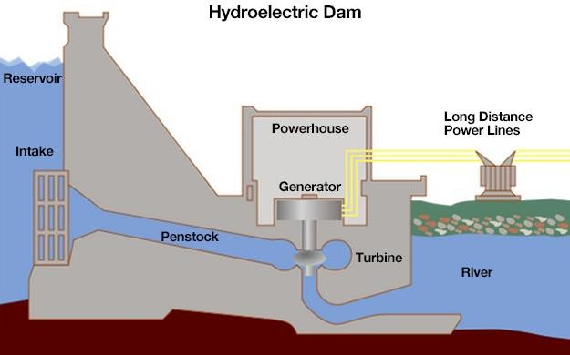

1

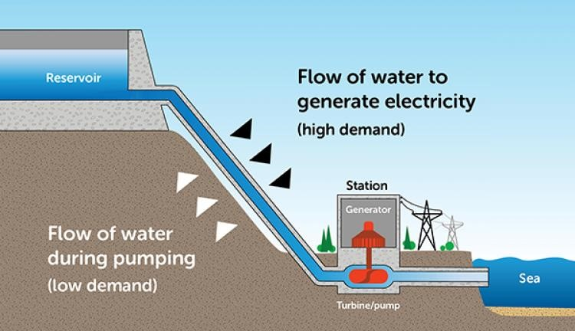

2

* There are two general types of hydropower:
  1. Conventional hydropower uses water in dams or flowing in streams and rivers to spin a turbine and generate electricity.
  2. Pumped storage systems use and generate electricity by moving water between two reservoirs at different elevations.

# Most common forms of renewable energy

* **Geothermal energy:** Geothermal energy is heat from the hot interior of the earth or near the earth's surface. Fissures in the earth's crust allow water, heated by geothermal energy, to rise naturally to the surface at hot springs and geysers. Wells drilled into the earth allow a controlled release of steam or water to the surface to power steam turbines to generate electricity. The near constant temperature of the earth near the earth's surface is used in geothermal heat pumps for heating and cooling buildings.

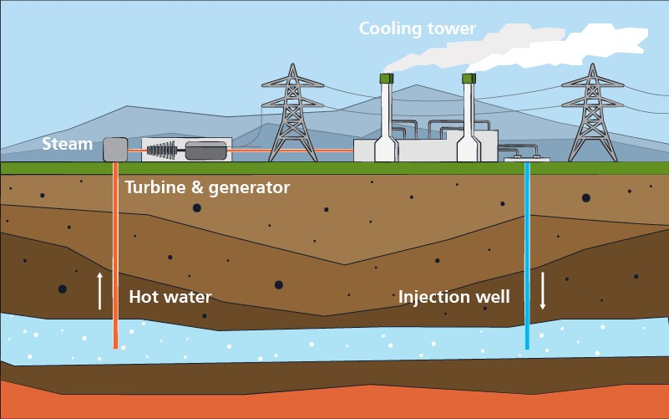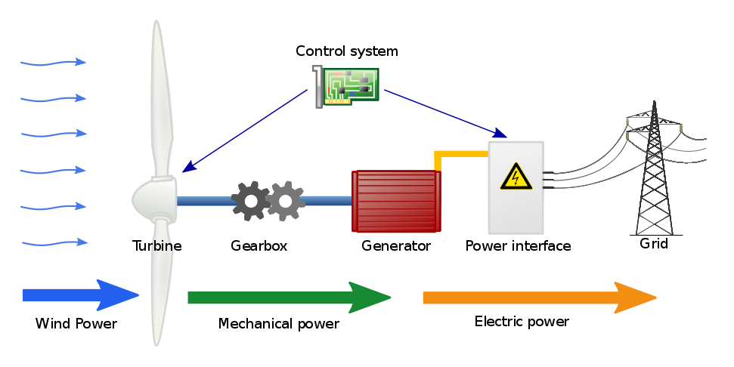

* **Wind energy:** Wind turbines use blades to collect the wind's kinetic energy. Wind flows over the blades creating lift, which causes the blades to turn. The blades are connected to a drive shaft that turns an electric generator, which produces electricity.

# Most common forms of renewable energy

● **Solar energy:** Solar energy systems use radiation from the sun to produce heat and electricity. There are three basic categories of solar energy systems:

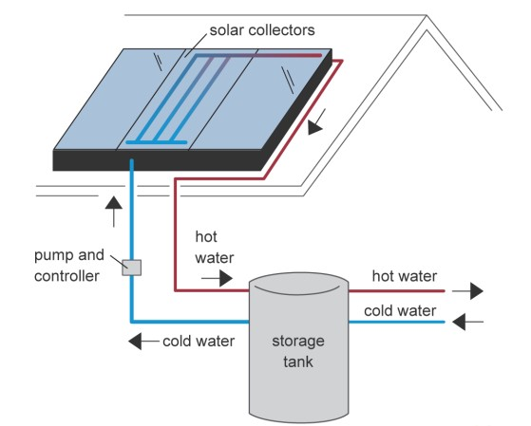

1

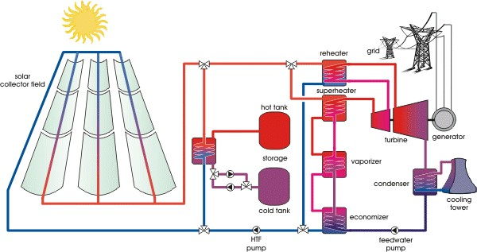

2

1. Solar thermal systems use solar collectors to absorb solar radiation to heat water or air for space heating and water heating.
2. Solar thermal power plants use concentrating solar collectors to focus the sun's rays to heat a fluid to a high temperature. This fluid generates steam to power a turbine and a generator.
3. Photovoltaic (PV) systems use solar electric cells that convert solar radiation directly into electricity. Individual PV cells are arranged into modules (panels) of varying electricity-producing capacities. PV systems range from single PV cells for powering calculators to large power plants with hundreds of modules to generate large amounts of electricity.



**Sec**

**2**

**:**

**Getting to know Smart Grid**

# Smart Grid Definitions

* The U.S. Department of Energy: “a class of technology people are using to bring utility electricity delivery systems into the 21st century, using computer-based remote control and automation. These systems are made possible by two-way communication technology and computer processing that has been used for decades in other industries. They are beginning to be used on electricity networks, from the power plants and wind farms all the way to the consumers of electricity in homes and businesses. They offer many benefits to utilities and consumers—mostly seen in big improvements in energy efficiency on the electricity grid and in the energy users’ homes and offices”.
* The International Energy Agency (IEA): “A smart grid is an electricity network that uses digital and other advanced technologies to monitor and manage the transport of electricity from all generation sources to meet the varying electricity demands of end-users. Smart grids coordinate the needs and capabilities of all generators, grid operators, end-users, and electricity market stakeholders to operate all parts of the system as efficiently as possible, minimizing costs and environmental impacts while maximizing system reliability, resilience, and stability”.



* The Korea Smart Grid Institute: “Smart Grid refers to the next-generation network that integrates information technology into the existing power grid to optimize energy efficiency through two-way exchange of electricity information between suppliers and consumers in real time”.

# The Essence of Smart Grid

* Urban areas consume up to 80% of global electricity generation
* We are in the middle of a transformation

o Decarbonization o Decentralization o Digitalization

* Sustainable Society and Smart infrastructure drives transformation of transactive grid edge* and new consumer opportunities
* Digitalization enables new services and new business models
* **Energy supply side** ● **Energy demand side** o Smart grids o Smart buildings

o Smart industries

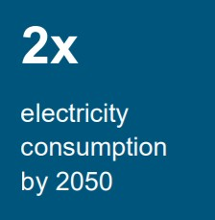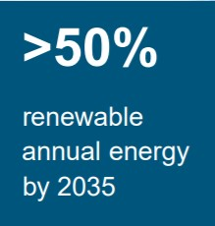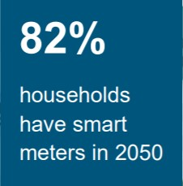

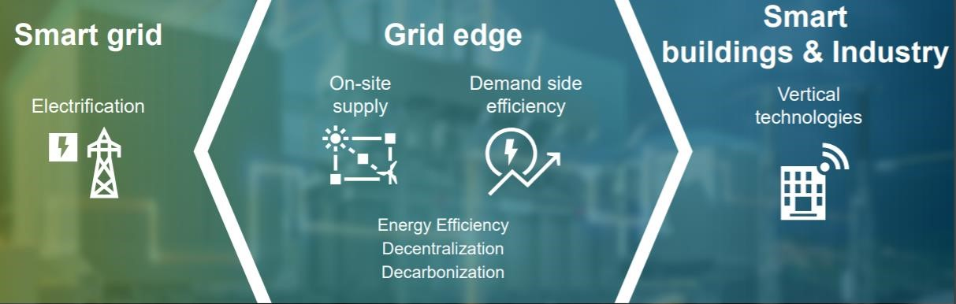

* **Grid Edge:** Innovation and disruption often play out at the boundary of grid technology toward a decentralized, distributed and transactive electric grid.

# Logo, company name Description automatically generatedRationale For Smart Grid Technology

* The world’s electricity systems face a number of challenges: o ageing infrastructure o continued growth in demand o the integration of increasing numbers of variable

renewable energy sources and electric vehicles

* + the need to improve the security of supply o the need to lower carbon emissions
* Smart grid technologies offer ways not just to meet these challenges but also to develop a cleaner energy supply
  + more energy efficient o more affordable o more sustainable

# Rationale For Smart Grid Technology

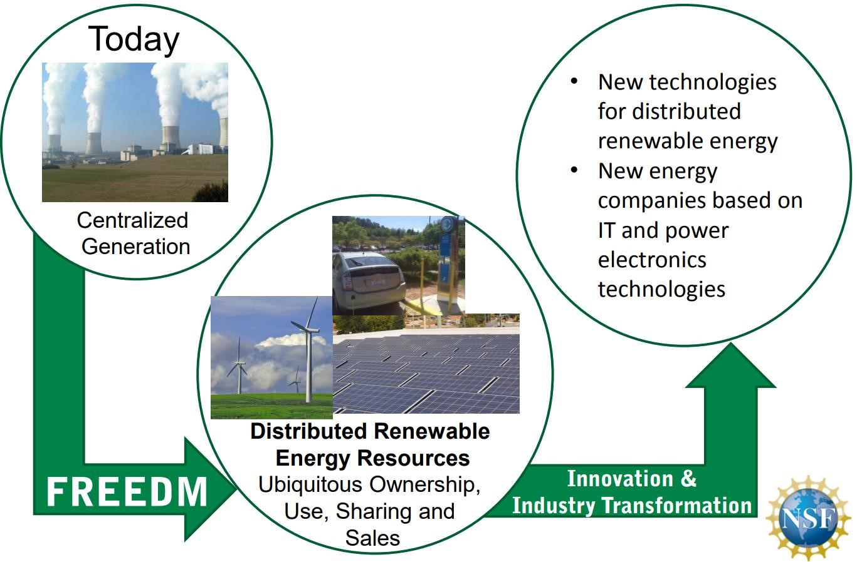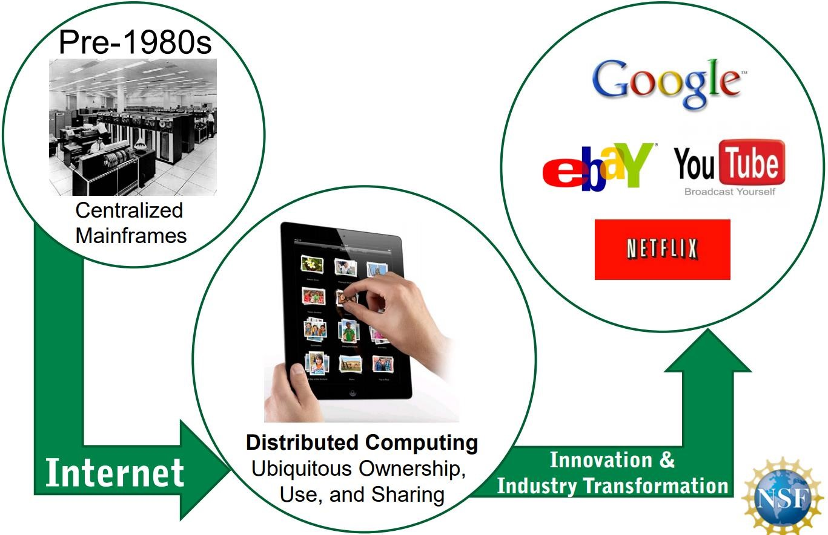

# Rationale For Smart Grid Technology

* These challenges must also be addressed with regard to each region’s unique technical, financial and commercial regulatory environment.
* 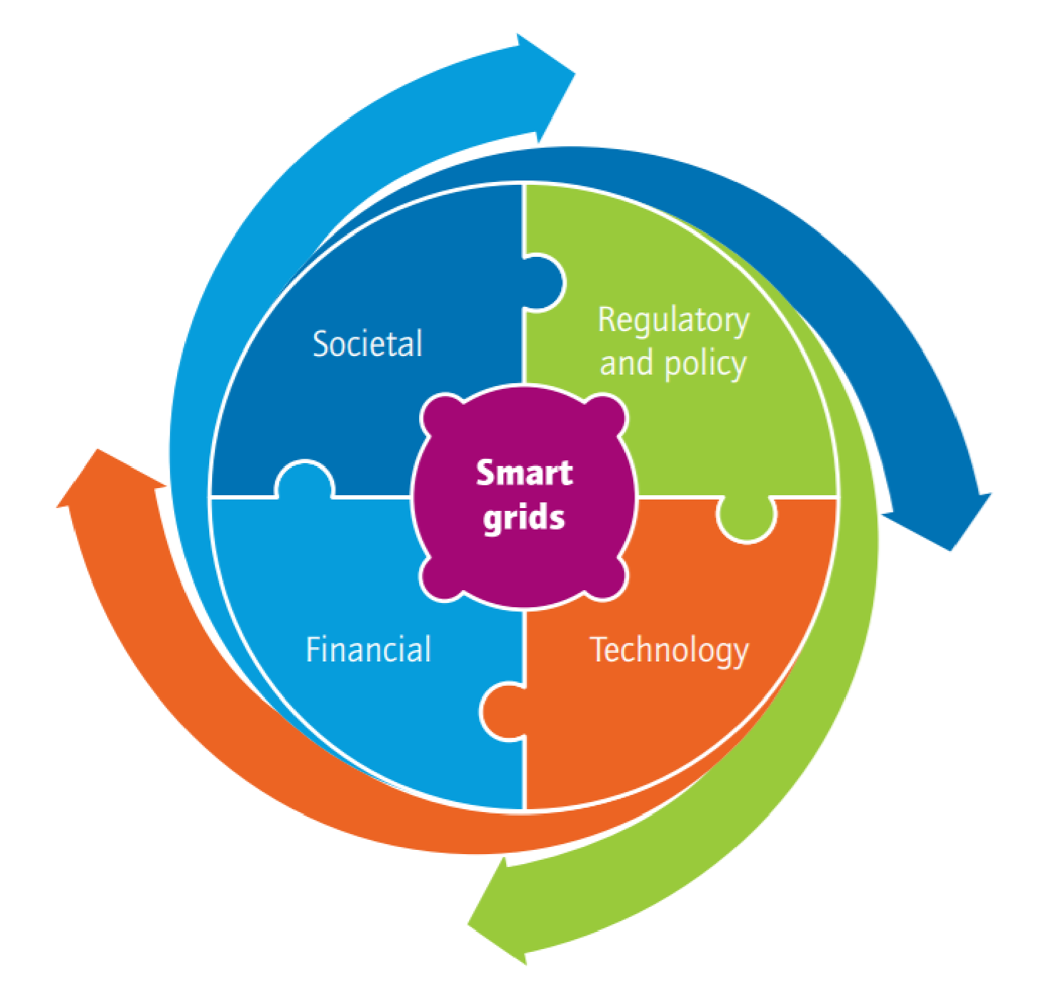Given the highly regulated nature of the electricity system, proponents of smart grids must ensure that they engage with all stakeholders, including equipment manufacturers, system operators, consumer advocates and consumers, to develop tailored technical, financial and regulatory solutions that enable the potential of smart grids.
* Smart cities and islands are exposed to a diverse set of cyber security threats and criminal misuses.
* This complex environment also presents a significant challenge for digital forensic investigations, which will invariably rely upon the data generated by the smart city components.

o To envision a secure smart city cyber security platform with access to reliable forensic evidence, due diligence for data transfer and storage in the Cloud is mandatory.

# Energy system scheme with Smart Grid infrastructure

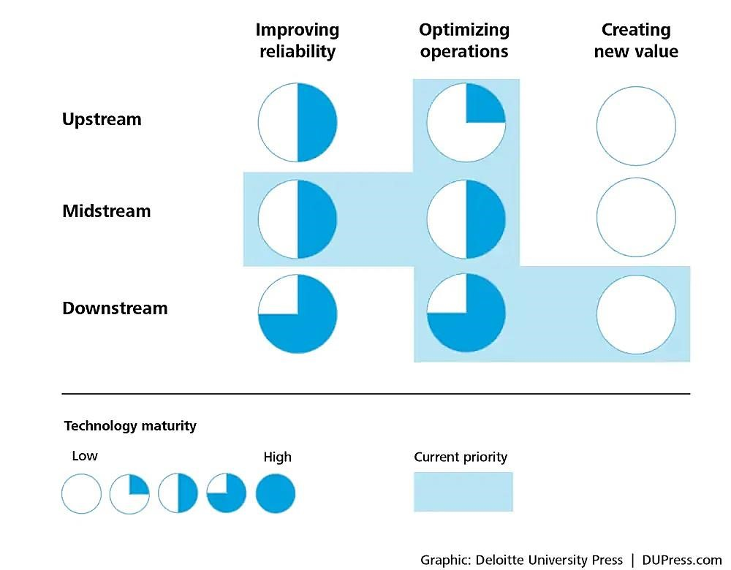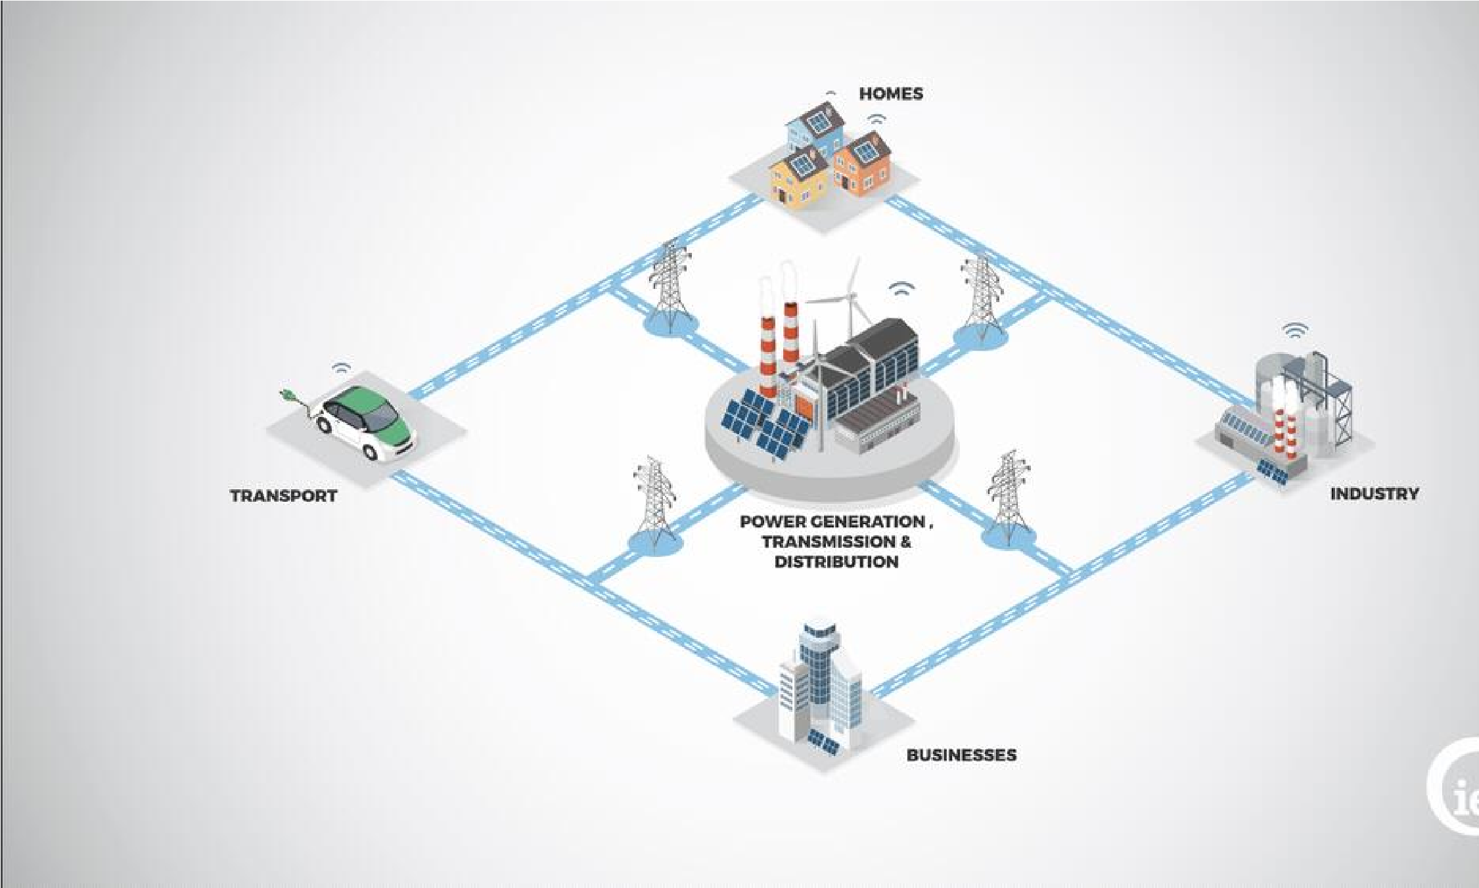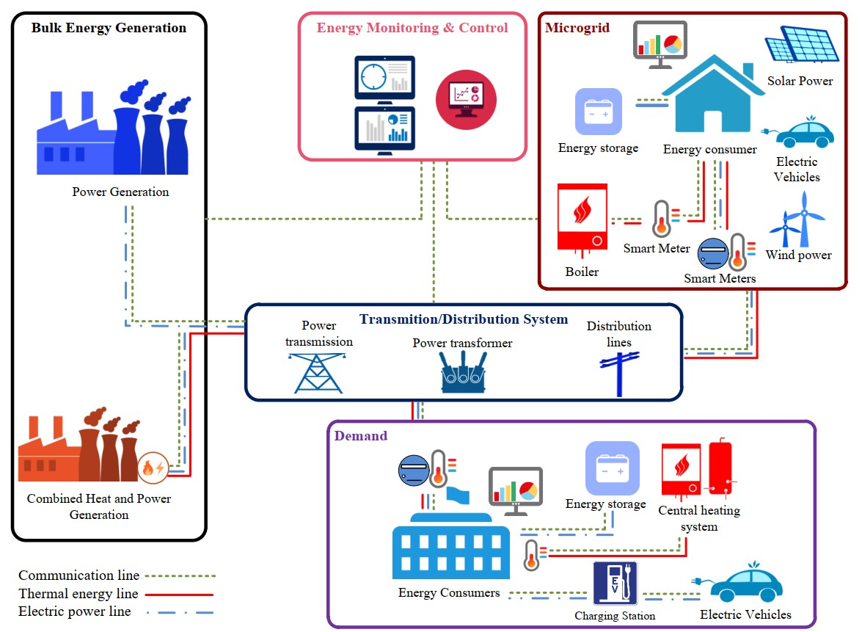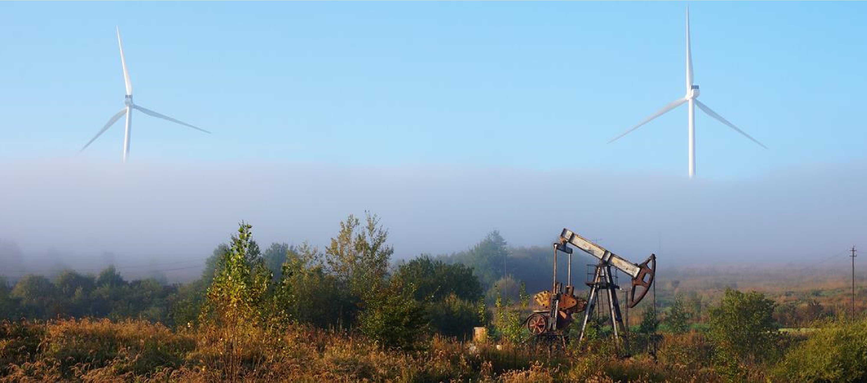

**Sec**

**2**

**:**

**Energy Transition**

**What is energy transition?**

* The Earth is heating up. According to NASA, in 2020 the planet’s average temperature was 1.02°C warmer than the baseline 1950–1980 mean.
  + 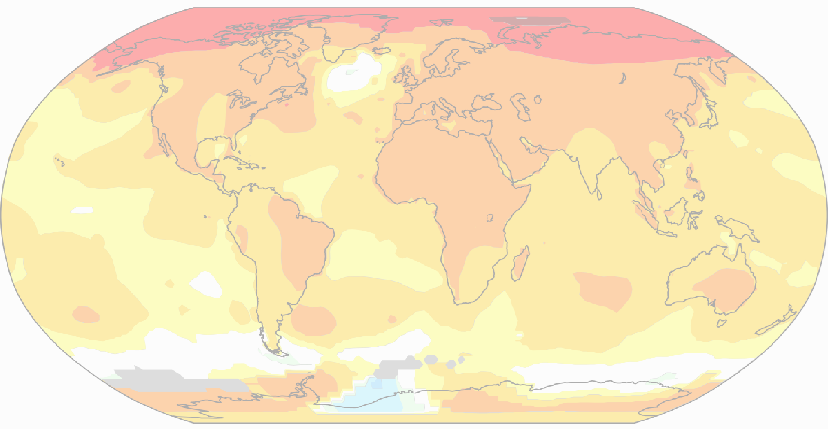**Global warming,** in addition to causing the polar ice caps to melt and sea levels to rise, is causing other **climate changes** like desertification and an increase in extreme weather events such as hurricanes, floods and fires: the distortion of the climate risks causing incalculable damage.
* The scientific community is in agreement that this is due to anthropogenic emissions of greenhouse gases into the atmosphere, especially since the Industrial Revolution.
  + The main such gas, carbon dioxide, originates largely from the energy sector (including but not limited to the generation of electricity).
* In December 2015, at COP 21 in Paris, an international agreement was signed that set the target of limiting global warming by the end of this century to below 2°C compared with pre-industrial levels and preferably limiting it to 1.5°C.

COP26, which took place in November 2021 in Glasgow, confirmed the commitment to achieve carbon neutrality by 2050.

**What is energy transition?**

* The energy transition is a pathway toward transformation of the global energy sector from fossil-based to zerocarbon by the second half of this century.
* 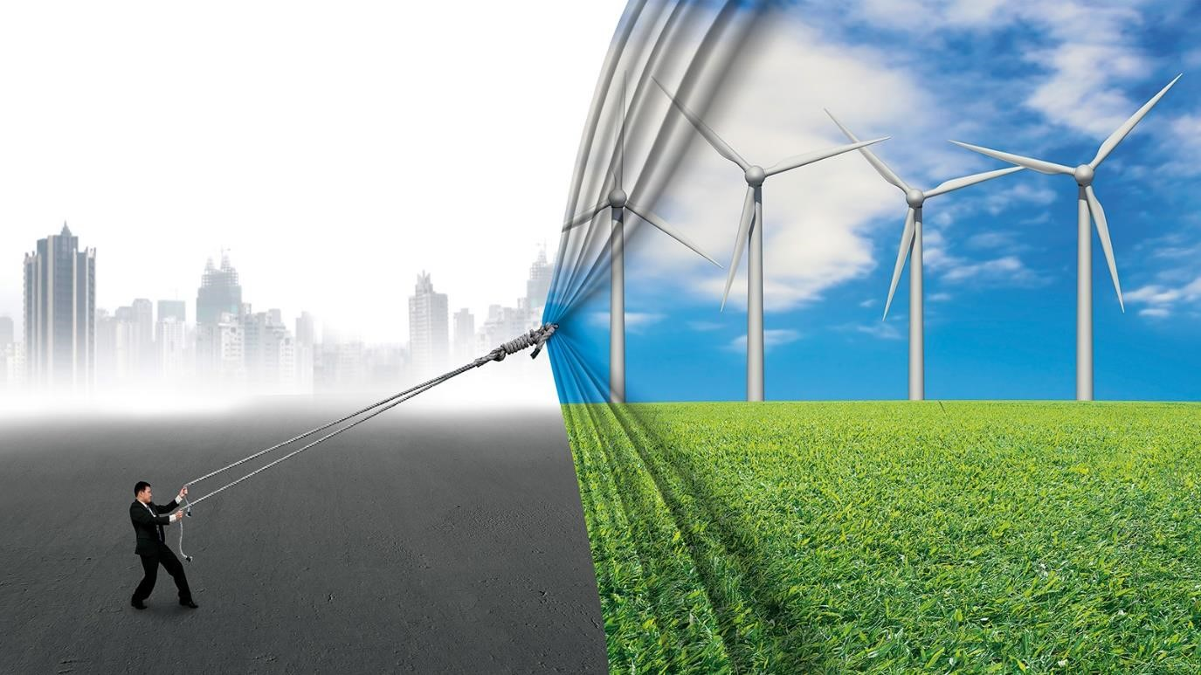At its heart is the need to reduce energy-related CO2 emissions to limit climate change.
* Decarbonisation of the energy sector requires urgent action on a global scale, and while a global energy transition is underway, further action is needed to reduce carbon emissions and mitigate the effects of climate change.
* Renewable energy and energy efficiency measures can potentially achieve 90% of the required carbon reductions.

## Requirements of energy transition

* In order to achieve this goal, our main tool is the energy transition:

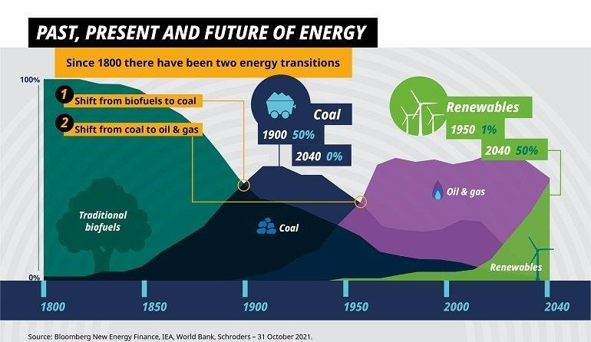o The shift from an energy mix based on fossil fuels to one that produces very limited, if not zero, carbon emissions, based on renewable energy sources.

* A huge contribution to decarbonization comes from the electrification of consumption, replacing fossil fuel-generated electricity with energy generated from renewable sources, which also makes other sectors like transport cleaner; the digitalization of networks also contributes by improving energy efficiency.

## Benefits of energy transition

* The energy transition is not only limited to the gradual closure of coal-fired power stations and the development of clean energies: it is a paradigm shift that concerns the entire system.
* 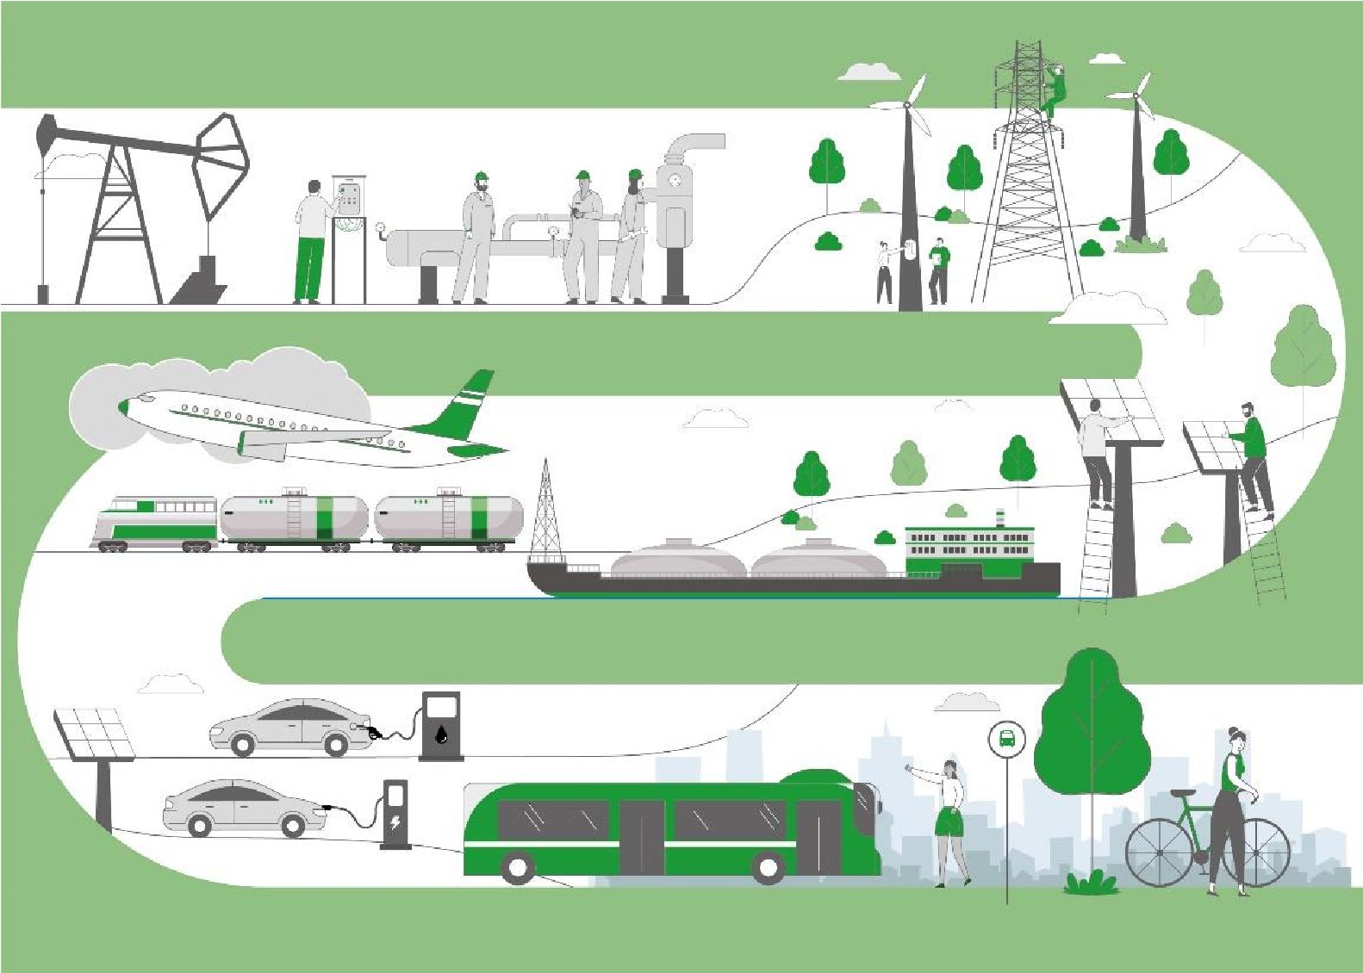This solution can provide benefits not only for the climate but also for the economy and for society. The digitalization of electricity grids can lead to the age of smart grids and open the way for new services for consumers.
* From the environmental perspective, renewable sources and electric mobility reduce pollution, while coal-fired power stations can be repurposed in line with the principles of the circular economy.
* Concerning social sustainability, the new jobs created can absorb those people previously working in the thermoelectric sector. It is important that the energy transition be inclusive and ensure that no one is left behind.

## Actions towards energy transition

● Renewables now make up the majority of annual power capacity additions:

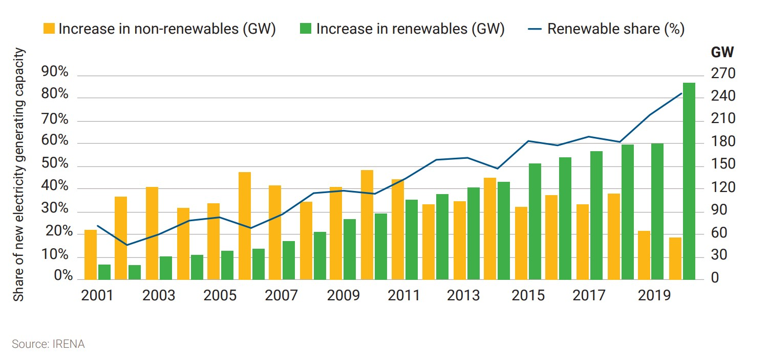

## Actions towards energy transition

● Automakers leaving internal combustion engine market:

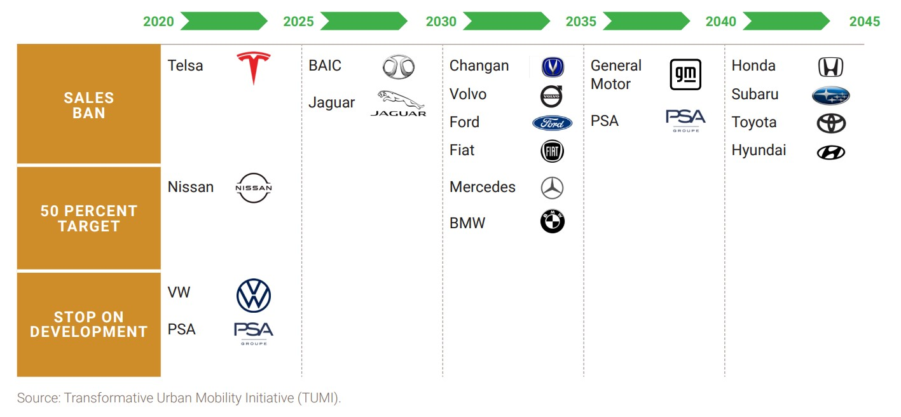

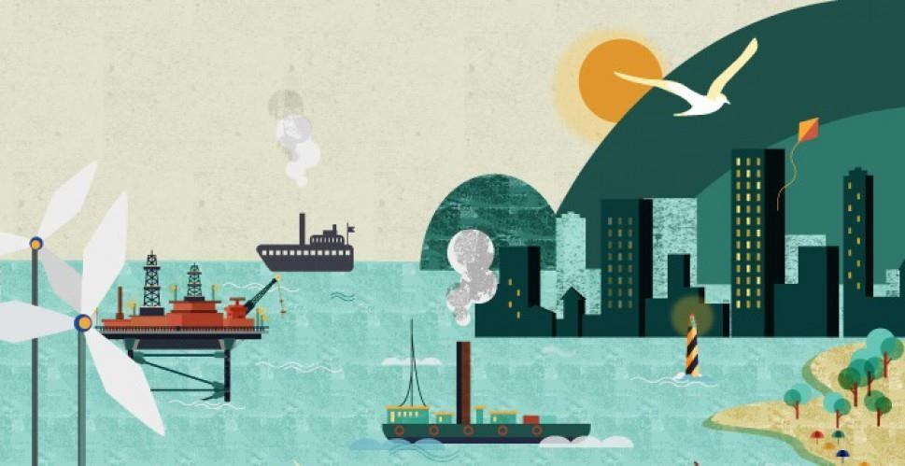

**Sec**

**4**

**:**

**Energy Transition in Smart Islands**

## Smart Islands: New Solutions

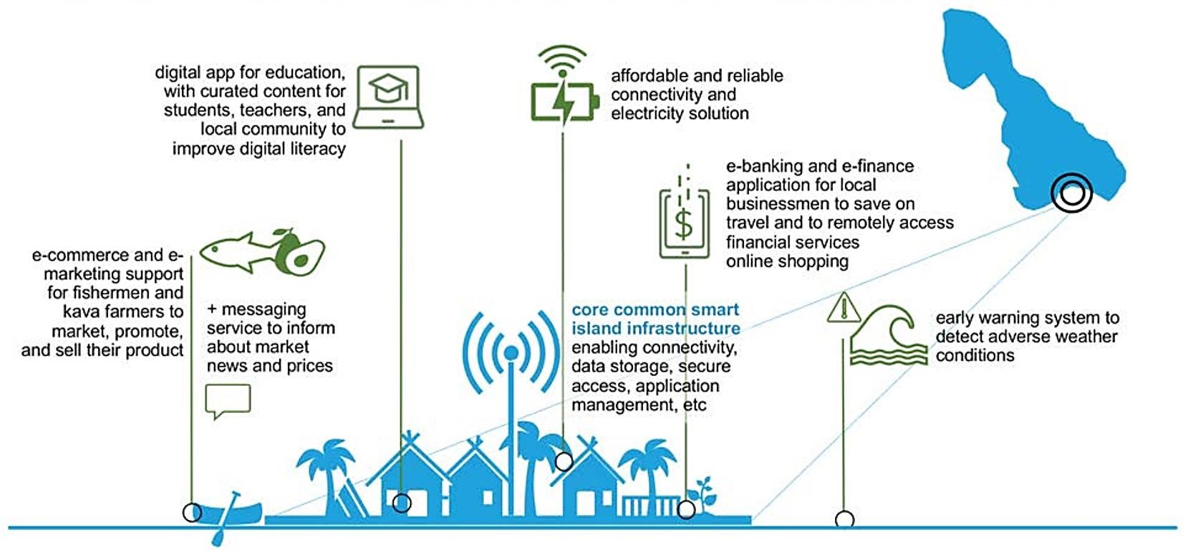

## Challenges of islands’ energy supply

* Islands typically have sensitive energy systems depending on natural surroundings, but innovative technologies and the exploitation of renewable energy (RE) sources present opportunities like self-sufficiency, but also challenges, such as grid instability.
* 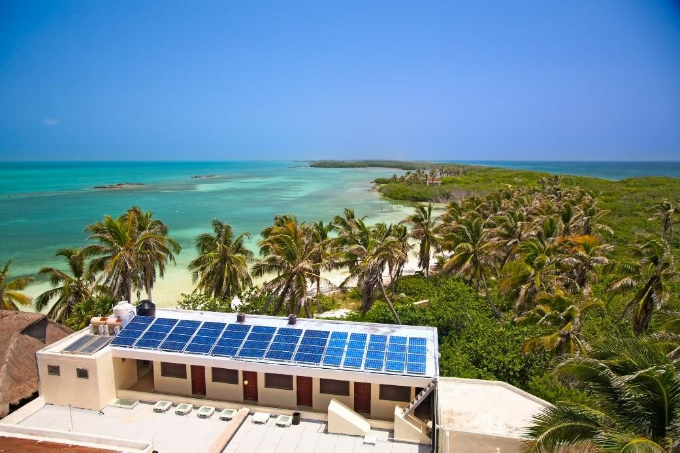Islands are under more pressure than mainlands due to their inherent isolation and higher dependence on their natural surroundings, including conditions affecting possible RE utilization.
* Islands face exorbitant electricity costs when importing fossil fuels and are also among the most vulnerable regions to rising sea levels, drought and flooding.
* Innovative teamwork is putting them on the fast track to 100% energy independence – the green way

## Energy considerations of the islands

* self-reliant islands and remote communities development of resilient energy systems
* Island and remote communities have unique physical features that impact energy systems.
* For many of these communities, access to resilient, affordable, sustainable, and clean energy resources is a priority.
* 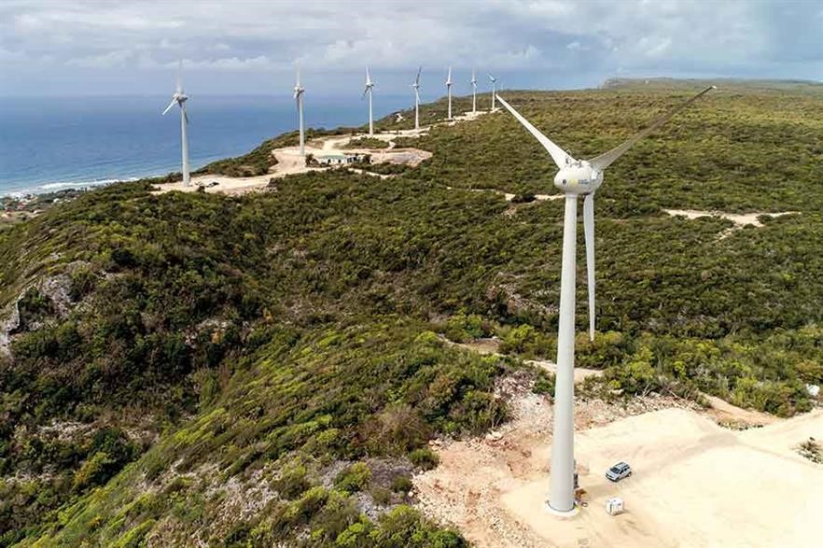The Pacific, and the surrounding areas, have some of the world’s highest electricity prices in the world.
* Like many islands around the globe, the featured islands are heavily reliant on fossil fuels for electricity generation, leaving them vulnerable to global oil price fluctuations that directly impact the cost of electricity.

## Providing an island with smart grid

* Smart grids are energy networks monitor energy flows and adapt the changes in energy supply and demand accordingly.
* 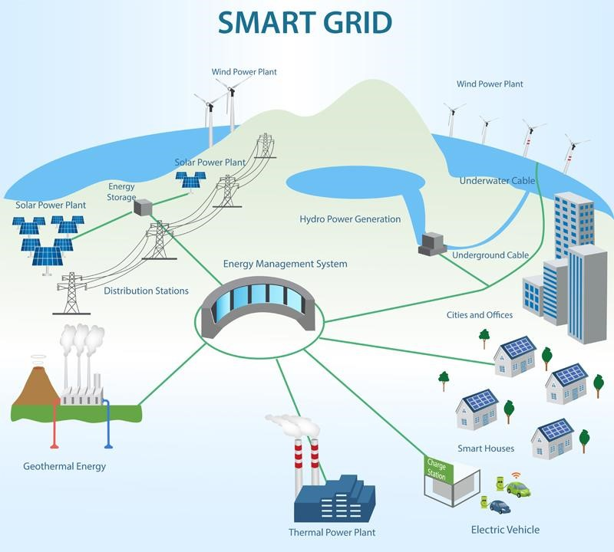When connected with smart metering systems, smart grids provide consumers and suppliers information on real-time consumption.
* With smart meters, consumers can adapt – in time and volume – their energy usage to different energy prices throughout the day, saving money on their energy bills by consuming more energy in lower price periods.
* The scale of these pilot projects enables to test the different components and systems in the field in vigorous environmental and operational conditions, while reducing the impacts of possible failures of integrating these systems into an existing infrastructures.

## Renewable energy for islands

* These small pieces of land surrounded by water are taking advantage of their geographical features to install renewable energies and accelerate their sustainable development.
* 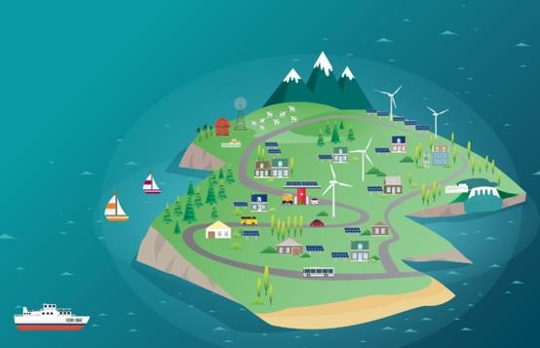For increasing their security, the islands prefer to use indigenous sources as renewable ones; unfortunately, the intermittence and stochastic character of these “fatal” energy sources make them more difficult to manage and it is aggravated in the case of small island networks.
* This transition away from imported, carbon-dense fuel could improve local economic and ecological resilience, reduce electricity prices, and dramatically reduce per capita carbon emissions.

## Renewable energy for islands

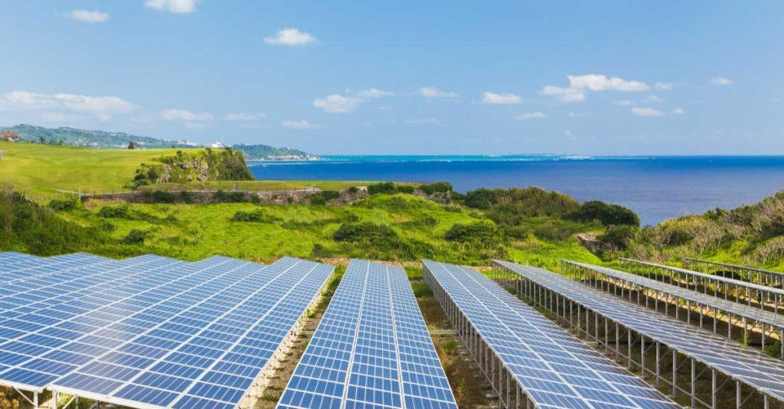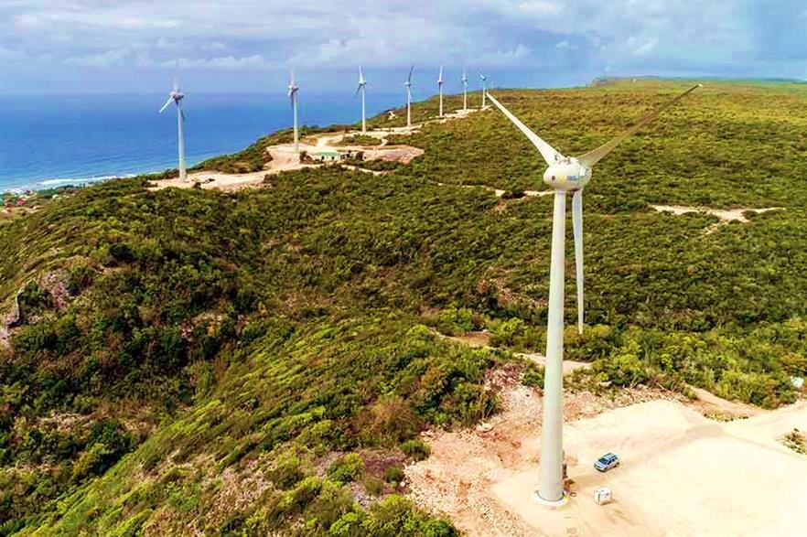

* Many islands have access to abundant **wind and solar** energy resources and could significantly cut ties with the fossil fuel industry.
* **Hydropower** can be developed on mountainous islands where it often rains (and which have a large amount of rainfall).
* **Biofuels** derived from coconut, palm or sweet sorghum oils would enable local economies to thrive and reduce dependence on fossil fuel imports, helping islands to be sustainable.
* **Algae** – even though these are still in an early stage of development – can bring great benefits to island communities for their fuel production.
* **Ocean energy** from the action of **tides, waves** are other remarkable renewable resources for islands.

## Smart sustainable energy system for the islands

**Some**

**of**

**the**

**suggestable**

**technological**

**solutions**

**to**

**be**

**investigated**

**according**

**to**

**relevant**

**pillars**

**for**

**an**

**island**

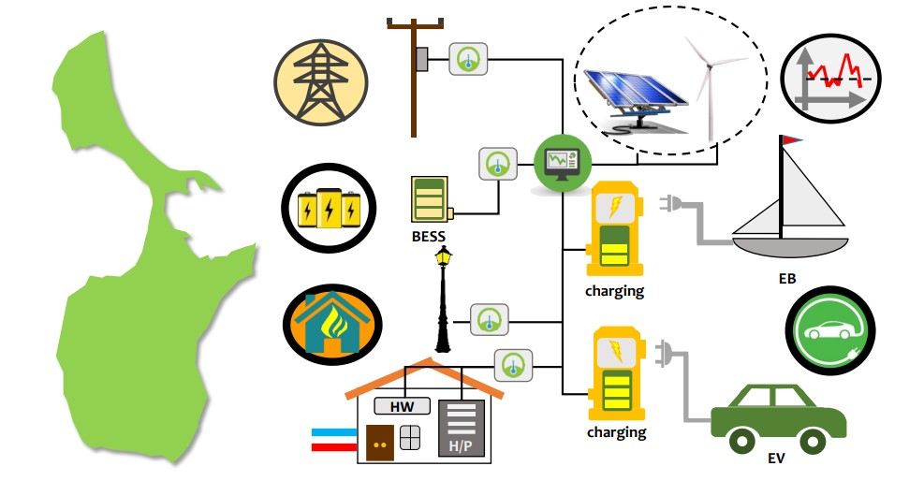

## The Smart Islands Energy System (SMILE)

* 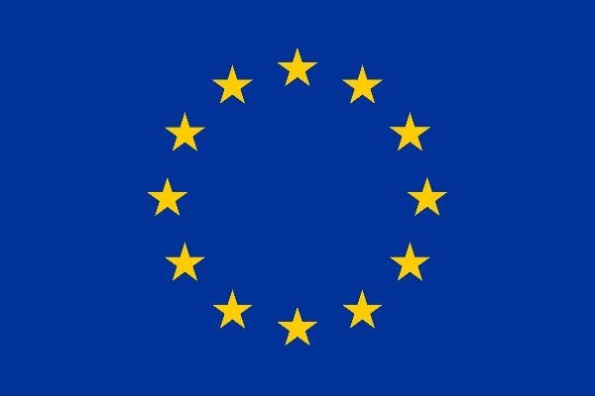This project was a collaboration of nineteen partners from various European countries and is funded by the European Union’s ‘Horizon 2020 research and innovation program.
* The project demonstrated nine different smart grid technologies on three different islands. The end goal of the project was to promote the market introduction of these nine technologies.
* 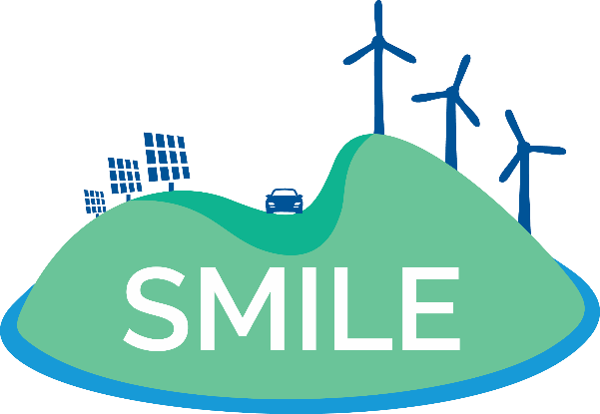The scale of these pilot projects enabled to test the different components and systems in the field in vigorous environmental and operational conditions, while reducing the impacts of possible failures of integrating these systems into an existing infrastructure.

## SMILE thematic pillars

**Demand Response (DR)** services with the use of predictive algorithms are proposed and tested in the most appropriate scheme for each pilot



**Smartening the Distribution Grid**

through

advanced monitoring and predictive models

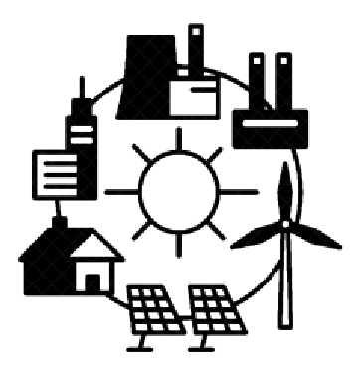

|  |  |  |  |  |  |  |
| --- | --- | --- | --- | --- | --- | --- |
|  |  | **Energy storage** provided with the use of BESS or heating storage, and storage management through models and algorithms |  |  |  | **Smart Integration of grid users from Transportation**, using the flexible capacity of electric vehicles and boats |

**Domestic heating/cooling systems**, using renewable technologies coupled with energy/heat storage options



## SMILE pilot projects

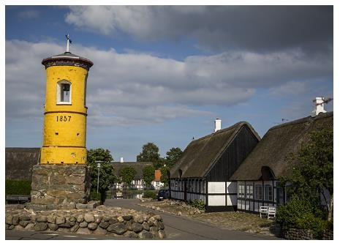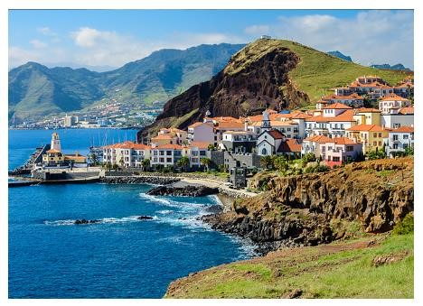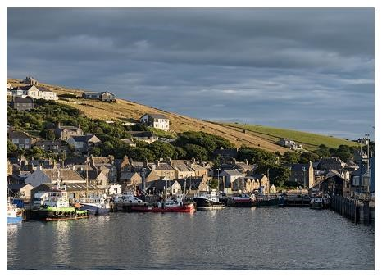

**Samsø**

(Denmark) ● In order to facilitate the transition, the SMILE project implemented three large-scale pilot projects in different regions of Europe with similar topographic characteristics but different policies, regulations and energy markets.

**Orkney Islands**

* The objective is to test solutions while establishing mutual learning (UK) processes and providing best practice guidance for replication in other regions.
* The three pilots will test different combinations of technological solutions according to local specificities and conditions and the **Madeira** existing infrastructure. (Portugal)

## Europe’s local-to-global energy transition strategy

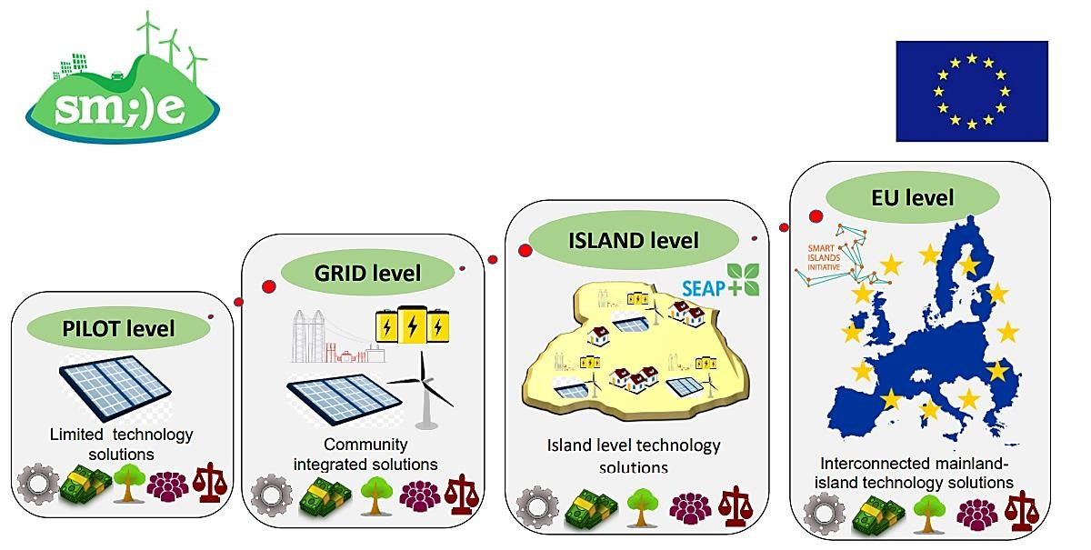

## Energy Transition Initiative

* The U.S. Department of Energy's (DOE) Energy Transitions Initiative Partnership Project (ETIPP) works alongside remote, island, and islanded communities seeking to transform their energy systems and increase energy resilience through strategic energy planning and the implementation of solutions that address their specific challenges.



* The Energy Transitions Initiative (ETI) provides a proven framework and technical resources and tools to help islands, states, and cities transition to a clean energy

economy and achieve their clean energy goals.

**Remote** communities **Island** communities

* are isolated from population centers • are isolated from the mainland by and as a result, have limited access to waterways. centralized energy systems.

**Islanded** communities

* are not grid-tied to large transmissionscale power systems and as a result, experience frequent issues with power quality or reliability.

## Energy Transition Initiative

To watch the video of this slide, refer to the video presentation.



## Case Study: Hawaii island

* After initially setting a goal of 70% clean energy by 2030 by ETI, Hawaii further chose a more ambitious target in 2015 by setting a goal of 100% renewable electricity by 2045.
* Hawaii has set the most aggressive clean energy goal in the U.S., requiring 100% renewable electricity by 2045.
* Hawaii is already much further along in its clean energy goals than most states, with the share of customers hosting solar photovoltaic systems being about 20 times greater than that of an average U.S. utility.
* 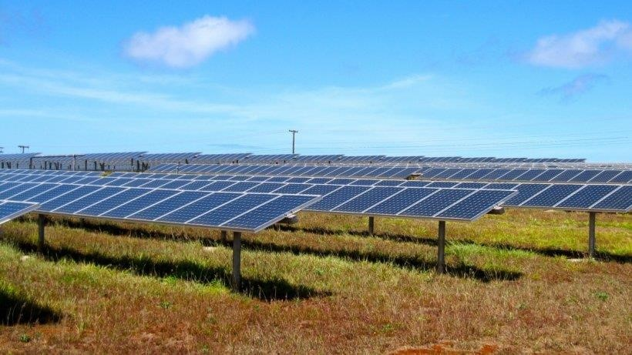The National Renewable Energy Laboratory has collaborated with one of America’s largest solar installers, SolarCity, to examine ways for PV systems to better interact with the grid. The work pointed the way for Hawaiian Electric Company to allow more PV systems to be installed.
* ETI is providing training to the Hawaii Public Utilities Commission to help the staff deal with an increasing number of dockets related to renewable energy.



**Digital Transformation: Enhancing IoT**

**-**

**driven Solutions for Smart Islands**

___________________________

Mohammed Al

-

Ajmi,

Senior Lecturer.

University of Technology and Applied Science, HCT

Mohammed.alajmi@hct.edu.om



Applied Use Cases in the implementing Smart Islands

–

Use Cases



# Mohammed Khamis Al-Ajmi

Information Technology Authority

Head of Quality & Analyst in Digital Forensics - National Digital ForensicLab - Oman CERT

Analyst and Quality Executive in Digital Forensics - National DigitalForensic Lab - Oman

CERT



▪

▪



Head of Educational Technology, Middle East College Author of Books (Arabic):

Guide To Microsoft Servers

The 7 Element of Digital Citizenship

[LinkedIn](https://www.linkedin.com/in/malajmi30/)

**Upon completion of this course, the Participant will be able to:**

• Apply / Implement the previous learning in real world use cases ( 5 use cases).

# Use Cases

## 1. Enterprise Data Backup

**Use Case Description**

* ABC Enterprise currently keeps 18 months of CRM data in RDBMS and 7 years of archived data on tapes.
* ABC Enterprise wants to move from tape backups to HDFS backups
* Access of data is easier
* Can use commodity hardware with potential to move to the cloud
* No offline backups required
* Provide adhoc querying capability on the data

# Use Cases

## 1. Enterprise Data Backup

**Characteristics**

|  |  |  |
| --- | --- | --- |
| **Characteristics** | **Type** | **Notes** |
| Sources | RDBMS |  |
| Data Types | Numeric and relational |  |
| Mode | Historical |  |
| Data Acquisition | Pull |  |
| Availability | After 1 day | Data needs to be available in the data warehouse after 1 day since the original data is created |
| Store type | Write once, read many |  |
| Response Times | As good as possible | Given adhoc querying requirements, queries can run for a few seconds. |
| Modelbuilding | None |  |

Online Training Course on “Digital Transformation: Enhancing IoT driven Solutions for Smart Islands”, 18-31 July 2022

# Use Cases

## 1. Enterprise Data Backup

|  |  |  |
| --- | --- | --- |
| **Module** | **Technology option** | **Notes** |
| Acquire | Sqoop | Default choice for Database Extract |
| Transport | N/A |  |
| Persist | HDFS | Store in native HDFS format as Sequence Files |
| Transform | N/A |  |
| Reporting | Impala | Basic adhoc querying tool |
| Advanced  Analytic | N/A |  |

**Big Data Solution** 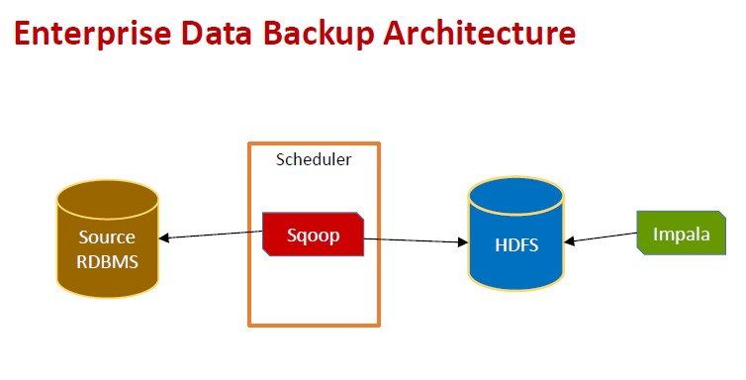

# Use Cases

**2. Media File Store Use Case Description**

* ABC Enterprise has contact center where all calls are recorded. These recordings need to be archived for analytics
* ABC Enterprise wants to move from tape archive to online archive
* Provide adhoc querying capability on the data

# Use Cases

## 2. Media File Store

**Characteristics**

|  |  |  |
| --- | --- | --- |
| **Characteristics** | **Type** | **Notes** |
| Sources | Contact Center recording solutions |  |
| Data Types | Media files |  |
| Mode | Historical |  |
| Data Acquisition | Pull |  |
| Availability | After 1 day | Data needs to be available in the media store after 1 day since the original data is created |
| Store type | Write once, read many |  |
| Response Times | As good as possible | Given adhoc querying requirements, queries can run for a few seconds. |
| Modelbuilding | None |  |

# Use Cases

## 2. Media File Store

|  |  |  |
| --- | --- | --- |
| **Module** | **Technology option** | **Notes** |
| Acquire | Files | Only choice for media files |
| Transport | FTP | Easy transfer; security and compression capable |
| Persist | HDFS, MYSQL | Media files stored in HDFS ; Meta-data and analytics stored in MySQL |
| Transform | Custom | Custom Media Analyzer for tagging media files and storing meta data |
| Reporting | Impala | Custom Media Reporting tool to analyze meta data and listen to recordings |
| Advanced  Analytic | N/A |  |

**Big Data Solution** 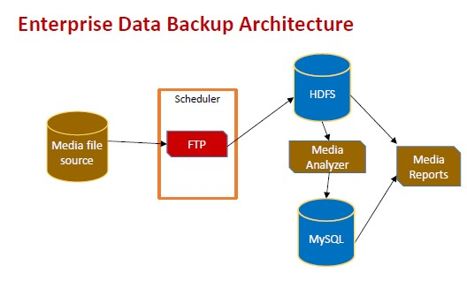

# Use Cases

## 3. Social Media Sentiment Analysis

**Use Case Description**

* ABC news corporation tracks popular topics on social media and uses them for their news reporting
* They want an automated system to capture social media interactions on popular topics and do real time sentiment analysis
* Sentiment Analysis need to be summarized and archived for future analysis too.

# Use Cases

## 3. Social Media Sentiment Analysis

**Characteristics**

|  |  |  |
| --- | --- | --- |
| **Characteristics** | **Type** | **Notes** |
| Sources | Twitter, Facebook | Social media popular topics. Topics are configurable |
| Data Types | Tweets, posts (JSON) |  |
| Mode | Real time |  |
| Data Acquisition | Streaming / push |  |
| Availability | Real time | On the fly analytics |
| Store type | Write many, read many |  |
| Response Times | Real time | Given adhoc querying requirements, queries can run for a few seconds. |
| Modelbuilding | Sentiment Analysis |  |

# Use Cases

## 3. Social Media Sentiment Analysis

**Big Data Solution**

|  |  |  |
| --- | --- | --- |
| **Module** | **Technology option** | **Notes** |
| Acquire | Streaming | Streaming supported by all social media websites |
| Transport | Kafka | Kafka provides scalable real time transport for data. Has interfaces to Twitter streaming as well as Spark |
| Persist | Cassandra | Store data by topic. The social media topic would be used as the key. |
| Transform | Apache Spark | Real time stream subscription and transformation |
| Reporting | Custom | Custom application for reading Cassandra data and summarizing for news |
| Advanced Analytic | Apache Spark | Sentiment Analysis on the fly with stream processing |

# Use Cases

## 3. Social Media Sentiment Analysis

**Big Data Solution**

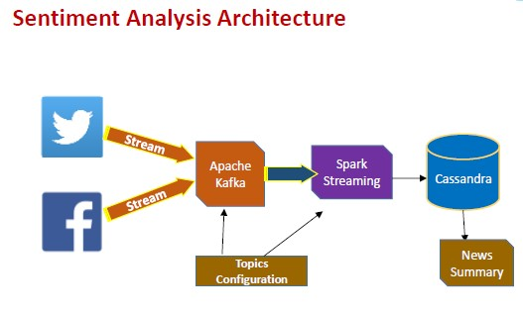

# Use Cases

## 4. Credit Card Fraud Detection

**Use Case Description**

* ABC Systems runs a web based retail solution where customers can order any kind of products (like Amazon)
* Sometimes credit card thieves use stolen information to make purchases. This later results in loss of revenue
* ABC systems needs a real time Credit Card Fraud prediction system so that the purchase is blocked before its complete.

# Use Cases

## 4. Credit Card Fraud Detection

**Characteristics**

|  |  |  |
| --- | --- | --- |
| **Characteristics** | **Type** | **Notes** |
| Sources | web transactions | Data is captured in real time while payment is being made on the web |
| Data Types | Numeric / CRM |  |
| Mode | Real time / Historical | Historical data collection ; prediction in real time |
| Data Acquisition | Streaming / push | Data pushed from browser as transactions happen |
| Availability | Real time | Real time predictions |
| Store type | Write once , read many |  |
| Response Times | Minimal | Prediction need to be made when the purchase is made. |
| Modelbuilding | Binary Classification | Model to predict if a transaction is fraudulent or not. |

# Use Cases

## 4. Credit Card Fraud Detection

**Big Data Solution**

|  |  |  |
| --- | --- | --- |
| **Module** | **Technology option** | **Notes** |
| Acquire | Web Events | Generated by custom web app. Deployed on a web farm |
| Transport | Kafka | Kafka provides scalable real time transport for data. Web Transaction events from web app. |
| Persist | MongoDB | Web events/transactions accumulated and stored in Mongo DB; Also models built are stored in Mongo DB |
| Transform | Spark |  |
| Reporting | None | Architecture can be enhanced to add adhoc reporting on the web transactions if required. |
| Advanced Analytic | Apache Spark | Binary Classification model building |

# Use Cases

## 4. Credit Card Fraud Detection

**Big Data Solution**

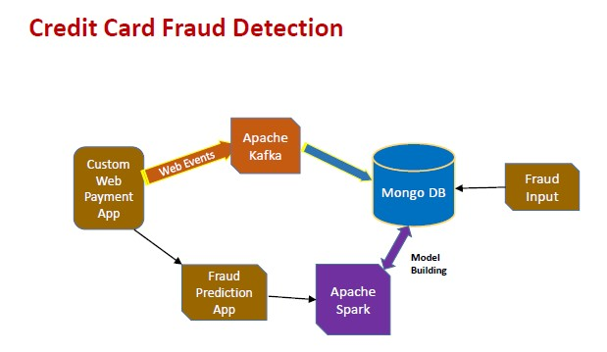

# Use Cases

## 5. Connected Car - IOT

**Use Case Description**

* ABC Car company wants to connect cars in real time to analytics engine
* Cars have multiple sensors. Sensor data need to be analyzed (real time / historical) to generate alarms for possible failures to the driver
* ABC needs a satellite enabled data collection and alarm system backed by a big data infrastructure

# Use Cases

## 5. Connected Car - IOT

**Characteristics**

|  |  |  |
| --- | --- | --- |
| **Characteristics** | **Type** | **Notes** |
| Sources | Car sensors | Sensors in car |
| Data Types | Numbers | Numeric event sensor data |
| Mode | Historical / Real time | Critical data processed real time. Rest historical |
| Data Acquisition | Push | Sensors send data to collection centers |
| Availability | Real time | Real time alarms needed |
| Store type | Write many, read many | Car profile need to be stored |
| Response Times | Real time | Real time profile fetches for real time alarming |
| Modelbuilding | Car issue prediction | Predict possible future issues |

# Use Cases

## 5. Connected Car - IOT

**Big Data Solution**

|  |  |  |
| --- | --- | --- |
| **Module** | **Technology option** | **Notes** |
| Acquire | Events from Car Sensors |  |
| Transport | ? |  |
| Persist | ? |  |
| Transform | ? |  |
| Reporting | Custom |  |
| Advanced Analytic | ? |  |

Replace the Question Mark (?) with appropriate Technology option for each Big Data Module.

# Use Cases

## 5. Connected Car - IOT

**Big Data Solution**

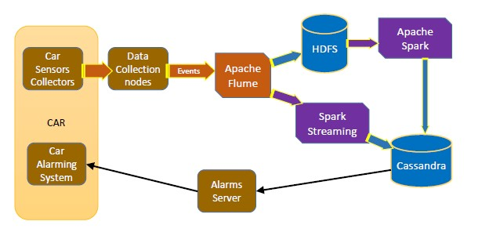



**Digital Transformation: Enhancing IoT**

**-**

**driven Solutions for Smart Islands**

___________________________

Jamal

Sophieh

Expert and

Manager of Digital Economy Department (ICT ministry of Iran)

jsophieh@ut.ac.ir



Applied use cases in the implementing smart islands

–

use case

2



**Jamal Sophieh**

More than 20 years of experience in the ICT sector and in management and business field

PhD of Entrepreneurship and Business Creation (University of Tehran- Entrepreneurship Faculty)

University Instructor and Lecturer in University of Tehran and University of Shahid Beheshti (Tehran) for 5 years.

Senior Instructor of Digital Transformation and Digital Economy



Expert and Manager of Digital Economy Department (ICT ministry of Iran) for 5 years.

Coordinator and Expert of ITU Study Groups (Telecommunication Infrastructure Company- TIC.ir) for 3 years

Senior Analyst of Strategic and Comprehensive Planning (Telecommunication Infrastructure CompanyTIC.ir) for 5 years

Journalist and Analyst of ICT Specialized Magazines for 15 years

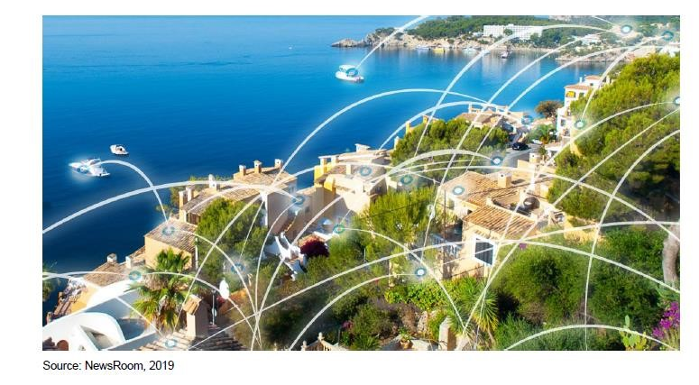

**Croatia’s Islands: Making the Most of Their Territorial Capital**

**Through Smart**

key areas of intervention or KAI

The thematic coverage of smart islands encompasses a wide range of development sectors

1. smart governance and smart resource management
2. smart economy
3. smart mobility
4. smart environment
5. smart living and safe islands

**Based on the conducted analysis, the key areas of intervention for “smart islands” are identified below:**

# Smart governance and smart resource management

1. e-public administration
2. ICT infrastructure
3. communication platforms for dialogue with citizens, and the civil and private sectors
4. smart planning of island development
5. encouraging social innovations
6. transparency of public data and information
7. integrated management systems for islands’ infrastructure and natural resources

**Based on the conducted analysis, the key areas of intervention for “smart islands” are identified below:**

# Smart economy

1. ecosystem for entrepreneurs
2. diversification of island economies
3. sustainable tourism development
4. territorial branding
5. development of creative and cultural industries and IT sector
6. expansion of opportunities for locally produced food
7. e-commerce
8. e-business and businesses networking
9. lifelong learning in line with the needs of the labour market and informatic literacy
10. development of skills related to smart specialization and entrepreneurship

**Based on the conducted analysis, the key areas of intervention for “smart islands” are identified below:**

# Smart mobility

1. infrastructure for clean island transport
2. alternative fuel infrastructure
3. walking, cycling and non-motorized transport infrastructure and services
4. digitalization of island transport systems
5. clean island transport vehicles
6. improving the mobility of the island population (not only tourists)
7. intermodal transport and better connectivity of islands and mainland

i) increasing the awareness of the local population and visitors about the need to preserve the environment and providing means for more rational use of resources

**Based on the conducted analysis, the key areas of intervention for “smart islands” are identified below:**

**4. Smart environment**

Croatia’s islands: Making the most of their territorial capital through smart solutions 26 a) renewable energy sources and promoting self-sustainable islands

1. smart energy and water distribution systems and smart drainage
2. smart public infrastructure
3. smart buildings, homes and districts
4. smart waste management
5. control and monitoring of air, soil and water quality, noise reduction
6. smart and environmental management of industrial sites
7. smart measures for adapting to climate change
8. increasing the awareness of the local population and visitors about the need to preserve the environment and providing means for more rational use of resources

**Based on the conducted analysis, the key areas of intervention for “smart islands” are identified below:**

**5. Smart living and safe islands**

1. high capacity broadband network
2. support to the development of e-citizens
3. digitalization in the field of health care (smart healthcare infrastructure)
4. and e-health services
5. smart educational infrastructure and development of educational platforms
6. social and inclusive infrastructure provision (including universal access for elderly and disabled)
7. protection, valorization and promotion of cultural heritage and cultural services
8. improvement in quality and security of public spaces
9. more effective development of a program to combat indigenous wildlife

# Palma de Mallorca in Spain

The municipality of **Palma de Mallorca is currently the second largest “Wi-Fi” city, after Miami (USA).** Wi-Fi Palma is a project run by the *Universitat de les Illes Balears* on big data and tourism. The project is being developed in cooperation with the Supercomputing Centre in Barcelona, the most powerful supercomputer in Spain. To increase its attractiveness as a tourism center, starting in 2014, Majorcan authorities began to provide free Wi-Fi access across the entire island starting in 2014 thus aiming to become an intelligent tourism destination.

# Europe

**On a global and European scale, there are good examples of smart island approaches worth learning from; some particularly relevant cases are presented below.** There are cases of islands implementing various smart solutions, which differ from smart city solutions in their scale and complexity, but which have the same aim of making a more efficient use of resources and achieving higher levels of environmental and social sustainability. **Samsoe island in Denmark**, for example, has a project known as *Fossil Free Island* where they are introducing a number of technologies such as biogas, smart energy systems, upgraded wind power feeding heat pumps, storage heat and electricity, energy savings, smart energy systems, and e-mobility (e-vehicles, ferry). Around 70-80 % of financing is obtained through public-private partnership and only 20% comes from funding or direct subsidy.

The **Island of Salina, often labelled as ‘the greenest of the Aeolian islands’**, has started its clean energy transition. The island has taken initiatives to promote eco-tourism and initiatives to reduce pol-lution and environmental degradation and is planning to implement energy efficiency and energy saving measures particularly in public lighting systems and the heating and cooling of its public buildings. Further, the municipalities aim to produce energy locally, capitalizing on the island’s abundant renew-able energy resources of electricity and heat, and to switch their public transport to electric minibuses powered by solar PV. Charging stations would be available for electric vehicles on the island as well. These initial plans and activities have been well received by residents, local tour operators and visitors.

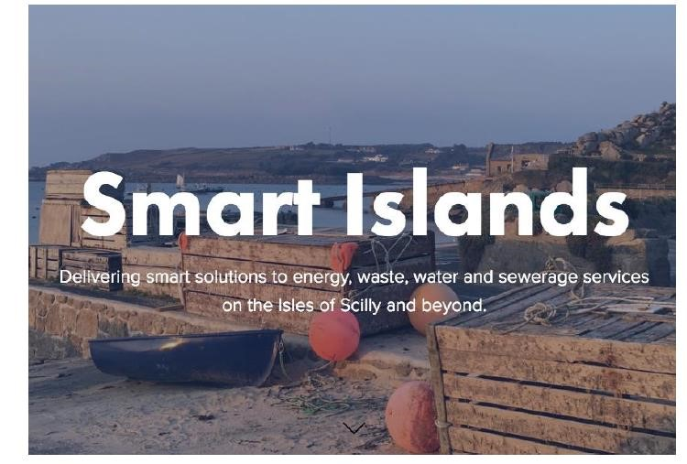

# The Smart Islands programme, the Isles of Scilly, United Kingdom

The Smart Islands programme in Scilly intends to deal with Scilly’s main infrastructure and utility issues through a sustainable and affordable approach, whilst providing a model for the community that can profit from a rapid transition from being carbon intensive to having a low carbon footprint. The main goals of the project are a 20% reduction in electricity bills by 2020 and 40% by 2025, to cover the isles’ energy demand with the renewable generation up to 40% by 2025, having 40% of vehicles be low carbon or electric by 2025 as well as increased offerings for internships, cultural exchange and STEM skill delivery for young people.

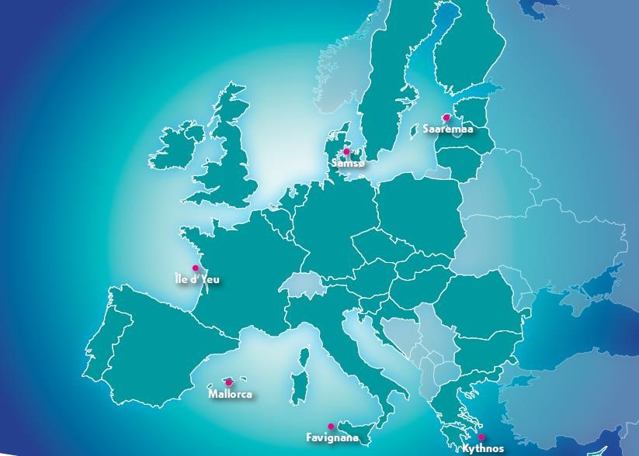

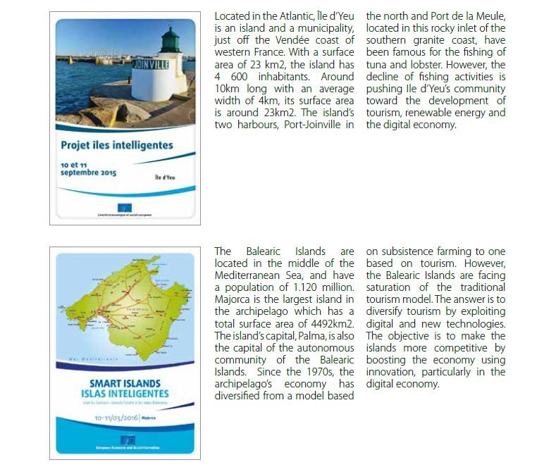

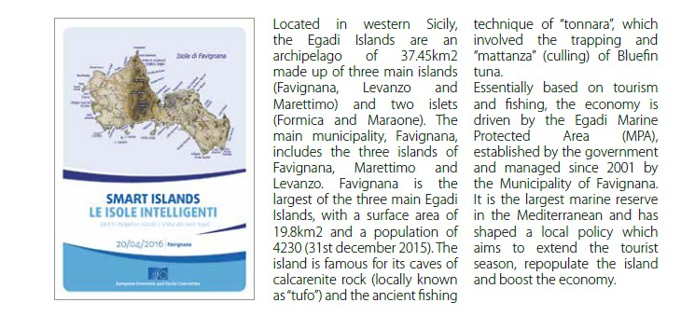

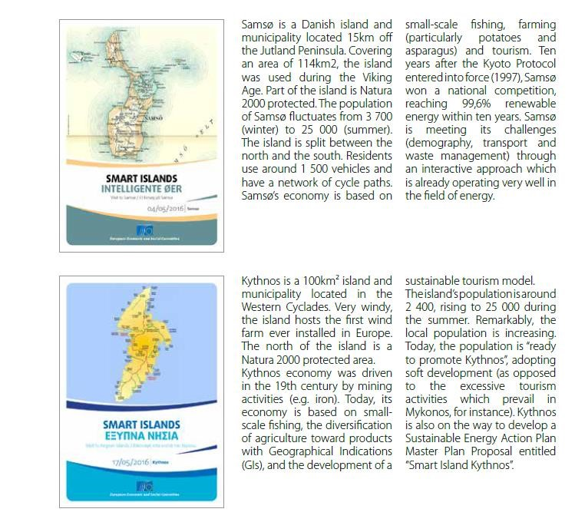

.

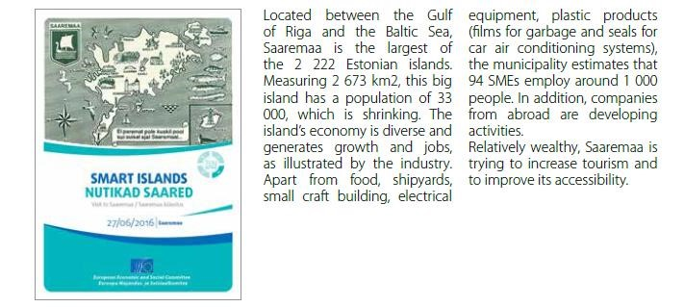

# Information and Communication Technologies (ICT)

* Big data and tourism

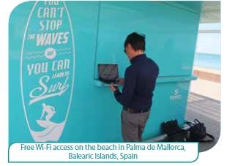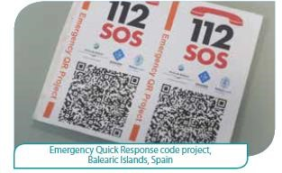

* Emergency Quick Response Code
* Internet broadband community
* Virtual care and services for the elderly population
* Smart small harbour services

# Innovation, including energy, transport and environment

* Offshore wind farm

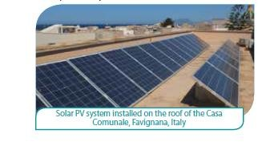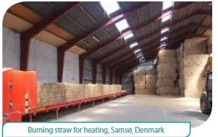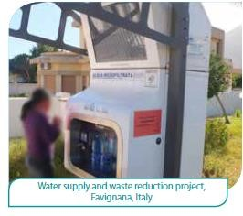

* Solar energy
* Energy efficiency and sustainable mobility
* Straw-fuelled heating systems
* Introduction of renewable sources of energy in the power
* Mix
* Public filtered water fountains to prevent plastic waste
* Marine Protected Area (MPA)

# Tourism development

* Redevelopment of the old processing factory

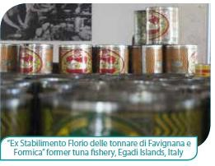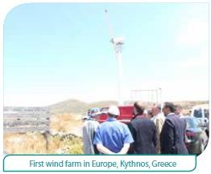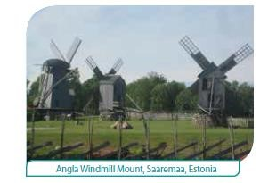

* Hiking and exploration trails
* Recreational fishing
* Ecotourism, preserving the heritage of renewable energy
* Preservation of the local architecture
* Cultural and heritage centre
* Geoparks

# Economic development other than energy or tourism

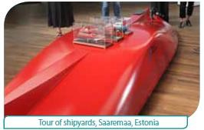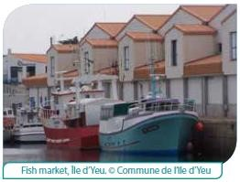

* Shipyards
* Small-craft competence center
* E-commerce
* Turning a declining market into a landing point
* Short supply chain
* Circular economy
* Labelling the island’s products

# Scientific initiatives to protect the marine environment

* 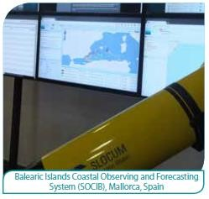Coastal observing and forecasting system
* Protection and study of marine meadows
* Rescue centre for Sea Turtles and Monk Seal Observatory

# Smart solutions in governance and social innovation

* Methods of cooperation
* SmileGov project
* The Pact of Islands
* Redeveloping the urban environment

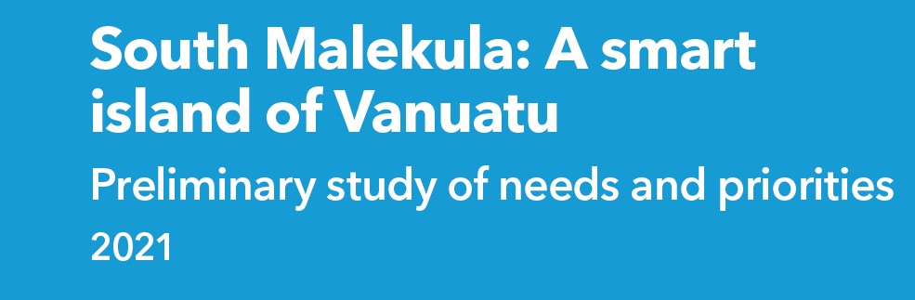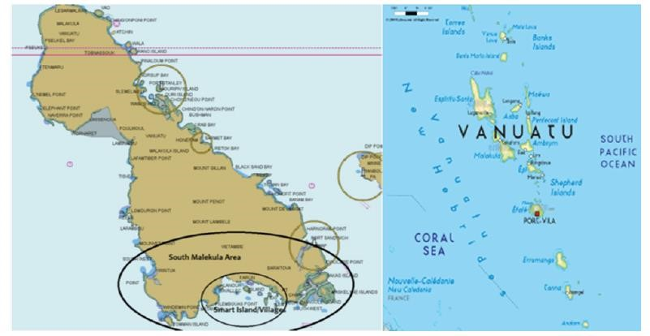

# Phased approach to the Smart Islands Vanuatu Programme

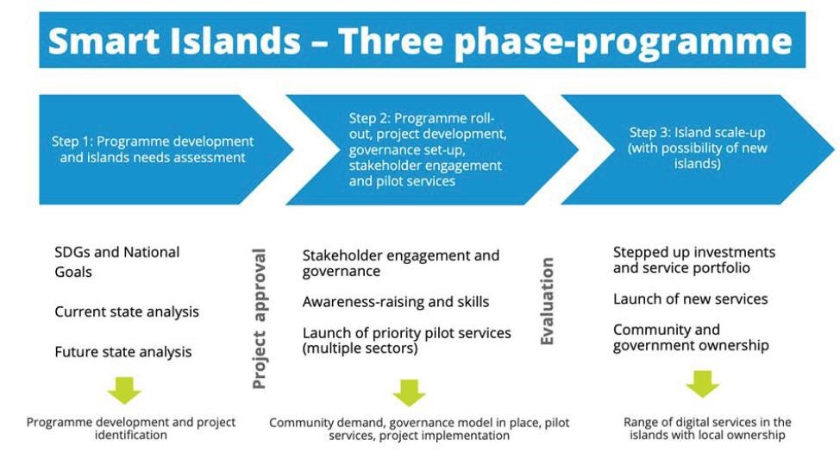

# Problem and solutions tree for Smart South Malekula

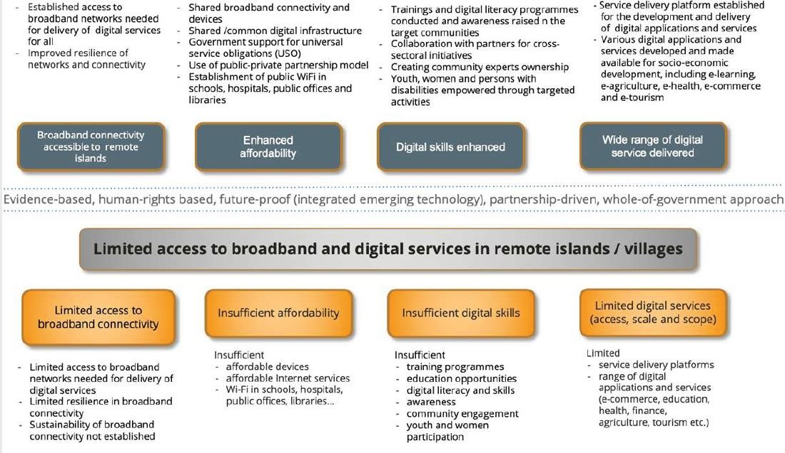

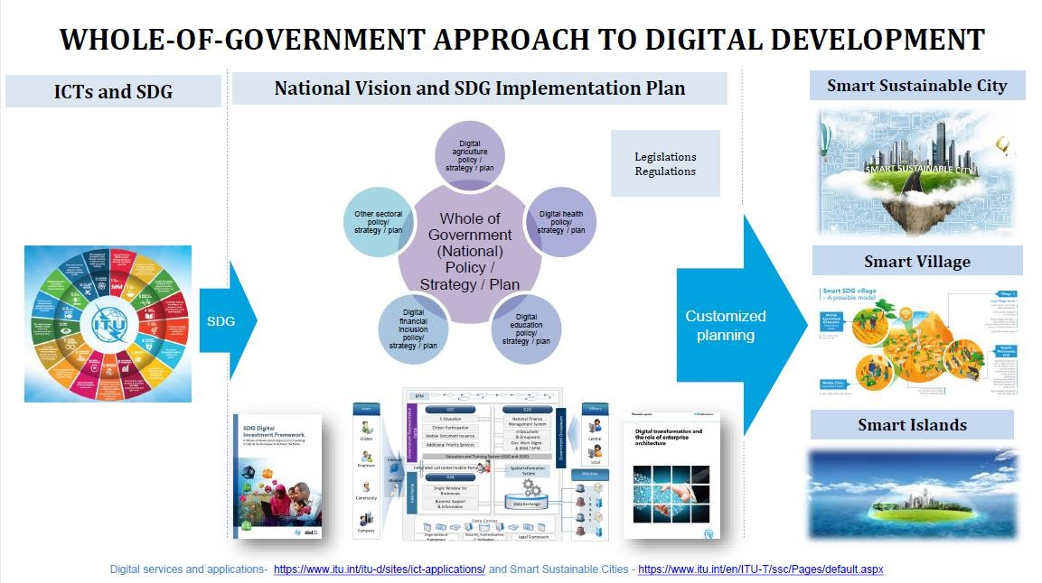

# Digitalization and Smart islands in the Kvarner archipelago

* Currently, in the European Union there are two major initiatives that address the issue of sustainable development of the islands. Top-down initiative coming from the Declaration on Clean energy for EU islands and bottom-up Smart Islands initiative.
* Both initiatives consider islands as living labs that can host innovative pilot projects and lead Europe's transition into a sustainable and low carbon environment. Following objectives of both initiatives, the Croatian government passes a law on islands that support the development of smart islands.

# Framework for Development of Smart Islands in Croatia

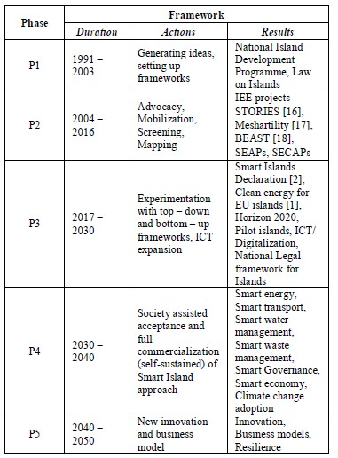

# Combining top-down with a bottom-up approach to develop Smart islands

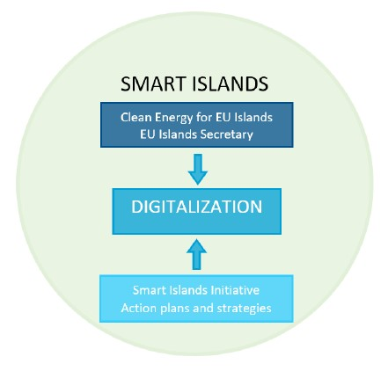

# LoRaWan connectivity and devices deployed for Smart Islands project

The network on the Cook Islands will run several smart island use cases including energy metering, water management, air quality streetlight operation and emergency notifications, such as tsunami sirens.



* A LoRaWAN network is being deployed on the Cook Islands in the South Pacific for a range of smart applications.
* It is a joint collaboration by semiconductors and advanced algorithms supplier Semtech and ICT and internet of things (ioT) solutions provider ICTnexus.
* As part of the ICTnexus Smart Islands project, an IoT platform will feature Semtech’s LoRadevices as well as a LoRaWAN network for the Island’s infrastructure.



* The LoRaWAN will enable the islands to implement several smart island use cases including energy metering, water management, air quality and weather station monitoring, streetlight operation, asset tracking and emergency notifications, such as tsunami sirens.
* “Scalability was key in choosing the right technology to develop the Cook Islands into truly smart islands,” said Tai Kauraka Tangaroa, chief executive officer at ICTnexus. “As we start with Rarotonga for launch, building IoT infrastructure across 15 islands is no simple task, but the strong capabilities of Semtech’s LoRa devices and LoRaWAN standard provided an ease of deployment and scalability this comprehensive project requires to succeed.



**Caribbean Smart Islands – Digital Technology as a catalyst for Economic Growth and**

# Sustainability

## The Smart Islands Forum

* Caribbean-Central American Action in partnership with Mastercard and the Inter-American Bank will host this first “Caribbean Smart Islands” Forum in Washington DC on June 26th, 2018 to discuss how public and private entities can partner in the digital payments ecosystem to generate economic growth in the Caribbean.
* This event will bring together global industry leaders, government, international organizations and NGOs and associations.

**Theme 1: Smart Islands: Enabling the Ecosystem for digital payments**

**Theme 2: Tourism as a catalyst for growth and resilience in the Caribbean**

**Theme 3: Harnessing Trade for Growth: Enabling Caribbean SMEs to enter global commerce**

**One case of investment:**

# Hitachi confirms £10.8m Smart Islands investment

The project is co-financed by the European Regional Development Fund and will be conducted in collaboration with the Smart Islands Partnership and UK smart energy pioneers Moixa and PassivSystems. The initiative aims to “unlock and balance renewable energy generation, making 100 homes more energy efficient and supporting 200 businesses in the Isles of Scilly and in Cornwall, whilst reducing fuel poverty through the use of innovative technologies”. Hitachi also announced that it will develop and deploy an ‘innovative IoT (Internet of Things) platform’ on the islands through the Smart Islands Project, to demonstrate “how an individual community can build a replicable and scalable model to rapidly transition from being carbon intensive to a low carbon community”. They added: “Through the deployment of smart solutions across the islands’ infrastructure, the company will demonstrate the potential of the UK to take a lead role in this area “to inform the UK’s industrial strategy as well as to ensure a sustainable future for many regions of the UK and beyond".

# Smart Island' digital platform up and running in Mallorca

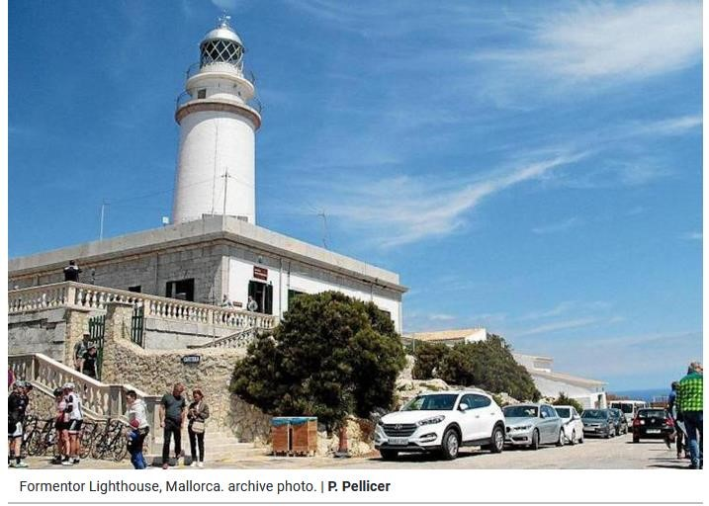

* The Consell de Mallorca’s **‘Smart Island’ digital platform** is already up and running, making it possible to consult a large amount of diata via a mobile phone, computer, or other public device such as information panels.
* The devices will be **installed at archaeological sites and lighthouses** to record visitor attendance.
* **Traffic 'Smart Island'** will monitor the roads, with 21 stations collecting data on vehicles,, making it possible to adjust mobility policies and message boards will warn drivers of traffic jams and other problems on the roads.
* **Meteorological stations** will monitor environmental conditions in certain areas of the island, which is very important for emergency management.

<https://www.majorcadailybulletin.com/news/local/2021/07/31/87555/mallorca-technology-smart-island-digital-platform.html>

* **Environmental and structural sensorial devices** have been installed at the Palau de la Diputación, the main headquarters of the Consell and at the Betlem de la Sang chapel, to control and prevent the deterioration of these facilities.
* Devices have also been placed on the **Misericòrdia building in Palma** to monitor energy efficiency and **at 180 bus stops** to advise passengers of waiting times, mobility alternatives and other issues.
* State-of-the-art hardware has been given to Firefighters and the Emergency Services.
* ‘Smart Island’ works via a data transmission network and the Government has poured **9 million euros** into the project.

<https://www.majorcadailybulletin.com/news/local/2021/07/31/87555/mallorca-technology-smart-island-digital-platform.html>

